### Lesson 5 Practice Problems

1. Each of these is a pair of equivalent ratios. For each pair, explain why they are equivalent ratios or draw a diagram that shows why they are equivalent ratios.
   1. $4:5$ and $8:10$
   2. $18:3$ and $6:1$
   3. $2:7$ and $10,​000:35,​000$
2. Explain why $6:4$ and $18:8$ are not equivalent ratios.
3. Are the ratios $3:6$ and $6:3$ equivalent? Why or why not?
4. This diagram represents 3 batches of light yellow paint. Draw a diagram that represents 1 batch of the same shade of light yellow paint.

* 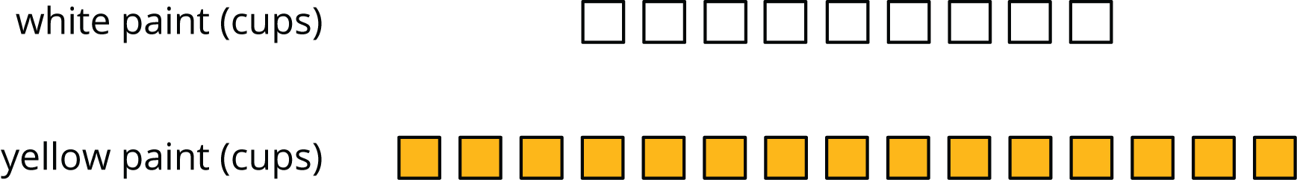
* from Unit 2, Lesson 4

1. In the fruit bowl there are 6 bananas, 4 apples, and 3 oranges.
   1. For every 4 __________________, there are 3 __________________.
   2. The ratio of __________________ to __________________ is $6:3$.
   3. The ratio of __________________ to __________________ is 4 to 6.
   4. For every 1 orange, there are ______ bananas.

* from Unit 2, Lesson 1

1. Write fractions for points $A$ and $B$ on the number line.

* 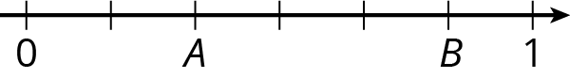
* from Unit 2, Lesson 1



© CC BY Open Up Resources. Adaptations CC BY IM.