## Activity 2: Drink Mix on a Double Number Line

The other day, we made drink mixtures by mixing 4 teaspoons of powdered drink mix for every cup of water. Here are two ways to represent multiple batches of this recipe:

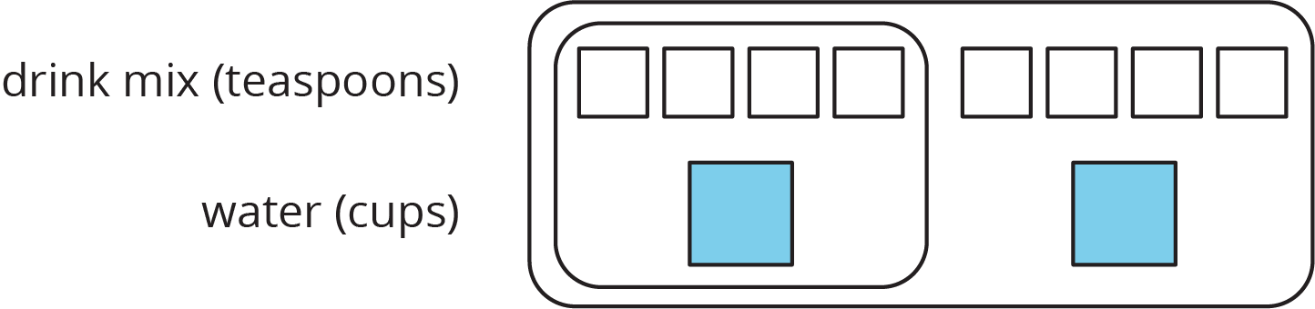

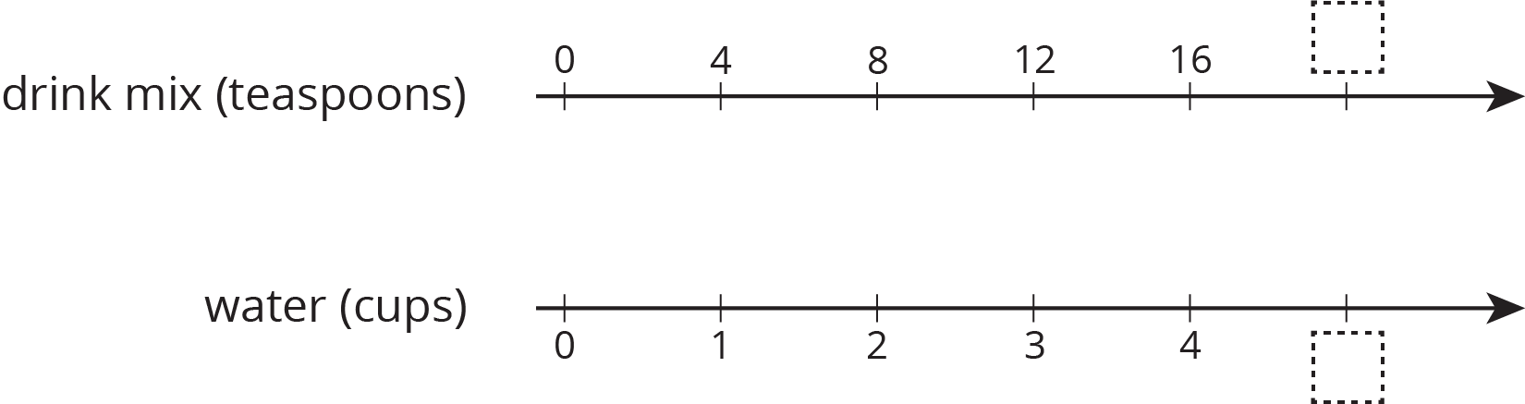

1. How can we tell that $4:1$ and $12:3$ are equivalent ratios?
2. How are these representations the same? How are these representations different?
3. How many teaspoons of drink mix should be used with 3 cups of water?
4. How many cups of water should be used with 16 teaspoons of drink mix?
5. What numbers should go in the empty boxes on the **double number line diagram**? What do these numbers mean?

#### Are you ready for more?

Recall that a *perfect square* is a number of objects that can be arranged into a square. For example, 9 is a perfect square because 9 objects can be arranged into 3 rows of 3. 16 is also a perfect square, because 16 objects can be arranged into 4 rows of 4. In contrast, 12 is not a perfect square because you can’t arrange 12 objects into a square.

1. How many whole numbers starting with 1 and ending with 100 are perfect squares?
2. What about whole numbers starting with 1 and ending with 1,000?



© CC BY Open Up Resources. Adaptations CC BY IM.