## Activity 1: Ordering on a Number Line

1. Locate and label the following numbers on the number line:

$\frac{1}{2}$

$\frac{1}{4}$

$1\frac{3}{4}$

* 1.5
* 1.75
* 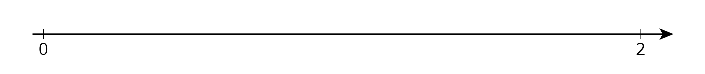

1. Based on where you placed the numbers, locate and label four more fractions or decimals on the number line.



© CC BY Open Up Resources. Adaptations CC BY IM.