## Activity 3: Art Paste on a Double Number Line

A recipe for art paste says “For every 2 pints of water, mix in 8 cups of flour.”

1. Follow the instructions to draw a double number line diagram representing the recipe for art paste.
   1. Use a ruler to draw two parallel lines.
   2. Label the first line “pints of water.” Label the second line “cups of flour.”
   3. Draw at least 6 equally spaced tick marks that line up on both lines.
   4. Along the water line, label the tick marks with the amount of water in 0, 1, 2, 3, 4, and 5 batches of art paste.
   5. Along the flour line, label the tick marks with the amount of flour in 0, 1, 2, 3, 4, and 5 batches of art paste.
2. Compare your double number line diagram with your partner’s. Discuss your thinking. If needed, revise your diagram.
3. Next, use your double number line to answer these questions:
   1. How much flour should be used with 10 pints of water?
   2. How much water should be used with 24 cups of flour?
   3. How much flour **per**pint of water does this recipe use?

#### Are you ready for more?

A square with side of 10 units overlaps a square with side of 8 units in such a way that its corner $B$ is placed exactly at the center of the smaller square. As a result of the overlapping, the two sides of the large square intersect the two sides of the small square exactly at points $C$ and $E$, as shown. The length of $CD$ is 6 units.

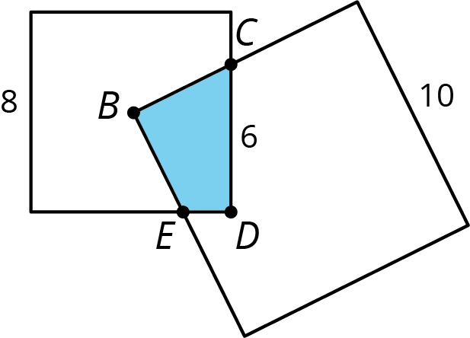

What is the area of the overlapping region $CDEB$?



© CC BY Open Up Resources. Adaptations CC BY IM.