## Lesson 7: Creating Double Number Line Diagrams

### Cool Down: Revisiting Paws, Ears, and Tails

Each of these cats has 2 ears, 4 paws, and 1 tail.

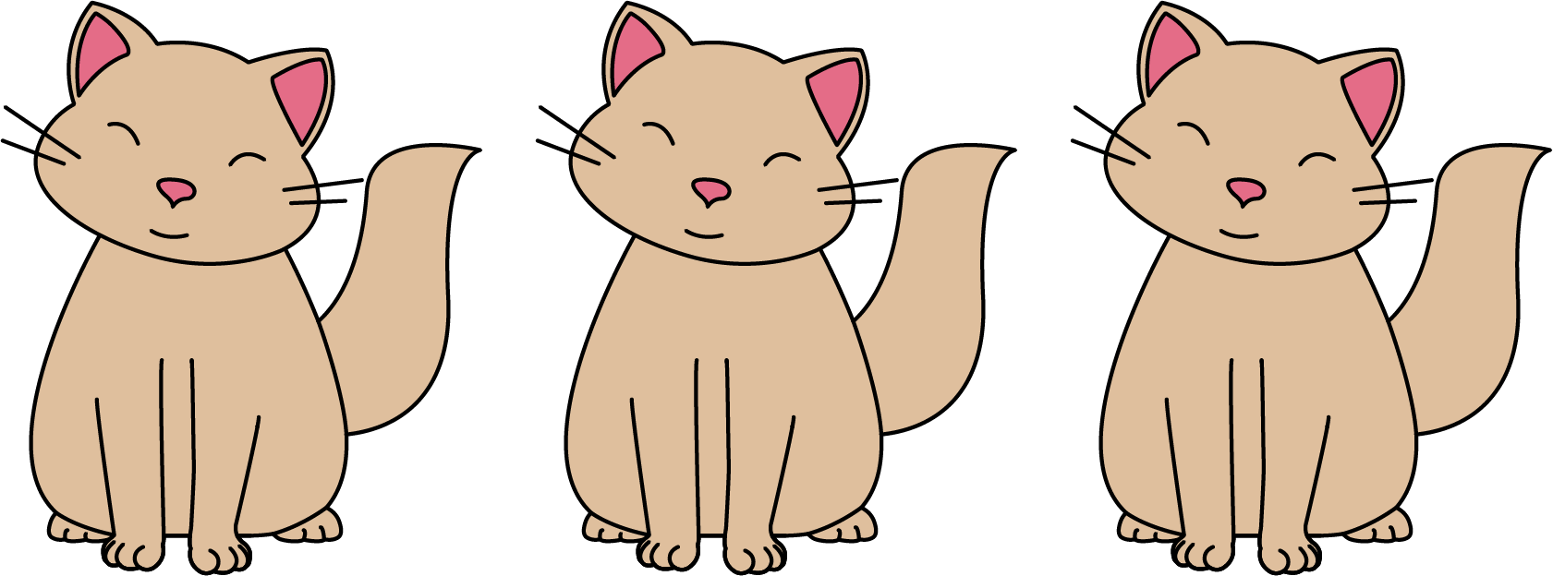

1. Draw a double number line diagram that represents a ratio in the situation.
2. Write a sentence that describes this situation and that uses the word *per*.



© CC BY Open Up Resources. Adaptations CC BY IM.