### Lesson 7 Practice Problems

1. A recipe for cinnamon rolls uses 2 tablespoons of sugar per teaspoon of cinnamon for the filling. Complete the double number line diagram to show the amount of cinnamon and sugar in 3, 4, and 5 batches.

* 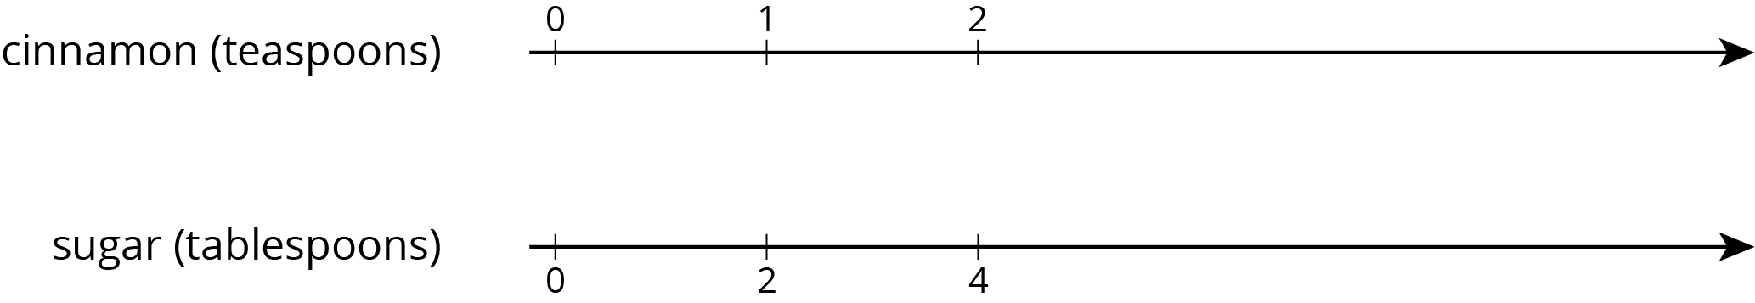

1. One batch of meatloaf contains 2 pounds of beef and $\frac{1}{2}$ cup of bread crumbs. Complete the double number line diagram to show the amounts of beef and bread crumbs needed for 1, 2, 3, and 4 batches of meatloaf.

* 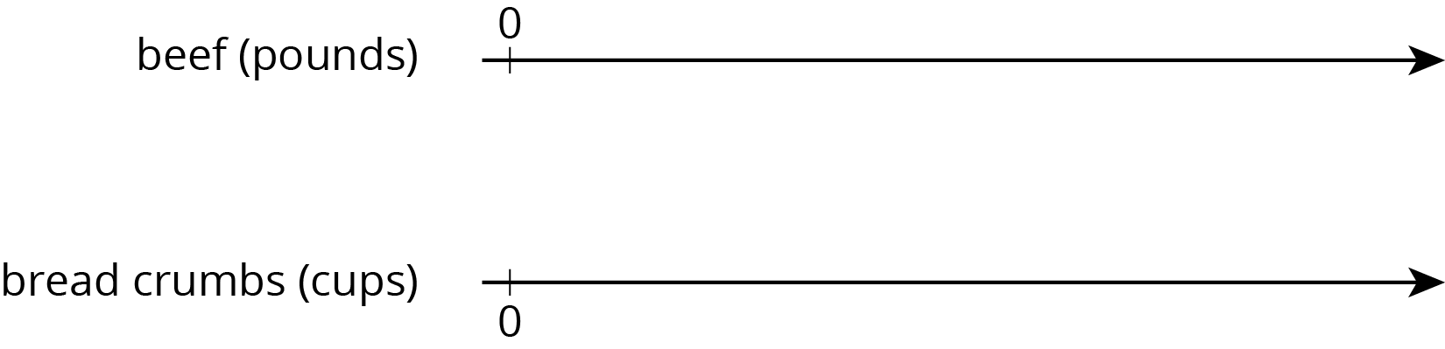

1. A recipe for tropical fruit punch says, “Combine 4 cups of pineapple juice with 5 cups of orange juice.”
   1. Create a double number showing the amount of each type of juice in 1, 2, 3, 4, and 5 batches of the recipe.
   2. If 12 cups of pineapple juice are used with 20 cups of orange juice, will the recipe taste the same? Explain your reasoning.
   3. The recipe also calls for $\frac{1}{3}$ cup of lime juice for every 5 cups of orange juice. Add a line to your diagram to represent the amount of lime juice in different batches of tropical fruit punch.
2. One batch of pink paint uses 2 cups of red paint and 7 cups of white paint. Mai made a large amount of pink paint using 14 cups of red paint.
   1. How many batches of pink paint did she make?
   2. How many cups of white paint did she use?

* from Unit 2, Lesson 4
  1. Find three different ratios that are equivalent to the ratio $3:11$.
  2. Explain why your ratios are equivalent.
* from Unit 2, Lesson 5

1. Here is a diagram that represents the pints of red and yellow paint in a mixture.

* 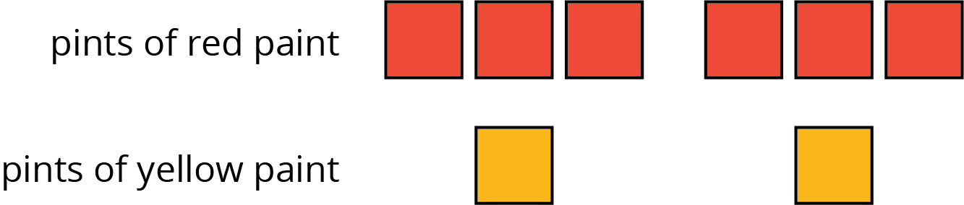
* Select **all** statements that accurately describe the diagram.
  1. The ratio of yellow paint to red paint is 2 to 6.
  2. For every 3 pints of red paint, there is 1 pint of yellow paint.
  3. For every pint of yellow paint, there are 3 pints of red paint.
  4. For every pint of yellow paint there are 6 pints of red paint.
  5. The ratio of red paint to yellow paint is $6:2$.
* from Unit 2, Lesson 2



© CC BY Open Up Resources. Adaptations CC BY IM.