## Activity 2: Grocery Shopping

Answer each question and explain or show your reasoning. If you get stuck, consider drawing a double number line diagram.

1. Eight avocados cost $4.
   1. How much do 16 avocados cost?
   2. How much do 20 avocados cost?
   3. How much do 9 avocados cost?

* 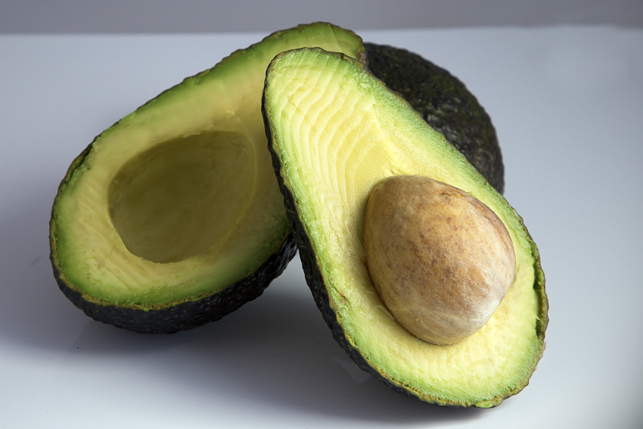

1. Twelve large bottles of water cost $9.
   1. How many bottles can you buy for $3?
   2. What is the cost per bottle of water?
   3. How much would 7 bottles of water cost?

* 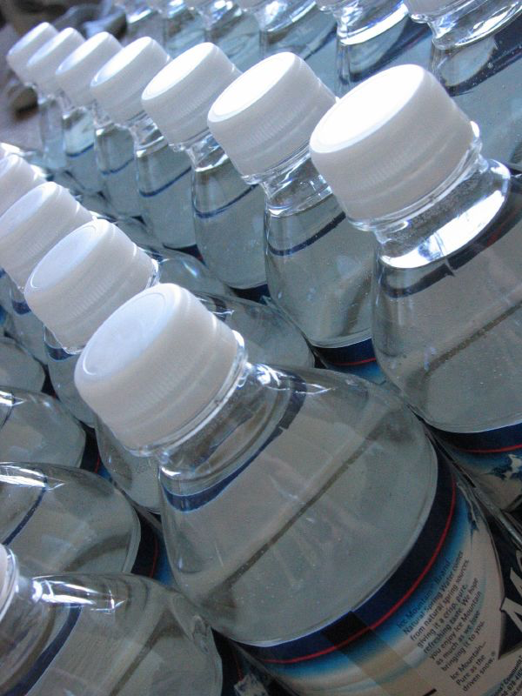

1. A 10-pound sack of flour costs $8.
   1. How much does 40 pounds of flour cost?
   2. What is the cost per pound of flour?

#### Are you ready for more?

It is commonly thought that buying larger packages or containers, sometimes called *buying in bulk*, is a great way to save money. For example, a 6-pack of soda might cost $3 while a 12-pack of the same brand costs $5.

Find 3 different cases where it is not true that buying in bulk saves money. You may use the internet or go to a local grocery store and take photographs of the cases you find. Make sure the products are the same brand. For each example that you find, give the quantity or size of each, and describe how you know that the larger size is not a better deal.



© CC BY Open Up Resources. Adaptations CC BY IM.