## Lesson 8: How Much for One?

### Cool Down: Unit Price of Rice

Here is a double number line showing that it costs $3 to buy 2 bags of rice:

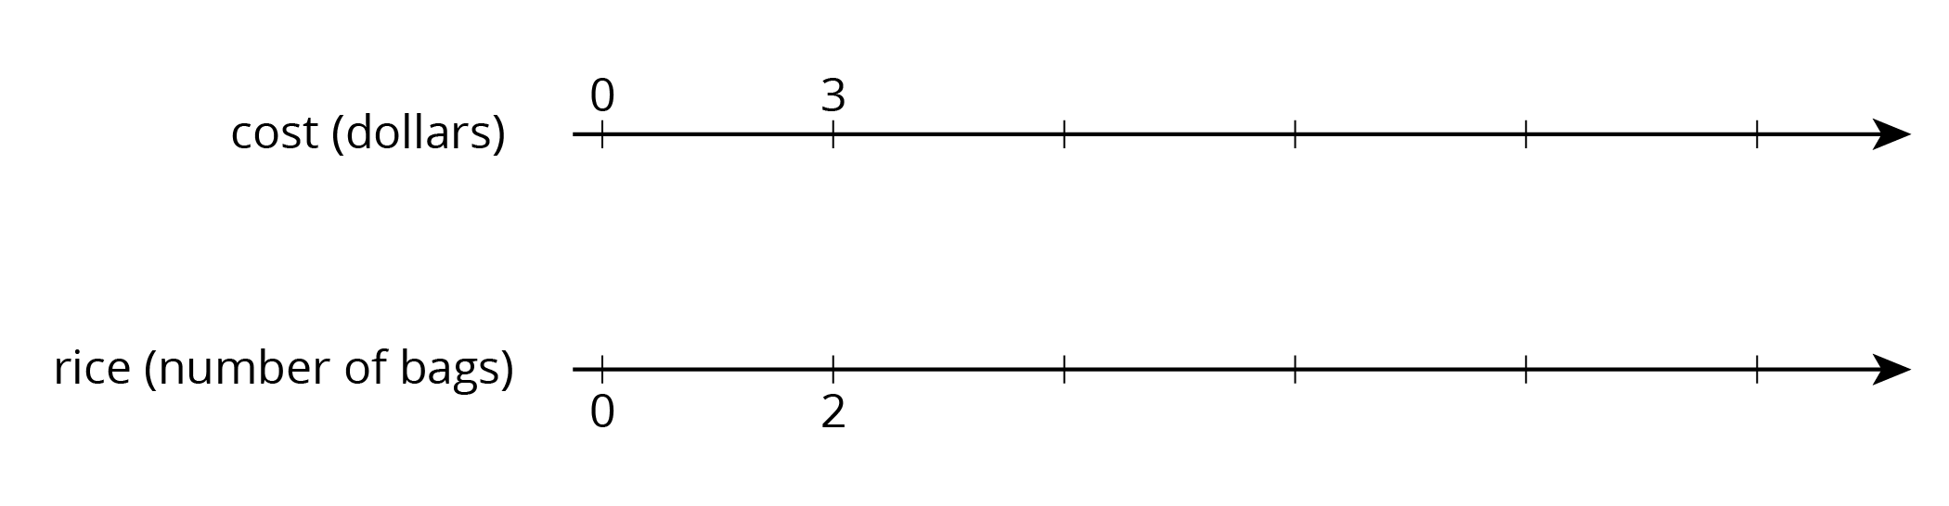

1. At this rate, how many bags of rice can you buy with $12?
2. Find the cost per bag.
3. How much do 20 bags of rice cost?



© CC BY Open Up Resources. Adaptations CC BY IM.