## Activity 2: Moving 10 Meters

Your teacher will set up a straight path with a 1-meter warm-up zone and a 10-meter measuring zone. Follow the following instructions to collect the data.

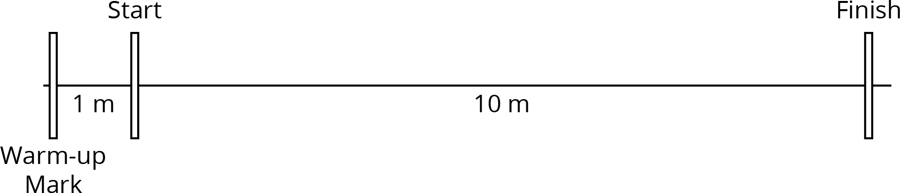

​

* 1. The person with the stopwatch (the “timer”) stands at the finish line. The person being timed (the “mover”) stands at the warm-up line.
  2. On the first round, the mover starts moving *at a slow, steady speed* along the path. When the mover reaches the start line, they say, “Start!” and the timer starts the stopwatch.
  3. The mover keeps moving steadily along the path. When they reach the finish line, the timer stops the stopwatch and records the time, rounded to the nearest second, in the table.
  4. On the second round, the mover follows the same instructions, but this time, moving *at a quick, steady speed*. The timer records the time the same way.
  5. Repeat these steps until each person in the group has gone twice: once at a slow, steady speed, and once at a quick, steady speed.

| * + your slow moving time (seconds) | * + your fast moving time (seconds) |
| --- | --- |
|  |  |

1. After you finish collecting the data, use the double number line diagrams to answer the questions. Use the times your partner collected while you were moving.

* Moving slowly:
* 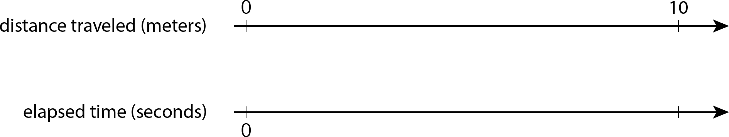
* Moving quickly:
* 
  1. Estimate the distance in meters you traveled in 1 second when moving slowly.
  2. Estimate the distance in meters you traveled in 1 second when moving quickly.
  3. Trade diagrams with someone who is not your partner. How is the diagram representing someone moving slowly different from the diagram representing someone moving quickly?



© CC BY Open Up Resources. Adaptations CC BY IM.