## Lesson 9: Constant Speed

### Cool Down: Train Speeds

Two trains are traveling at constant speeds on different tracks.

Train A:

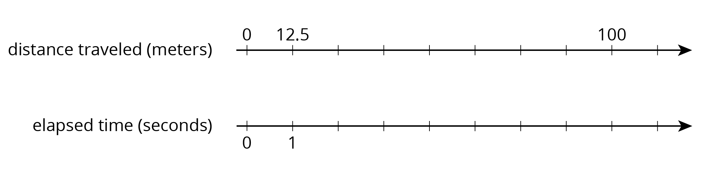

Train B:

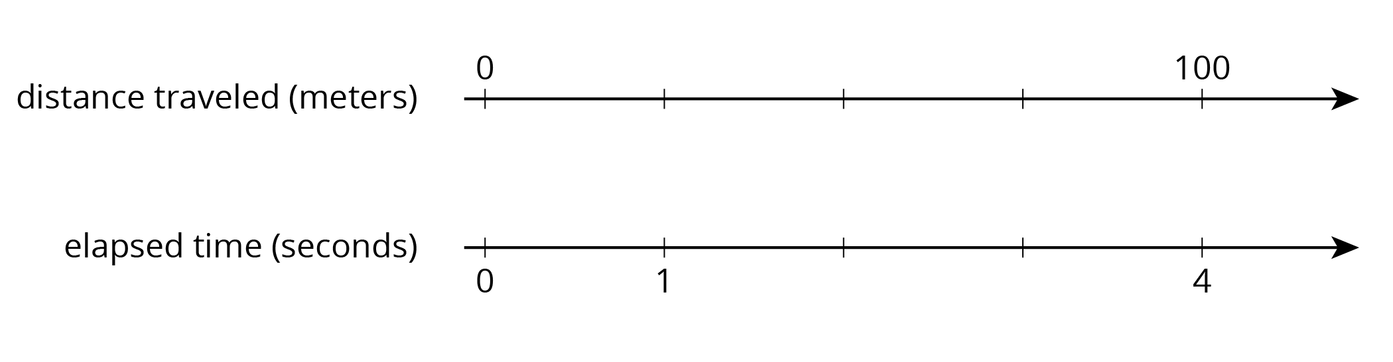

Which train is traveling faster? Explain your reasoning.



© CC BY Open Up Resources. Adaptations CC BY IM.