### Lesson 9 Practice Problems

1. Han ran 10 meters in 2.7 seconds. Priya ran 10 meters in 2.4 seconds.
   1. Who ran faster? Explain how you know.
   2. At this rate, how long would it take each person to run 50 meters? Explain or show your reasoning.
2. A scooter travels 30 feet in 2 seconds at a constant speed.

* 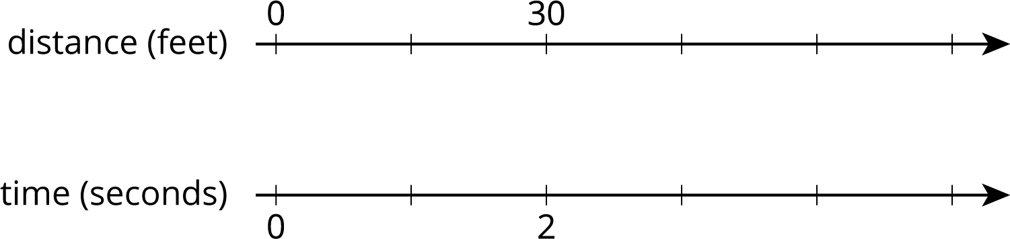
  1. What is the speed of the scooter in feet per second?
  2. Complete the double number line to show the distance the scooter travels after 1, 3, 4, and 5 seconds.
  3. A skateboard travels 55 feet in 4 seconds. Is the skateboard going faster, slower, or the same speed as the scooter?

1. A cargo ship traveled 150 nautical miles in 6 hours at a constant speed. How far did the cargo ship travel in one hour?

* 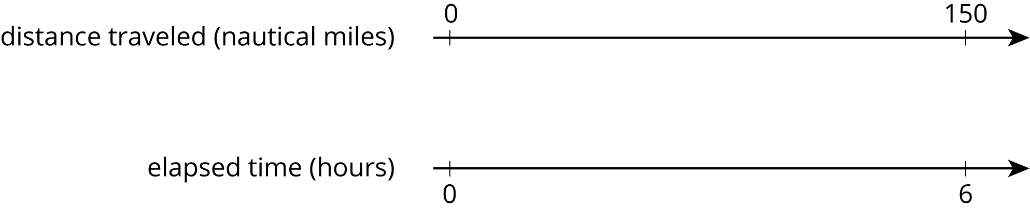

1. A recipe for pasta dough says, “Use 150 grams of flour per large egg.”
   1. How much flour is needed if 6 large eggs are used?
   2. How many eggs are needed if 450 grams of flour are used?

* from Unit 2, Lesson 3

1. The grocery store is having a sale on frozen vegetables. 4 bags are being sold for $11.96. At this rate, what is the cost of:
   1. 1 bag
   2. 9 bags

* from Unit 2, Lesson 8

1. A pet owner has 5 cats. Each cat has 2 ears and 4 paws.
   1. Complete the double number line to show the numbers of ears and paws for 1, 2, 3, 4, and 5 cats.
   2. If there are 3 cats in the room, what is the ratio of ears to paws?

* 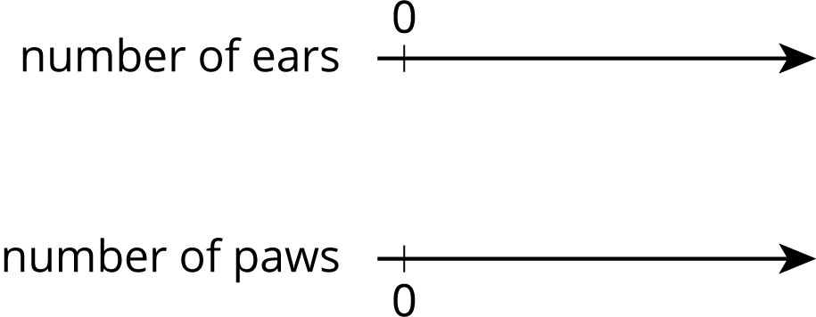
  1. If there are 4 cats in the room, what is the ratio of paws to ears?
  2. If all 5 cats are in the room, how many more paws are there than ears?
* from Unit 2, Lesson 7

1. Each of these is a pair of equivalent ratios. For each pair, explain why they are equivalent ratios or draw a representation that shows why they are equivalent ratios.
   1. $5:1$ and $15:3$
   2. $25:5$ and $10:2$
   3. $198:1,​287$ and $2:13$

* from Unit 2, Lesson 5



© CC BY Open Up Resources. Adaptations CC BY IM.