## Introducing Ratios: Check Your Readiness (A)

1. Here are three fractions: $\frac{2}{3}$, $\frac{4}{5}$, $\frac{6}{9}$. Two of these fractions are equivalent to each other. Which two? Explain or show your reasoning.
   1. 28 is 7 times what number?
   2. 8 is 32 times what number?
   3. 4000 is 4 times what number?
   4. Choose one part and explain how you know your answer is correct.
2. Label each tick mark with its location on the number line:

* 

1. Here is a number line:

* 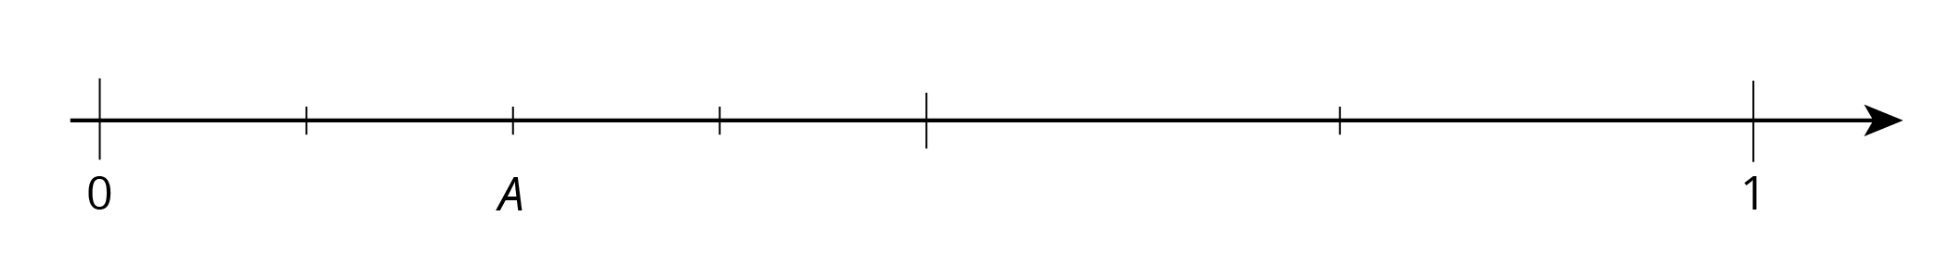
  1. Write the number at $A$ as a fraction.
  2. Write the number at $A$ as an equivalent fraction.

1. One batch of brownies calls for 1 box of brownie mix and the ingredients shown.

| * type of brownie | * eggs | * water | * oil |
| --- | --- | --- | --- |
| * fudge-like | * 2 eggs | $\frac{1}{4}$* cup | $\frac{1}{2}$* cup |
| * cake-like | * 3 eggs | $\frac{1}{4}$* cup | * cup |

* 1. What amounts of eggs, water, and oil would you need for 2 batches of fudge-like brownies?
  2. What amounts of eggs, water, and oil would you need for 3 batches of cake-like brownies?

1. Which travels faster: a car that travels 6 miles in 10 minutes at a constant speed, or a train that travels 6 miles in 8 minutes at a constant speed? Explain how you know.



© CC BY Open Up Resources. Adaptations CC BY IM.