## Introducing Ratios: End-of-Unit Assessment (B)

1. Select **all** the true statements.

* 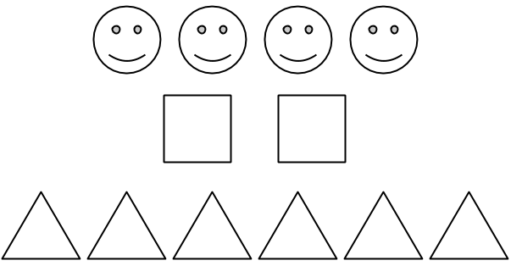
  1. The ratio of triangles to squares is 2 to 6.
  2. The ratio of squares to smiley faces is $2:4$.
  3. The ratio of smiley faces to triangles is 4 to 2.
  4. There are three triangles for every square.
  5. There are two smiley faces for every square.
  6. There are two triangles for every smiley face.

1. Select **all** the ratios that are equivalent to $9:6$.
$6:9$

$3:2$

$13:10$

$5:2$

$18:12$

2. A mixture of orange paint contains 8 teaspoons of red paint and 12 teaspoons of yellow paint. To make the same shade of orange paint using 18 teaspoons of red paint, how much yellow paint would you need? Use the double number line diagram to help if needed.

* 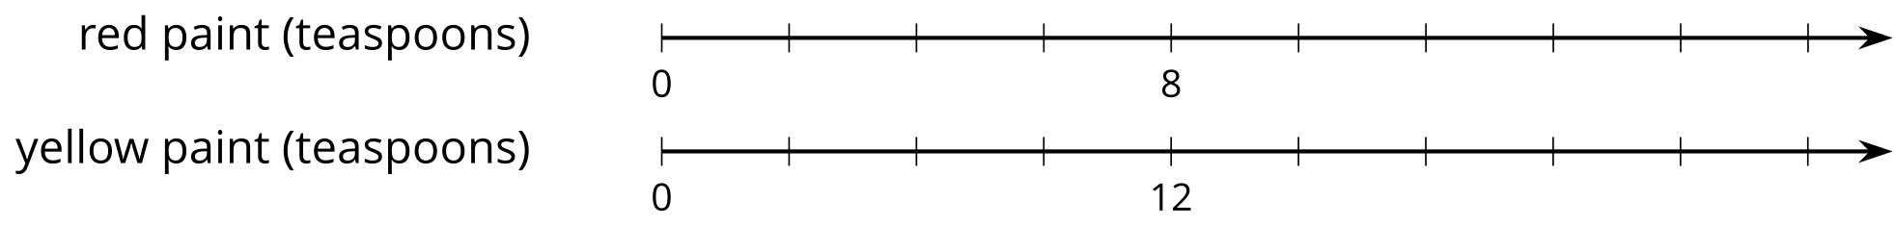
  1. 27 teaspoons
  2. 24 teaspoons
  3. 22 teaspoons
  4. 12 teaspoons

1. Elena rode her bike 2 miles in 10 minutes. She rode at a constant speed. Complete the table to show the time it took her to travel different distances at this speed.

| * distance traveled (miles) | * elapsed time (minutes) |
| --- | --- |
| * 2 | * 10 |
| * 1 |  |
|  | * 1 |

* 1. Three concert tickets cost $45. At this rate, what is the cost per ticket?
  2. Three milkshakes cost $9.75. At this rate, how much do 2 milkshakes cost?
  3. Three oranges cost $1.35. At this rate, how much do 5 oranges cost?

1. A bag contains 150 marbles. Some are blue, and the rest are white. There are 21 blue marbles for every 4 white marbles. How many blue marbles are in the bag? Explain your reasoning.
2. To make fruit punch, Priya mixes 3 scoops of powder with 5 cups of water. Mai mixes 4 scoops of powder with 6 cups of water.
   1. Create a double number line or a table that shows different amounts of powder and water that taste the same as Priya’s mixture.
   2. Create a double number line or a table that shows different amounts of powder and water that taste the same as Mai’s mixture.
   3. How do their two mixtures compare in taste? Explain your reasoning.



© CC BY Open Up Resources. Adaptations CC BY IM.