## Activity 3: The Student’s Collection

1. Sort your collection into three categories. You can experiment with different ways of arranging these categories. Then, count the items in each category, and record the information in the table.

|  |  |  |  |
| --- | --- | --- | --- |
| * category name |  |  |  |
| * category amount |  |  |  |

1. Write at least two sentences that describe **ratios** in the collection. Remember, there are many ways to write a ratio:
   * The ratio of *one category* to *another category* is ________ to ________.
   * The ratio of *one category* to *another category* is ________ : ________.
   * There are _______ of *one category* for every _______ of *another category*.

* Pause here so your teacher can review your sentences.

1. Make a visual display of your items that clearly shows one of your statements. Be prepared to share your display with the class.

#### Are you ready for more?

1. Use two colors to shade the rectangle so there are 2 square units of one color for every 1 square unit of the other color.
2. The rectangle you just colored has an area of 24 square units. Draw a different shape that does *not* have an area of 24 square units, but that can also be shaded with two colors in a $2:1$ ratio. Shade your new shape using two colors.

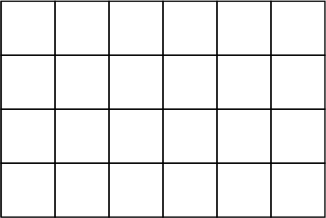



© CC BY Open Up Resources. Adaptations CC BY IM.