### Lesson 1 Practice Problems

1. In a fruit basket there are 9 bananas, 4 apples, and 3 plums.
   1. The ratio of bananas to apples is ________  **:**________.
   2. The ratio of plums to apples is ________ to ________.
   3. For every ________ apples, there are ________ plums.
   4. For every 3 bananas there is one ________.



1. Complete the sentences to describe this picture.

* 
  1. The ratio of dogs to cats is ________.
  2. For every ________ dogs, there are ________ cats.

1. Write two different sentences that use ratios to describe the number of eyes and legs in this picture.

* 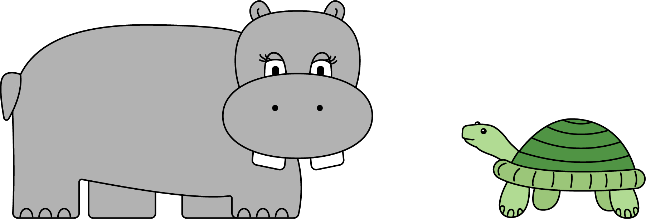

1. Choose an appropriate unit of measurement for each quantity.
   1. area of a rectangle
   2. volume of a prism
   3. side of a square
   4. area of a square
   5. volume of a cube
   * cm
   * cm3
   * cm2

* from Unit 1, Lesson 17

1. Find the volume and surface area of each prism.
   1. Prism A: 3 cm by 3 cm by 3 cm
   * 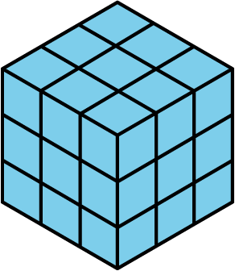
   * ​
   1. Prism B: 5 cm by 5 cm by 1 cm
   * 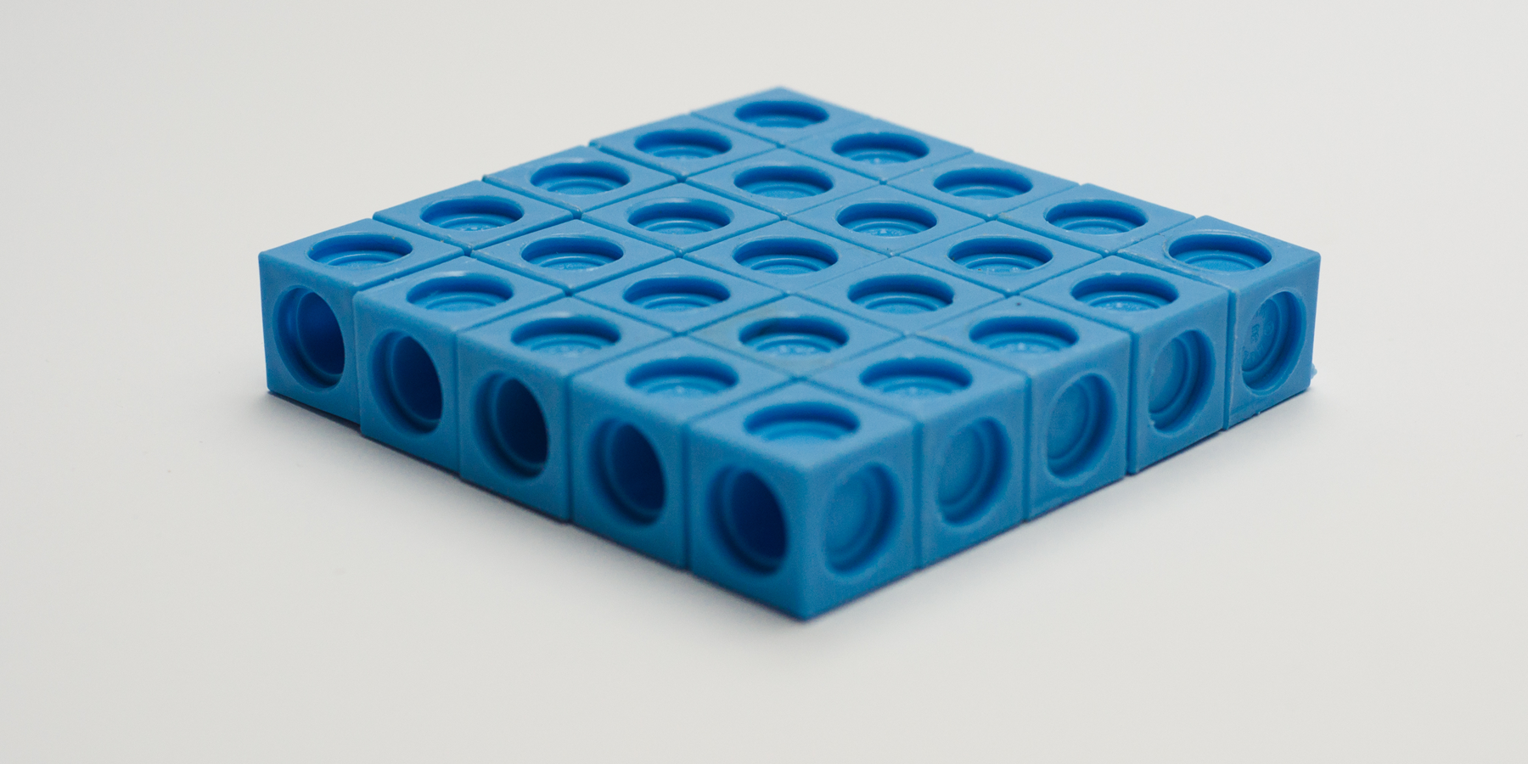
   1. Compare the volumes of the prisms and then their surface areas. Does the prism with the greater volume also have the greater surface area?

* from Unit 1, Lesson 16

1. Which figure is a triangular prism? Select **all** that apply.

* 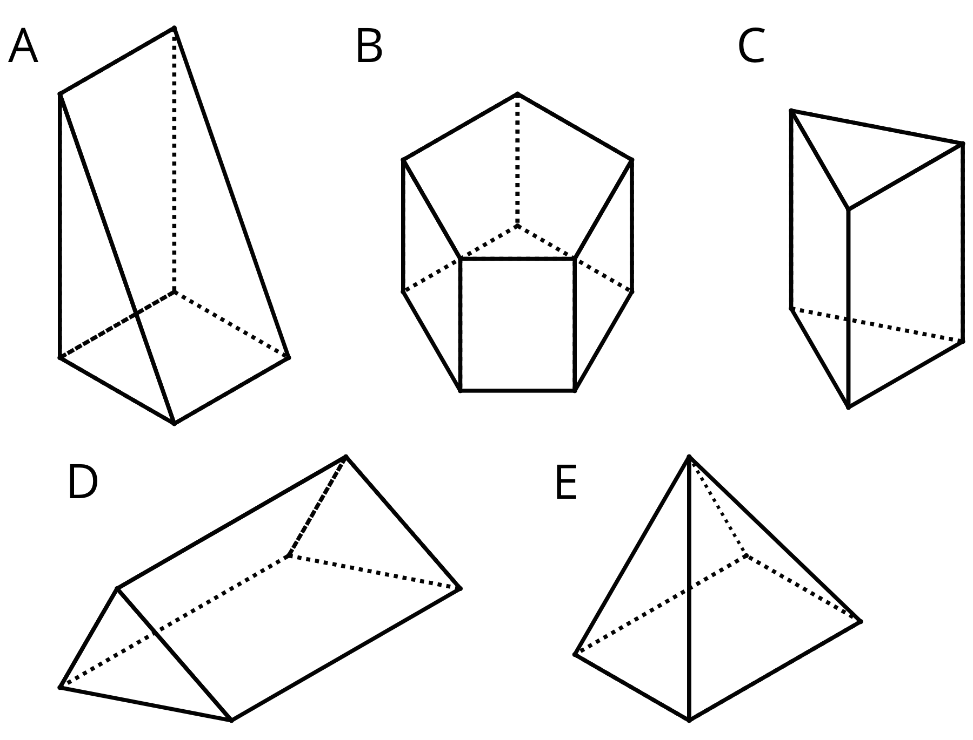
  1. A
  2. B
  3. C
  4. D
  5. E
* from Unit 1, Lesson 13



© CC BY Open Up Resources. Adaptations CC BY IM.