## Activity 1: How Is It Growing?

Look for a pattern in the figures.

1. How many total tiles will be in:
   1. the 4th figure?
   2. the 5th figure?
   3. the 10th figure?
2. How do you see it growing?

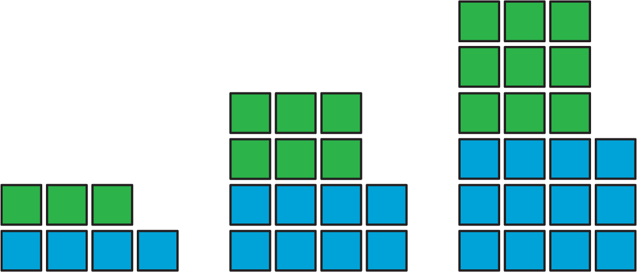



© CC BY Open Up Resources. Adaptations CC BY IM.