### Lesson 11 Practice Problems

1. Complete the table to show the amounts of yellow and red paint needed for different-sized batches of the same shade of orange paint.

| * yellow paint (quarts) | * red paint (quarts) |
| --- | --- |
| * 5 | * 6 |
|  |  |
|  |  |
|  |  |

* Explain how you know that these amounts of yellow paint and red paint will make the same shade of orange as the mixture in the first row of the table.

1. A car travels at a constant speed, as shown on the double number line.

* 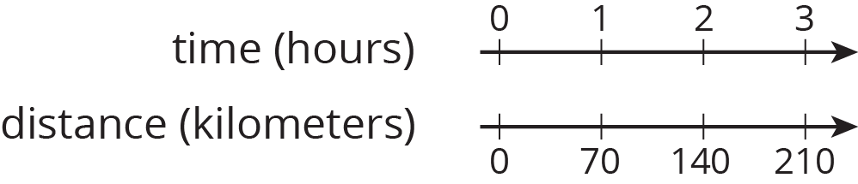
* How far does the car travel in 14 hours? Explain or show your reasoning.

1. The olive trees in an orchard produce 3,000 pounds of olives a year. It takes 20 pounds of olives to make 3 liters of olive oil. How many liters of olive oil can this orchard produce in a year? If you get stuck, consider using the table.

| * olives (pounds) | * olive oil (liters) |
| --- | --- |
| * 20 | * 3 |
| * 100 |  |
| * 3,000 |  |

1. At a school recess, there needs to be a ratio of 2 adults for every 24 children on the playground. The double number line represents the number of adults and children on the playground at recess.

* 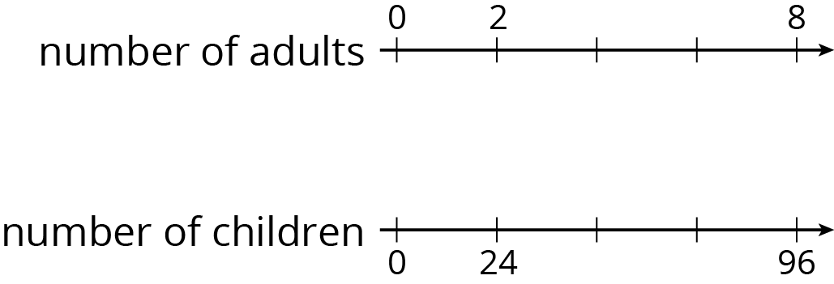
  1. Label each remaining tick mark with its value.
  2. How many adults are needed if there are 72 children? Circle your answer on the double number line.
* from Unit 2, Lesson 6

1. While playing basketball, Jada’s heart rate goes up to 160 beats per minute. While jogging, her heart beats 25 times in 10 seconds. Assuming her heart beats at a constant rate while jogging, which of these activities resulted in a higher heart rate? Explain your reasoning.

* from Unit 2, Lesson 10

1. A shopper bought the following items at the farmer’s market:
   1. 6 ears of corn for $1.80. What was the cost per ear?
   2. 12 apples for $2.88. What was the cost per apple?
   3. 5 tomatoes for $3.10. What was the cost per tomato?

* from Unit 2, Lesson 8



© CC BY Open Up Resources. Adaptations CC BY IM.