## Activity 4: Zeno’s Memory Card

In 2016, 128 gigabytes (GB) of portable computer memory cost $32.

1. Here is a double number line that represents the situation:

* 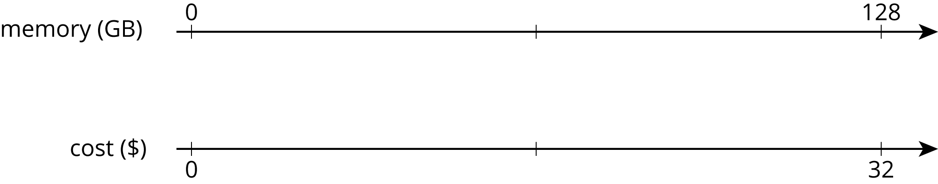
* One set of tick marks has already been drawn to show the result of multiplying 128 and 32 each by $\frac{1}{2}$. Label the amount of memory and the cost for these tick marks.
* Next, keep multiplying by $\frac{1}{2}$ and drawing and labeling new tick marks, until you can no longer clearly label each new tick mark with a number.

1. Here is a table that represents the situation. Find the cost of 1 gigabyte. You can use as many rows as you need.

| * memory (gigabytes) | * cost (dollars) |
| --- | --- |
| * 128 | * 32 |
|  |  |
|  |  |
|  |  |
|  |  |
|  |  |
|  |  |
|  |  |

1. Did you prefer the double number line or the table for solving this problem? Why?

#### Are you ready for more?

A kilometer is 1,000 meters because *kilo* is a prefix that means 1,000. The prefix *mega* means 1,000,000 and *giga* (as in gigabyte) means 1,000,000,000. One byte is the amount of memory needed to store one letter of the alphabet. About how many of each of the following would fit on a 1-gigabyte flash drive?

1. letters
2. pages
3. books
4. movies
5. songs



© CC BY Open Up Resources. Adaptations CC BY IM.