## Activity 1: Number Talk: Constant Dividend

Find the quotients mentally.

$150÷2$

$150÷4$

$150÷8$

Locate and label the quotients on the number line.

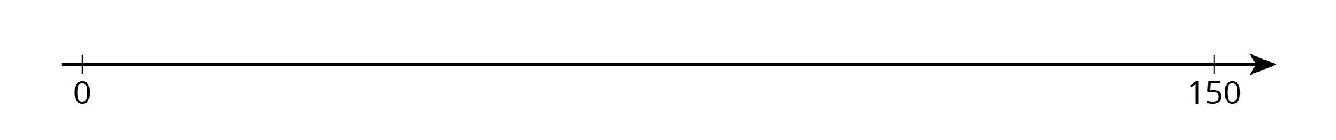



© CC BY Open Up Resources. Adaptations CC BY IM.