## Activity 2: A Trip to the Aquarium

Consider the problem: A teacher is planning a class trip to the aquarium. The aquarium requires 2 chaperones for every 15 students. The teacher plans accordingly and orders a total of 85 tickets. How many tickets are for chaperones, and how many are for students?

1. Solve this problem in *one* of three ways:

* Use a triple number line.
* 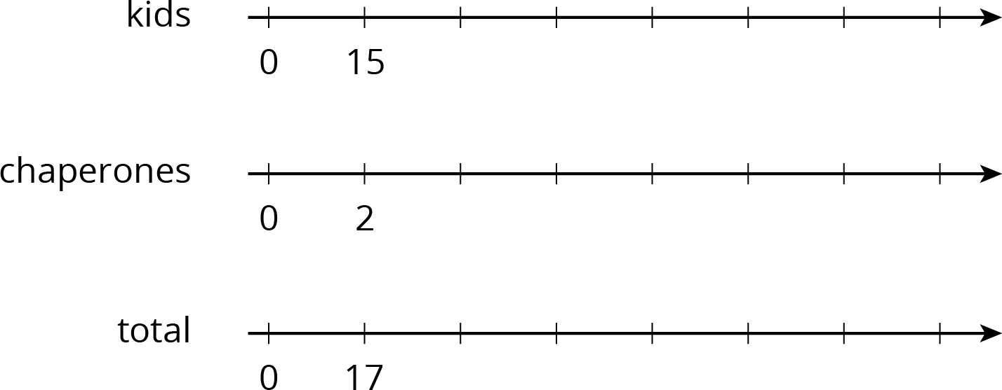
* Use a table.  
  (Fill rows as needed.)

| * kids | * chaperones | * total |
| --- | --- | --- |
| * 15 | * 2 | * 17 |
|  |  |  |
|  |  |  |
|  |  |  |
|  |  |  |

* Use a tape diagram.
* 

1. After your class discusses all three strategies, which do you prefer for this problem and why?

#### Are you ready for more?

Use the digits 1 through 9 to create three equivalent ratios. Use each digit only one time.

is equivalent to and



© CC BY Open Up Resources. Adaptations CC BY IM.