## Activity 1: Fix It!

Andre likes a hot cocoa recipe with 1 cup of milk and 3 tablespoons of cocoa. He poured 1 cup of milk but accidentally added 5 tablespoons of cocoa.

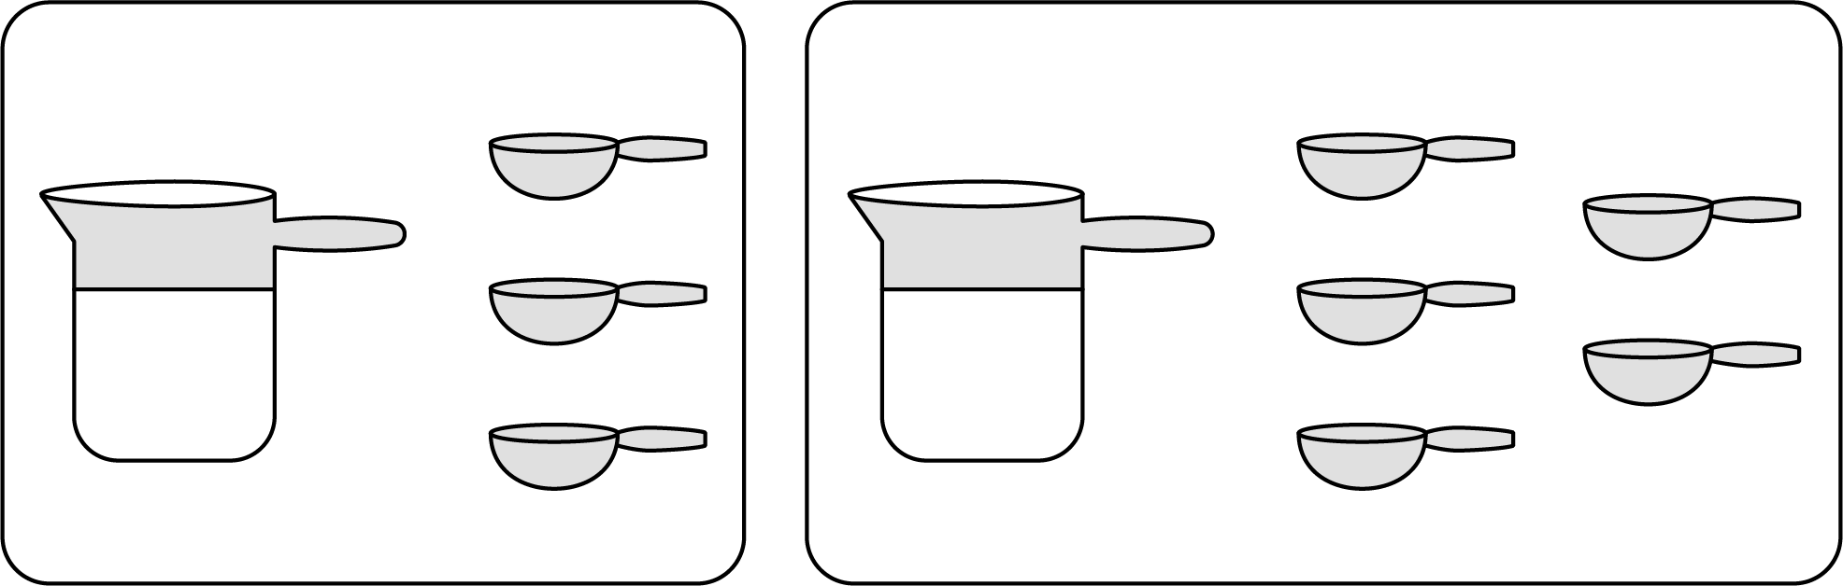

1. How can you fix Andre’s mistake and make his hot cocoa taste like the recipe?
2. Explain how you know your adjustment will make Andre’s hot cocoa taste the same as the one in the recipe.



© CC BY Open Up Resources. Adaptations CC BY IM.