## Activity 3: Researching Your Own Fermi Problem

1. Brainstorm at least five Fermi problems that you want to research and solve. If you get stuck, consider starting with “How much would it cost to . . .?” or “How long would it take to . . .?”
2. Pause here so your teacher can review your questions and approve one of them.
3. Use the graphic organizer to break your problem down into sub-questions.

* 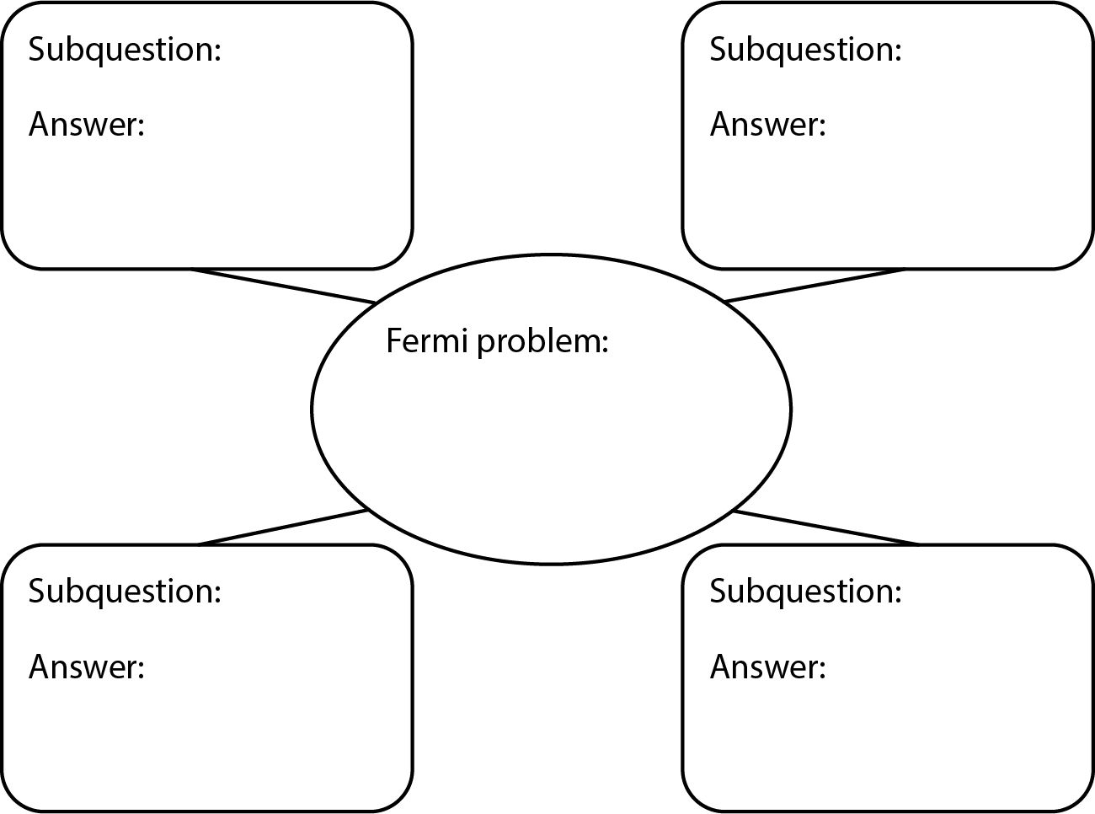

1. Find the information you need to get closer to answering your question. Measure, make estimates, and perform any necessary calculations. If you get stuck, consider using tables or double number line diagrams.
2. Create a visual display that includes your Fermi problem and your solution. Organize your thinking so it can be followed by others.



© CC BY Open Up Resources. Adaptations CC BY IM.