## Activity 3: Blue Paint and Art Paste

Elena mixed 2 cups of white paint with 6 tablespoons of blue paint.

Here is a diagram that represents this situation.

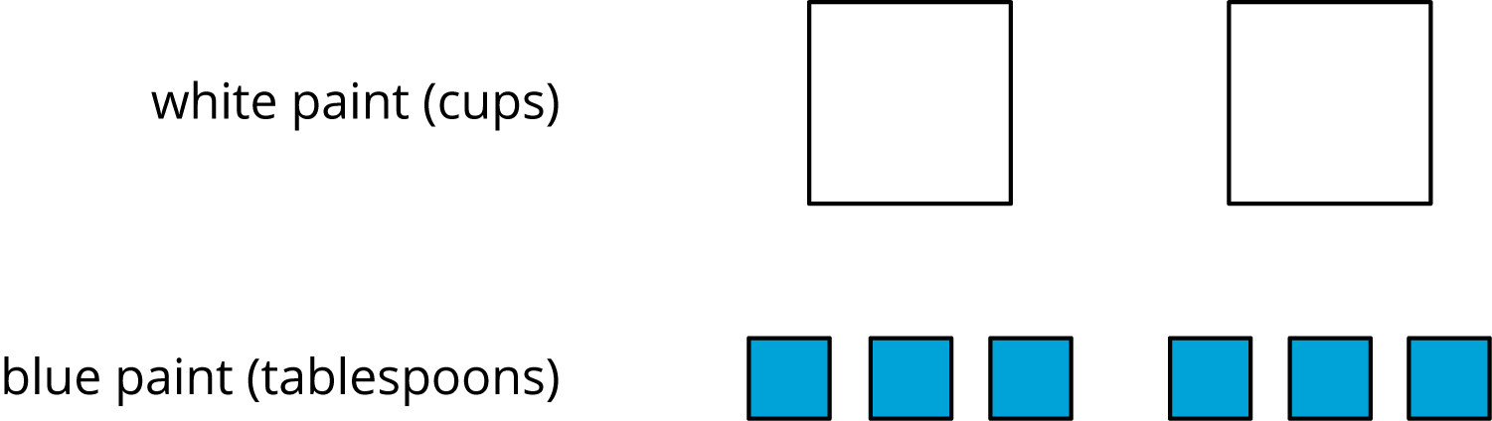

1. Discuss each statement, and circle **all** those that correctly describe this situation. Make sure that both you and your partner agree with each circled answer.
   1. The ratio of cups of white paint to tablespoons of blue paint is $2:6$.
   2. For every cup of white paint, there are 2 tablespoons of blue paint.
   3. There is 1 cup of white paint for every 3 tablespoons of blue paint.
   4. There are 3 tablespoons of blue paint for every cup of white paint.
   5. For each tablespoon of blue paint, there are 3 cups of white paint.
   6. For every 6 tablespoons of blue paint, there are 2 cups of white paint.
   7. The ratio of tablespoons of blue paint to cups of white paint is 6 to 2.
2. Jada mixed 8 cups of flour with 2 pints of water to make paste for an art project.
   1. Draw a diagram that represents the situation.
   2. Write at least two sentences describing the ratio of flour and water.



© CC BY Open Up Resources. Adaptations CC BY IM.