## Lesson 2: Representing Ratios with Diagrams

### Cool Down: Paws, Ears, and Tails

There are 3 cats in a room and no other creatures. Each cat has 2 ears, 4 paws, and 1 tail.

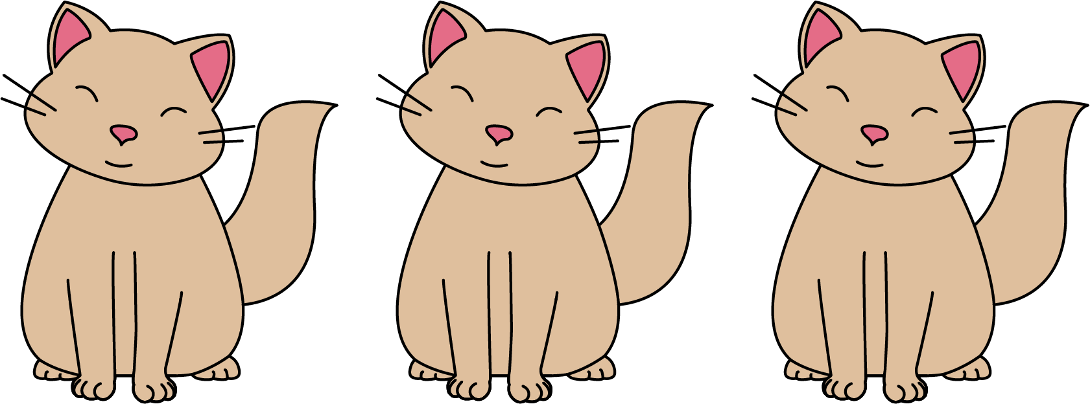

1. Draw a diagram that shows an association between numbers of ears, paws, and tails in the room.
2. Complete each statement:
   1. The ratio of ______________ to ______________ to ______________ is ______ : _______ : ______.
   2. There are ______ paws for every tail.
   3. There are ______ paws for every ear.



© CC BY Open Up Resources. Adaptations CC BY IM.