## Activity 2: Powdered Drink Mix

Here are diagrams representing three mixtures of powdered drink mix and water:

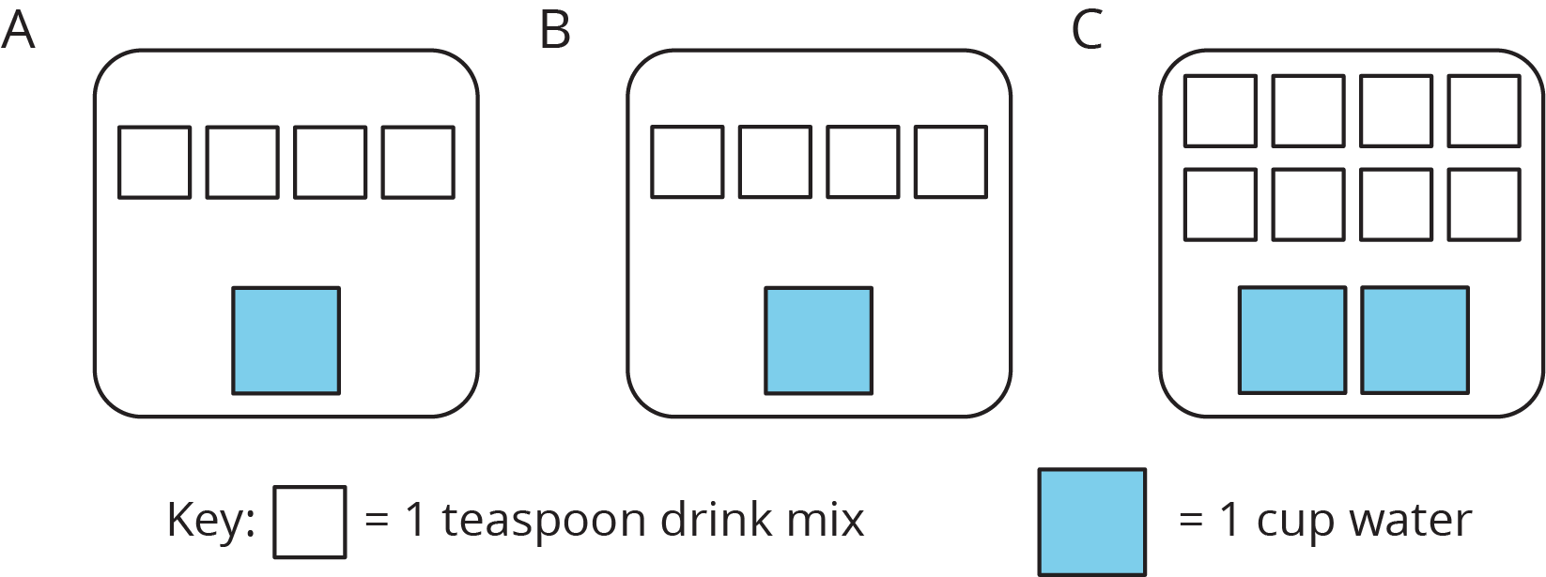

1. How would the taste of Mixture A compare to the taste of Mixture B?
2. Use the diagrams to complete each statement:
   1. Mixture B uses ______ cups of water and ______ teaspoons of drink mix. The ratio of cups of water to teaspoons of drink mix in Mixture B is ________.
   2. Mixture C uses ______ cups of water and ______ teaspoons of drink mix. The ratio of cups of water to teaspoons of drink mix in Mixture C is ________.
3. How would the taste of Mixture B compare to the taste of Mixture C?

#### Are you ready for more?

Sports drinks use sodium (better known as salt) to help people replenish electrolytes. Here are the nutrition labels of two sports drinks.

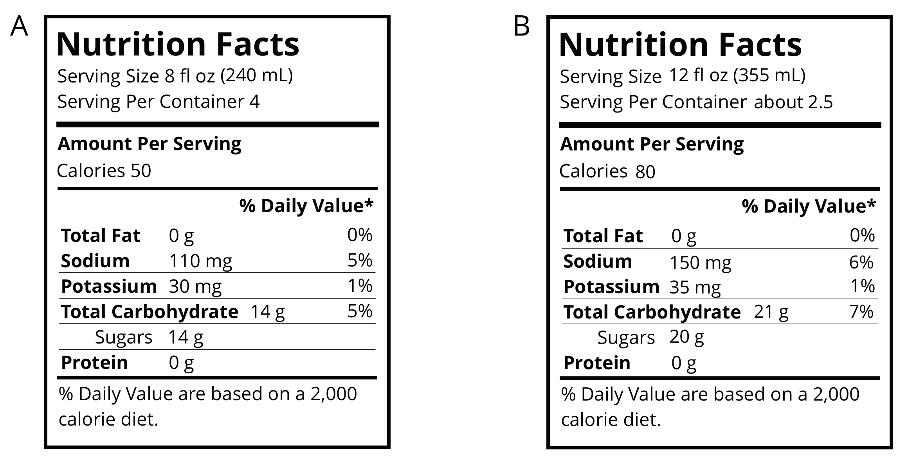

1. Which of these drinks is saltier? Explain how you know.
2. If you wanted to make sure a sports drink was less salty than both of the ones given, what ratio of sodium to water would you use?



© CC BY Open Up Resources. Adaptations CC BY IM.