### Lesson 3 Practice Problems

1. A recipe for 1 batch of spice mix says, “Combine 3 teaspoons of mustard seeds, 5 teaspoons of chili powder, and 1 teaspoon of salt.” How many batches are represented by the diagram? Explain or show your reasoning.

* 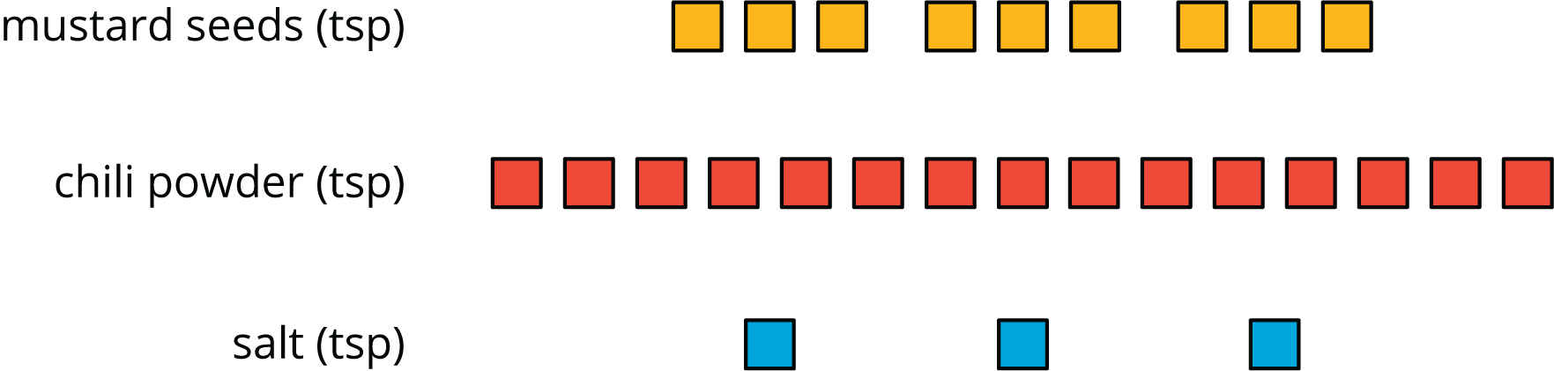

1. Priya makes chocolate milk by mixing 2 cups of milk and 5 tablespoons of cocoa powder. Draw a diagram that clearly represents two batches of her chocolate milk.
2. In a recipe for fizzy grape juice, the ratio of cups of sparkling water to cups of grape juice concentrate is 3 to 1.
   1. Find two more ratios of cups of sparkling water to cups of juice concentrate that would make a mixture that tastes the same as this recipe.
   2. Describe another mixture of sparkling water and grape juice that would taste different than this recipe.
3. Write the missing number under each tick mark on the number line.

* 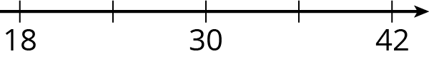
* from Unit 2, Lesson 1

1. At the kennel, there are 6 dogs for every 5 cats.
   1. The ratio of dogs to cats is ______ to ______.
   2. The ratio of cats to dogs is ______ to ______.
   3. For every ______ dogs there are ______ cats.
   4. The ratio of cats to dogs is ______ : ______.

* from Unit 2, Lesson 1

1. Elena has 80 unit cubes. What is the volume of the largest cube she can build with them?

* from Unit 1, Lesson 17

1. Fill in the blanks to make each equation true.
 $3⋅\frac{1}{3}=\text{_______}$

 $10⋅\frac{1}{10}=\text{_______}$

 $19⋅\frac{1}{19}=\text{_______}$

$a⋅\frac{1}{a}=\text{_______}$ 1. (As long as $a$ does not equal 0.)

$5⋅\text{_______}=1$

$17⋅\text{_______}=1$

$b⋅\text{_______}=1$

* from Unit 2, Lesson 1



© CC BY Open Up Resources. Adaptations CC BY IM.