### Lesson 4 Practice Problems

1. Here is a diagram showing a mixture of red paint and green paint needed for 1 batch of a particular shade of brown.

* 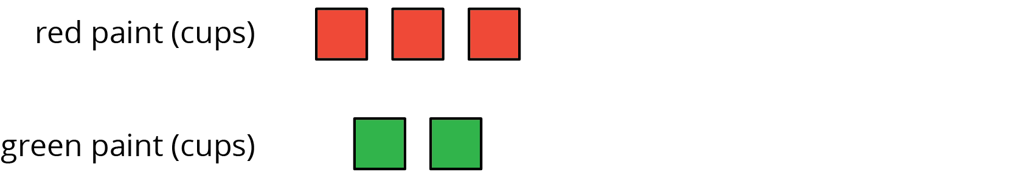
* Add to the diagram so that it shows 3 batches of the same shade of brown paint.

1. Diego makes green paint by mixing 10 tablespoons of yellow paint and 2 tablespoons of blue paint. Which of these mixtures produce the same shade of green paint as Diego’s mixture? Select **all** that apply.
   1. For every 5 tablespoons of blue paint, mix in 1 tablespoon of yellow paint.
   2. Mix tablespoons of blue paint and yellow paint in the ratio $1:5$.
   3. Mix tablespoons of yellow paint and blue paint in the ratio 15 to 3.
   4. Mix 11 tablespoons of yellow paint and 3 tablespoons of blue paint.
   5. For every tablespoon of blue paint, mix in 5 tablespoons of yellow paint.
2. To make 1 batch of sky blue paint, Clare mixes 2 cups of blue paint with 1 gallon of white paint.
   1. Explain how Clare can make 2 batches of sky blue paint.
   2. Explain how to make a mixture that is a darker shade of blue than the sky blue.
   3. Explain how to make a mixture that is a lighter shade of blue than the sky blue.
3. A smoothie recipe calls for 3 cups of milk, 2 frozen bananas and 1 tablespoon of chocolate syrup.
   1. Create a diagram to represent the quantities of each ingredient in the recipe.
   2. Write 3 different sentences that use a ratio to describe the recipe.

* from Unit 2, Lesson 2

1. Write the missing number under each tick mark on the number line.

* 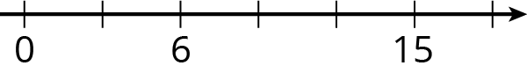
* from Unit 2, Lesson 1

1. Find the area of the parallelogram. Show your reasoning.

* 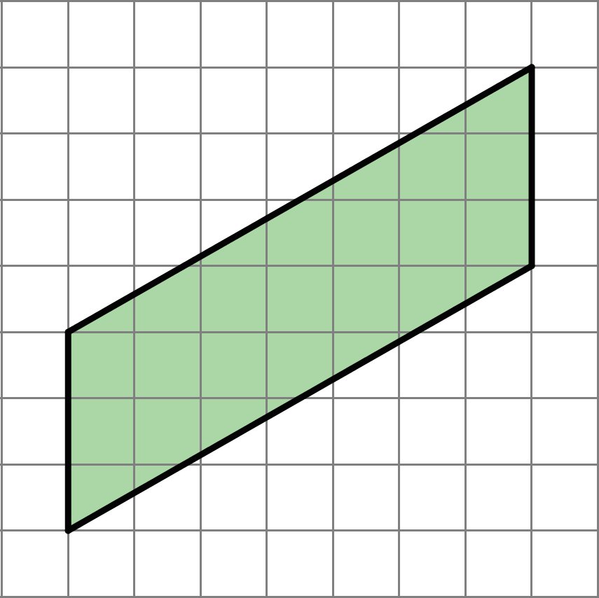
* from Unit 1, Lesson 4

1. Complete each equation with a number that makes it true.
 $11⋅\frac{1}{4}=\text{_______}$

 $7⋅\frac{1}{4}=\text{_______}$

 $13⋅\frac{1}{27}=\text{_______}$

$13⋅\frac{1}{99}=\text{_______}$

$x⋅\frac{1}{y}=\text{_______}$ 1. (As long as $y$ does not equal 0.)

* from Unit 2, Lesson 1



© CC BY Open Up Resources. Adaptations CC BY IM.