## Activity 3: Blue Paint on a Double Number Line

Here is a diagram showing Elena’s recipe for light blue paint.

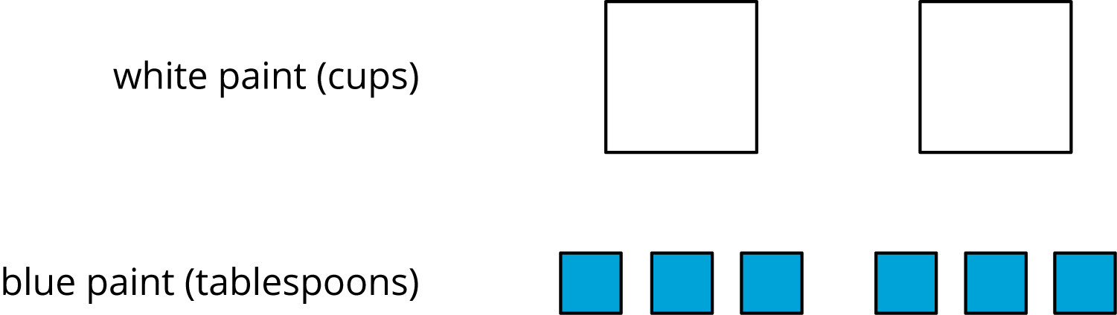

1. Complete the double number line diagram to show the amounts of white paint and blue paint in different-sized batches of light blue paint.

* 

1. Compare your double number line diagram with your partner. Discuss your thinking. If needed, revise your diagram.
2. How many cups of white paint should Elena mix with 12 tablespoons of blue paint? How many batches would this make?
3. How many tablespoons of blue paint should Elena mix with 6 cups of white paint? How many batches would this make?
4. Use your double number line diagram to find another amount of white paint and blue paint that would make the same shade of light blue paint.
5. How do you know that these mixtures would make the same shade of light blue paint?



© CC BY Open Up Resources. Adaptations CC BY IM.