## Activity 2: Just a Little Green

The other day, we made green water by mixing 5 ml of blue water with 15 ml of yellow water. We want to make a very small batch of the same shade of green water. We need to know how much yellow water to mix with only 1 ml of blue water.

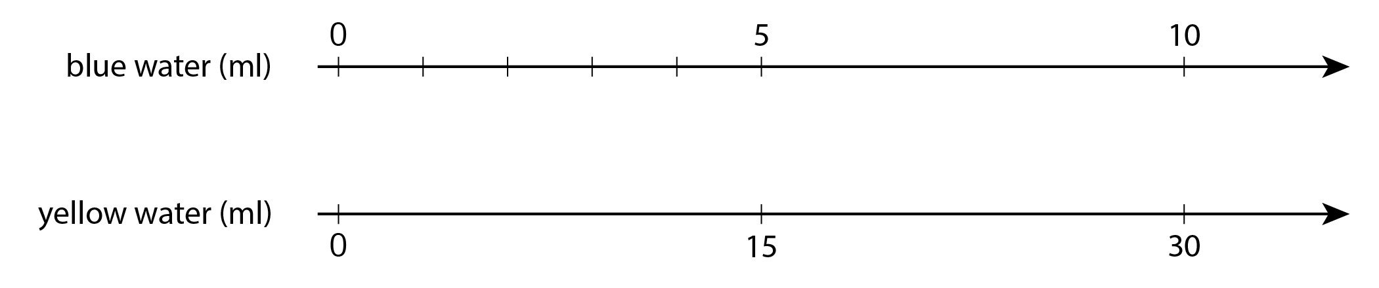

1. On the number line for blue water, label the four tick marks shown.
2. On the number line for yellow water, draw and label tick marks to show the amount of yellow water needed for each amount of blue water.
3. How much yellow water should be used for 1 ml of blue water? Circle where you can see this on the double number line.
4. How much yellow water should be used for 11 ml of blue water?
5. How much yellow water should be used for 8 ml of blue water?
6. Why is it useful to know how much yellow water should be used with 1 ml of blue water?



© CC BY Open Up Resources. Adaptations CC BY IM.