## Activity 3: More Shopping

1. Four bags of chips cost $6.
   1. What is the cost per bag?
   2. At this rate, how much will 7 bags of chips cost?
2. At a used book sale, 5 books cost $15.
   1. What is the cost per book?
   2. At this rate, how many books can you buy for $21?
3. Neon bracelets cost $1 for 4.
   1. What is the cost per bracelet?
   2. At this rate, how much will 11 neon bracelets cost?

* Pause here so your teacher can review your work.
* 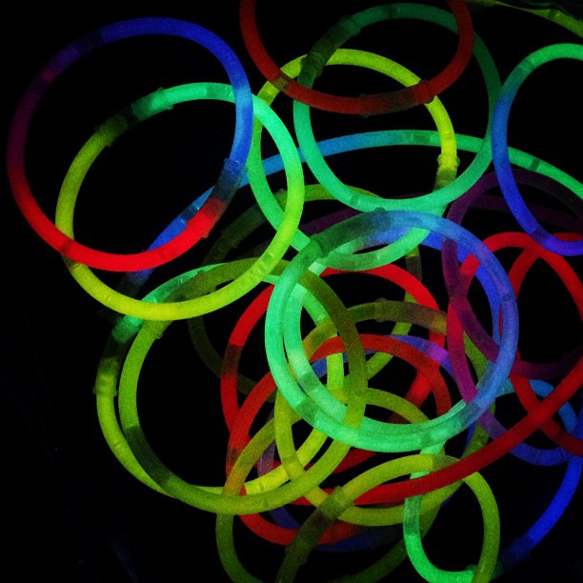

1. Your teacher will assign you one of the problems. Create a visual display that shows your solution to the problem. Be prepared to share your solution with the class.



© CC BY Open Up Resources. Adaptations CC BY IM.