### Lesson 8 Practice Problems

1. In 2016, the cost of 2 ounces of pure gold was $2,640. Complete the double number line to show the cost for 1, 3, and 4 ounces of gold.

* 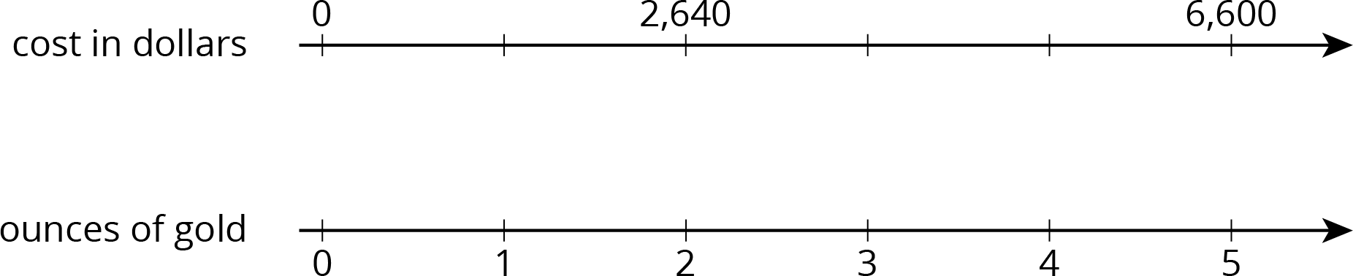

1. The double number line shows that 4 pounds of tomatoes cost $14. Draw tick marks and write labels to show the prices of 1, 2, and 3 pounds of tomatoes.

* 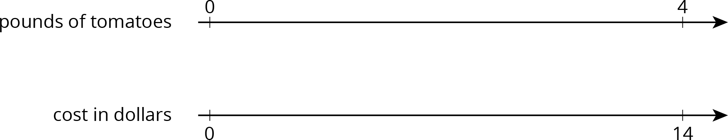

1. 4 movie tickets cost $48. At this rate, what is the cost of:
   1. 5 movie tickets?
   2. 11 movie tickets?
2. Priya bought these items at the grocery store. Find each unit price.
   1. 12 eggs for $3. How much is the cost per egg?
   2. 3 pounds of peanuts for $7.50. How much is the cost per pound?
   3. 4 rolls of toilet paper for $2. How much is the cost per roll?
   4. 10 apples for $3.50. How much is the cost per apple?
3. Clare made a smoothie with 1 cup of yogurt, 3 tablespoons of peanut butter, 2 teaspoons of chocolate syrup, and 2 cups of crushed ice.
   1. Kiran tried to double this recipe. He used 2 cups of yogurt, 6 tablespoons of peanut butter, 5 teaspoons of chocolate syrup, and 4 cups of crushed ice. He didn’t think it tasted right. Describe how the flavor of Kiran's recipe compares to Clare's recipe.
   2. How should Kiran change the quantities that he used so that his smoothie tastes just like Clare's?

* from Unit 2, Lesson 3

1. A drama club is building a wooden stage in the shape of a trapezoidal prism. The height of the stage is 2 feet. Some measurements of the stage are shown here.

* 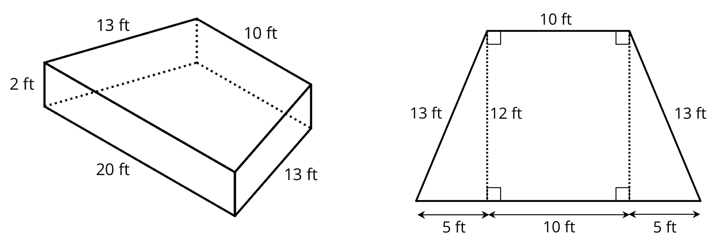
* What is the area of all the faces of the stage, excluding the bottom? Show your reasoning. If you get stuck, consider drawing a net of the prism.
* from Unit 1, Lesson 15



© CC BY Open Up Resources. Adaptations CC BY IM.