## Introducing Ratios: End-of-Unit Assessment (A)

1. Select **all** the true statements.

* 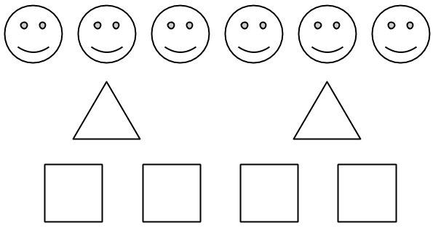
  1. The ratio of triangles to squares is 2 to 4.
  2. The ratio of squares to smiley faces is $6:4$.
  3. The ratio of smiley faces to triangles is 6 to 4.
  4. There are two squares for every triangle.
  5. There are two triangles for every smiley face.
  6. There are three smiley faces for every triangle.

1. Select **all** the ratios that are equivalent to $8:6$
$4:3$

$6:8$

$16:12$

$10:8$

$7:5$

2. A mixture of purple paint contains 6 teaspoons of red paint and 15 teaspoons of blue paint. To make the same shade of purple paint using 35 teaspoons of blue paint, how much red paint would you need? Use the double number line diagram to help if needed.

* 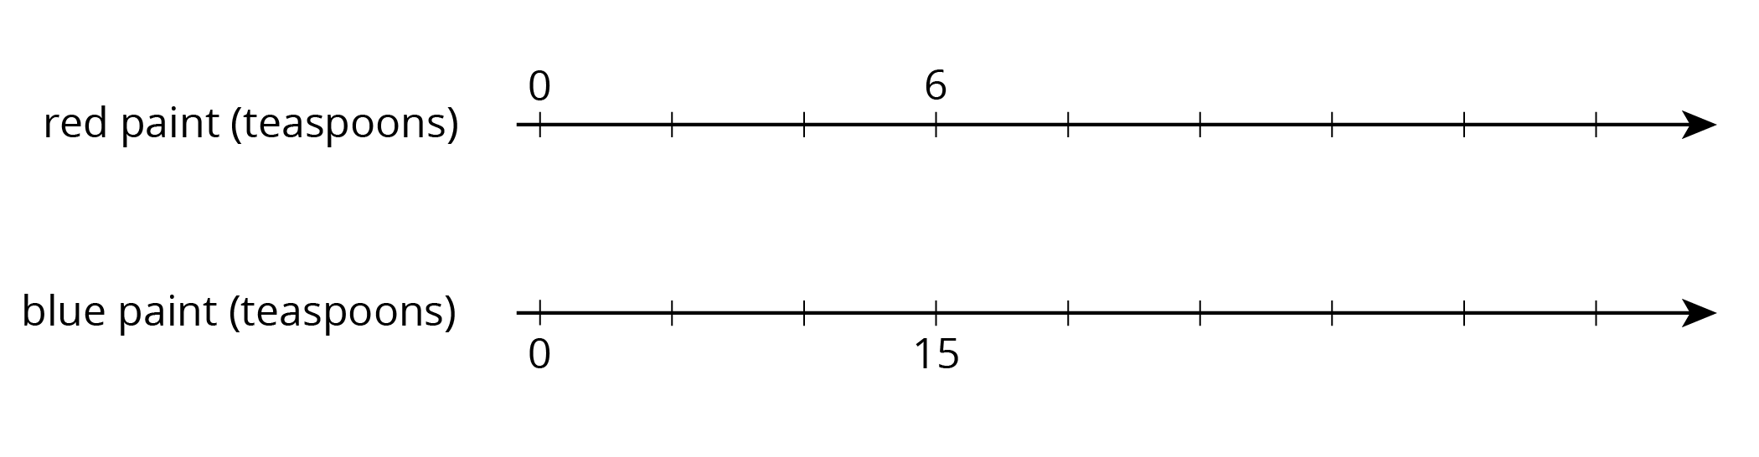
  1. 12 teaspoons
  2. 14 teaspoons
  3. 18 teaspoons
  4. 26 teaspoons

1. Lin rode her bike 2 miles in 8 minutes. She rode at a constant speed. Complete the table to show the time it took her to travel different distances at this speed.

| * distance traveled (miles) | * elapsed time (minutes) |
| --- | --- |
| * 2 | * 8 |
| * 1 |  |
|  | * 1 |



1. Solve each of the following:
   1. 3 movie tickets cost $36. At this rate, what is the cost per ticket?
   2. 3 ice cream cones cost $8.25. At this rate, how much do 2 ice cream cones cost?
   3. 3 bananas cost $0.99. At this rate, how much do 5 bananas cost?
2. A bag contains 120 marbles. Some are red and the rest are black. There are 19 red marbles for every black marble. How many red marbles are in the bag? Explain your reasoning.
3. To make orange fizz, Noah mixes 4 scoops of powder with 6 cups of water. Andre mixes 5 scoops of powder with 8 cups of water.
   1. Create a double number line or a table that shows different amounts of powder and water that taste the same as Noah’s mixture.
   2. Create a double number line or a table that shows different amounts of powder and water that taste the same as Andre’s mixture.
   3. How do their two mixtures compare in taste? Explain your reasoning.



© CC BY Open Up Resources. Adaptations CC BY IM.