MyDine Smart Menu Platform Product Requirements Specification (PRS) Document


Abstract
The MyDine Smart Menu Platform is a subscription based SaaS solution designed to modernize the dining experience by improving ordering speed, personalizing menu interactions, and enhancing restaurant operations. Customers access MyDine through their personal smartphones by scanning a table specific QR code which includes personalized recommendations, customized orders, and complete payments without requiring waiter intervention. For restaurants, MyDine decreases staff dependency by automating the ordering process, ensuring accurate real-time communication between diner, waiter, and kitchen interfaces. Managers benefit from detailed analytics on sales patterns, inventory usage, and customer behavior, allowing data-driven decisions that improve operational efficiency, staff management, and menu optimization.

GE401 Team 6
Atahan Atakul
Taha Ülsü
Hasan Özekin
Boran İsmet Macun
İlmay Taş
Özgür Göker
Table of Content
MyDine Smart Menu Platform Product Requirements Specification (PRS) Document 1
GE401 Team 6 1
1.0 Product Description 3
2.0 Problem / Need Statement 3
3.0 Fundamental Product Functions (Functions & Use Cases) 4
3.1 Customers (Guests) 5
3.2 Waiters and Service Personnel 5
3.3 Kitchen Staff 5
3.4 Restaurant Managers / Owners 6
3.5 Founders / System Administrators 6
4.0 Interfaces 6
4.1 Diner Interface 7
4.2 Kitchen Interface 7
4.3 Restaurant Owner Interface 8
5.0 Physical Characteristics 9
5.1 Subcomponents / Units 9
5.2 Physical Interfaces 10
5.3 Electronic Interfaces 10
6.0 Power and Connectivity Requirements 10
6.1 Diner Side 10
6.2 Business Owner Side 10
6.3 System Connectivity 11
7.0 Conclusion 11

List of Figures
Figure 1: Diner Interface Draft…..…………………...………………..…………………….....7
Figure 2: Kitchen Interface Draft…..………………..………………..………………………...7
Figure 3: Restaurant Owner Interface Draft……...…………………..……………………….8

1.0 Product Description
In today’s businesses, restaurants face major challenges while deciding a tradeoff between service quality, operational efficiency, and customer satisfaction. Long waiting times, miscommunication between staff and kitchen, and lack of personalization lead to imperfect dining experiences for guests. On the other hand, restaurants struggle with labor costs, inconsistent service quality, and limited data-driven insight regarding customer behavior.
myDine is a subscription-based SaaS solution by allowing guests to browse, order, and pay directly through a personalized digital menu. myDine removes the dependency on waitstaff for routine tasks, reducing waiting times and human error.
The platform uses past data to personalize menus to adapt user’s individual preferences, dietary needs, and past orders, ensuring every guest has personalized experiences. On the other perspective, myDine streamlines order management and kitchen communication, providing real-time analytics on sales, stocks and peak hours to support better decision making for owner/kitchen.
As a result, myDine enhances the relationship between customer satisfaction and restaurant efficiency, enabling businesses to reduce turnover, reduce labor costs, and provide an individual dining experience for guests.

2.0 Problem / Need Statement
In contemporary dining environments, restaurants face increasing pressure to provide faster service, individualized experiences, and operational efficiency. However, traditional ordering systems based on non - dynamic menus and manual waiter dependent order entry create significant delays during busy hours. Diners often wait long periods to place an order, struggle to navigate large menus with too many similar options, and receive limited guidance regarding their dietary needs and allergens. This lack of personalization and slow order flow reduces customer satisfaction and leads to inefficient table turnover
The target customers for the myDine Smart Menu Platform include franchises, full service restaurants, and health oriented consumers who value personalization, and transparency. myDine addresses the core pain points on both sides of the dining experience. For diners, it eliminates ordering delays by enabling immediate digital ordering and payment through a QR based interface, while also simplifying decision making through personalized menu recommendations based on user preferences, dietary needs, and past behavior. This allows customers to choose quickly and confidently, reducing the delay caused by overwhelming menu variety.
For restaurant owners and managers, myDine significantly decreases staff dependency through automated ordering, reducing errors and wait related bottlenecks. In addition, the platform provides real time inventory visibility, helping restaurants to avoid stock outs, over ordering, and operational waste. With integrated analytics on sales trends, customer choices, and ingredient usage, managers can make data driven decisions to improve workflow efficiency, optimize menu design, and enhance profitability. By balancing operational speed with customization, myDine improves the dining experience for customers while supporting restaurants in achieving higher efficiency and more consistent service quality.

3.0 Fundamental Product Functions (Functions & Use Cases)
MyDine Smart Menu Platform is designed to streamline dining by bringing customers, restaurant staff, managers, and founders under one unified system. The platform enables rapid menu discovery, faster ordering, personalized recommendations, seamless payment, optimized workflow management, and data driven decision making across the restaurant environment. Based on business needs and user expectations, MyDine supports multiple categories of users with roles and functionalities different from each other. Below, we detail these categories of users and their main interactions with the system.

3.1 Customers (Guests)
- Launch the virtual menu by reading the QR code from the table.
- Scroll through menu items with images, ingredients, and allergens.
- Use dietary preference filters (vegan, gluten-free, etc.).
- Customize orders with modifiers (size of portion, additional toppings).
- Order and settle directly on their cell phones.
- Give a rating and feedback after supper to improve future experiences.

3.2 Waiters and Service Personnel
- Monitor live customer orders placed via the system.
- Facilitate ordering or order alteration when necessary.
- Assign tables and make reservations in a timely fashion.
- Talk effortlessly with kitchen staff via the system.
- Update order statuses to ensure smooth delivery of service.

3.3 Kitchen Staff
- Receive kitchen tickets in real time when orders are placed.
- View orders by preparation station (grill, drinks, desserts, etc.).
- Flag dishes as "in progress" or "ready" to keep workflow under control.
- Minimize delays and improve accuracy in food preparation.

3.4 Restaurant Managers / Owners
- Receive a management dashboard showing key metrics: sales, feedback, best-selling items.
- Edit menus in real-time, change prices, and launch new promotions.
- Track inventory usage and streamline ingredient control.
- Track employee activity and improve operation efficiency.
- Collect customer insights to make data-driven business decisions.

3.5 Founders / System Administrators
- Maintain overall platform maintenance, performance, and data security.
- Handle updates, integration, and new feature development.
- Run cross-restaurant data analysis to discover system enhancements.
- Manage the strategic direction, innovation, and scalability of the MyDine ecosystem.

4.0 Interfaces
There are three main “initial” interface designs that we need to discuss: Diner interface, kitchen interface and restaurant order interface. Our target customers will be interested in these three interfaces. We excluded the administrator interface (interface for myDine team) at this point.

4.1 Diner Interface

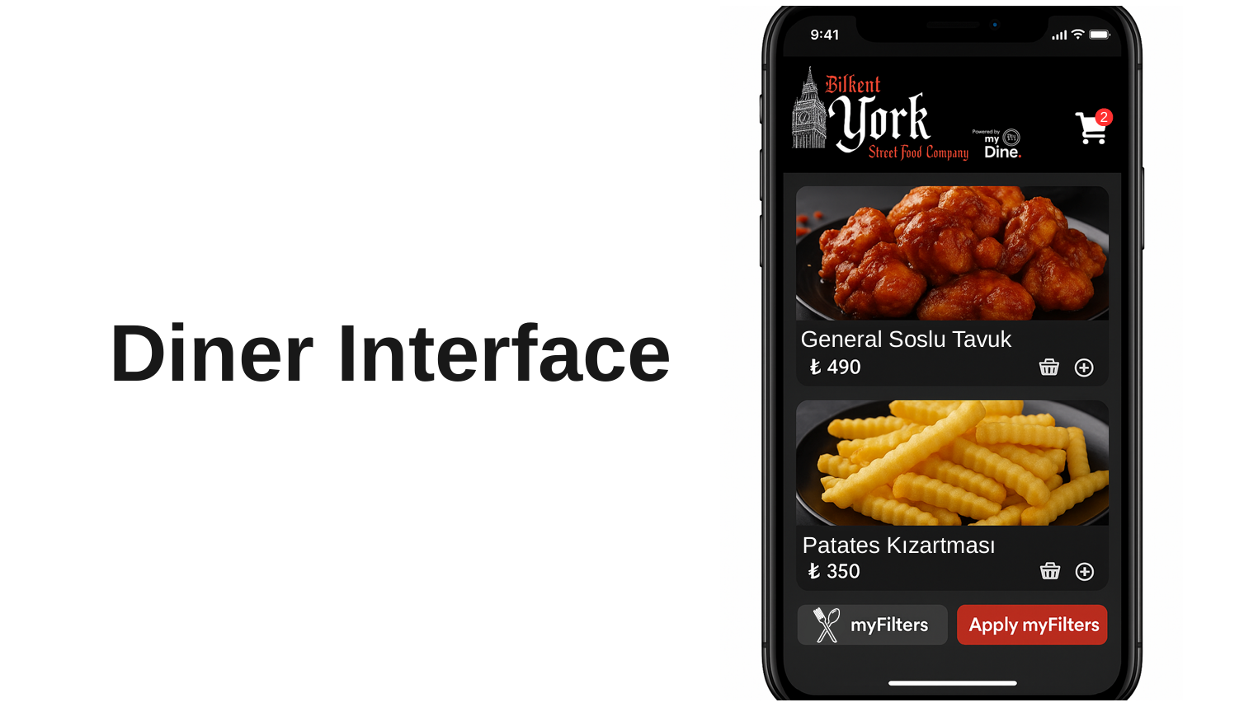
Figure 1: Diner Interface Draft
Diners can scroll vertically to browse a visual menu where each item is displayed with its photo, name, and price. They are able to select any item to view its detailed nutritional information, customize it with specific options, or add it directly to their shopping cart. The interface also allows diners to apply personal filters to narrow down the menu choices and provides a constant visual indicator of how many items are currently in their cart.

4.2 Kitchen Interface

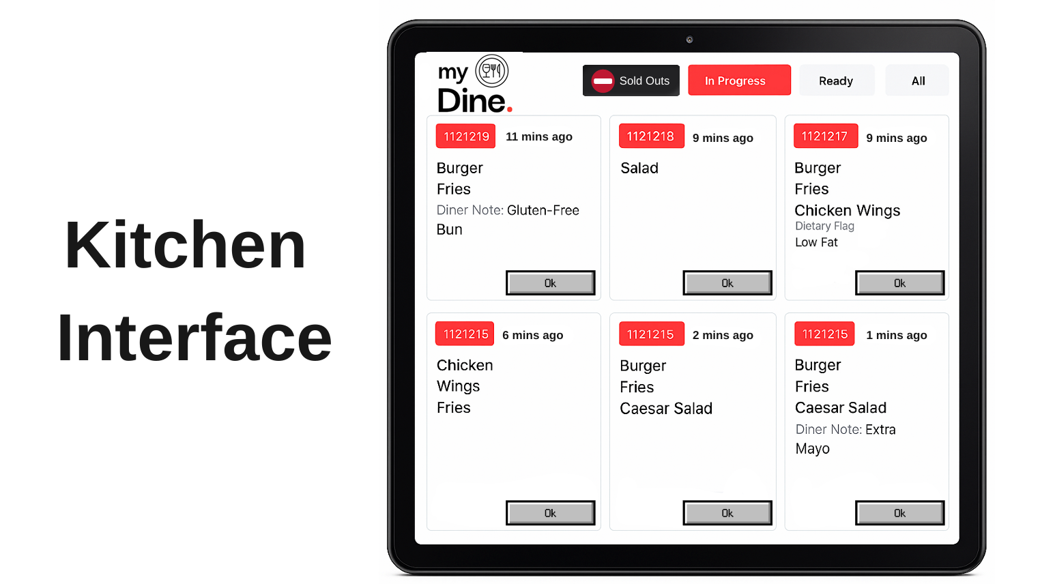
Figure 2: Kitchen Interface Draft
The kitchen staff can efficiently manage their workflow by viewing a grid of digital order tickets. They are able to filter this main view to see specific orders based on their status, such as "In Progress", "Ready" or “All”. For each individual ticket, staff can identify the order by its number, see how long it has been waiting, and review all the items it contains. The interface clearly highlights any important modifications or dietary needs, ensuring special requests are not missed. Using the “Sold Out” button, kitchen staff can also report any shortage in a meal. Finally, staff can acknowledge and clear an order from the active queue by pressing the "Ok" button on the ticket.
The interface for waiters and waitresses will be a simplified version of the kitchen's interface. Staff will still be able to filter orders by relevant statuses like "In Progress" and "Ready" to monitor the meal's progress for their tables. They can view the order number, item list, and any special modifications on each ticket, but kitchen-specific action buttons like "Ok" and "Sold Out" will be removed. The key difference is the addition of a payment status for each order, allowing the waiter to instantly see if the bill has been settled. If the ticket indicates the transaction has not yet happened, this serves as a cue for the waiter to go to the table and take the payment at the end of the meal.

4.3 Restaurant Owner Interface
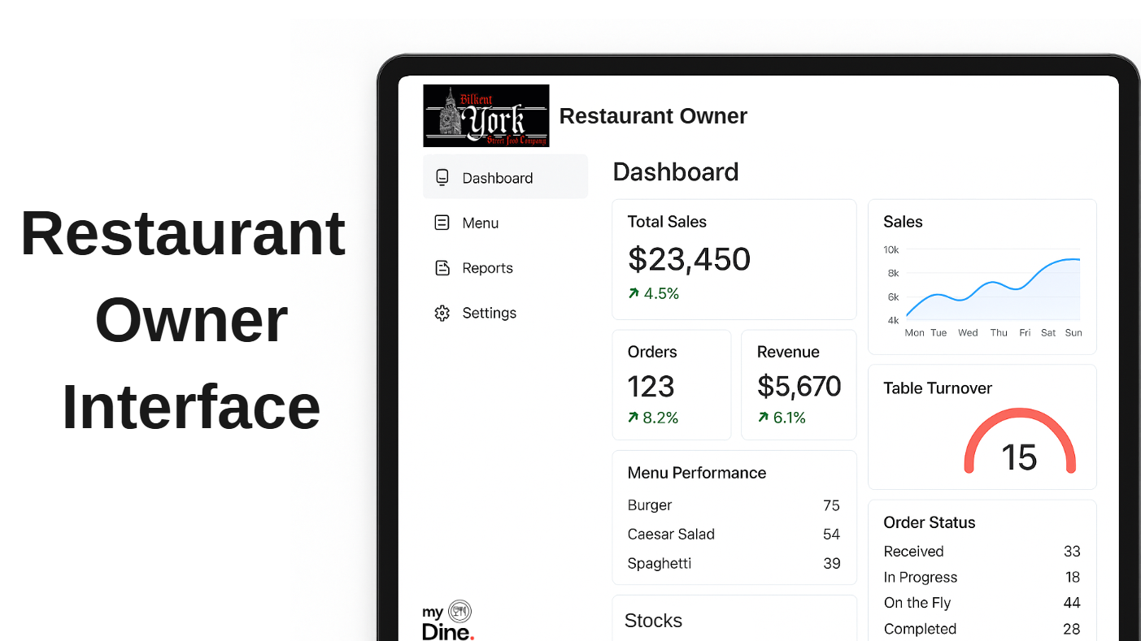
Figure 3: Restaurant Owner Interface Draft
The restaurant manager or owner can navigate through the system to get a comprehensive overview of their business operations. From the main "Dashboard," they can instantly monitor key performance indicators (KPIs) such as total sales, order counts, stocks, revenue, and table turnover. The interface allows them to visually analyze sales patterns, evaluate menu performance by identifying top-selling items and their order counts, and manage inventory through a dedicated stock widget. Crucially, they can also get a live, real-time breakdown of all current order statuses, all within a dashboard that is customized with their own restaurant's logo.

5.0 Physical Characteristics
The MyDine Smart Menu Platform does not require any dedicated hardware for diners. Customers access the system entirely through their personal smartphones by scanning the QR code placed on the restaurant tables. No additional screens, tablets, kiosks, or physical terminals are provided to or required by the customer.
On the restaurant side, the system integrates with existing panels or web based management dashboards used by restaurant staff. Kitchen staff, waiters, and managers interact with MyDine through their existing screens, desktop computers, or tablets already used within the restaurant. MyDine does not introduce any additional proprietary hardware beyond QR code labels placed on each table.

5.1 Subcomponents / Units
MyDine does not include any physical subcomponents or hardware units. All functions are delivered through the digital platform accessed via existing consumer and restaurant devices.

5.2 Physical Interfaces
There are no physical interfaces. Users interact with MyDine via smartphones, tablets, or existing computers. The system does not require dedicated terminals or mechanical components.

5.3 Electronic Interfaces
MyDine does not require any electronic interfaces. The platform runs fully through internet access and modern web browsers, without the need for physical ports such as USB, HDMI, or serial connectors.

6.0 Power and Connectivity Requirements
The MyDine Smart Menu Platform depends on existing devices and standard internet connectivity within the restaurant environment. No additional individual hardware or specialized power sources are required.

6.1 Diner Side
Customers access MyDine through their personal smartphones.
Devices must have
- An active internet connection (Wi-Fi or mobile data)
- A modern web browser (Chrome, Safari, etc.)
MyDine does not require any dedicated power, charging, or external connectivity hardware for diners.

6.2 Business Owner Side
All MyDine features (kitchen tickets, order statuses, stock updates, dashboard analytics) operate through a web based platform, requiring no additional hardware installation.
Restaurant staff interact with MyDine using the restaurant’s existing panels, desktop computers, or tablets.
These devices rely on the restaurant’s standard power setup plugged in POS or battery powered tablets
Internet requirements:
- Stable Wi-Fi or Ethernet connectivity
- Minimum recommended speed for real-time order updates

6.3 System Connectivity
The platform functions through secure cloud based services. All communication customer orders, kitchen updates, inventory signals flows through encrypted internet connections. No additional local servers or wired interfaces (USB, serial, HDMI, DVI, etc.) are needed.

7.0 Conclusion
The MyDine Smart Menu Platform enhances the dining experience by combining faster service, seamless digital ordering, and personalized menu interactions within a single, accessible system. By enabling customers to browse, customize, and pay directly through their smartphones, MyDine significantly reduces waiting times and minimizes communication errors that repeatedly occur in traditional ordering processes.
For restaurants, the platform offers clear operational advantages through real time order tracking, dynamic inventory, and data driven metrics that support more efficient management and improved decision making. By leveraging existing devices and infrastructure, MyDine ensures easy adoption without requiring additional hardware investment. Overall, the platform provides a unified solution that benefits both diners and restaurant owners, creating a more efficient, consistent, and personalized dining environment.

