Simulate SOC

1. **Estimate the C inputs to the soil from NPP**

In order to run any SOC decomposition model you need to drive it with the inputs. The estimation of these is often done starting from the aboveground production, or the crop yields (which are most often available). The yields multiplied by their harvest factor allows you to reconstruct the aboveground biomass.  
In this case we are giving you already the C in the NPP. So you just need to multiply it with each allometric coefficient.

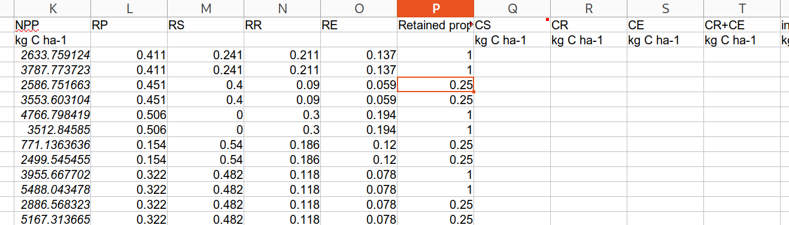

1.2 Estimate the aboveground C inputs (“CS” in the spreadsheet we gave you)

Multiply the NPP times the RS coefficient (where “S” stands for “shoots”).

You then have to consider than different agronomic practices implies a different amount of inputs returned to the soil. We estimated this for you as a factor (“Retained proportion” column). In some cases all residuals are returned to the soil (1), while in others like in Ultuna a very small part is returned (0.03 or 0.05, only becayse stubbles are difficult to remove fully).

1.3 Estimate the root C inputs (“CR” in the spreadsheet we gave you)

Multiply the NPP times the RR coefficient (where “R” stands for “roots”).

1.4 Estimate the exudates inputs (“CE” in the spreadsheet we gave you)

Multiply the NPP times the RE coefficient (where “E” stands for “exudates”).

The coefficient “RP” expresses the product compoonent (seeds for example). The four coefficients sum to 1.

In this exercise we are giving you the climate scaling (r) factors precalculated, but calculating that would have been another step.

1.5 Remember to consider also the C inputs from eventual amendments!

In this exercise we already give you the C content of the amendments additions, otherwise you would need to estimate it.

2. **Model the SOC evolution with the estimated inputs**

You now have to feed the model

2.1 initialize the model

This would require some discussion together since it is quite a debated topic, but for this exercise you can just assign 95% of the SOC measured at the beginning of the experiment to the O pool, and the remaining equally distributed in the other pools.

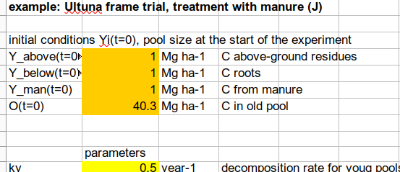

2.2 Fill in the r scaling factor

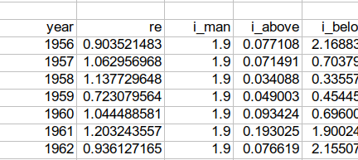

In our case we give you an annual value calculated for each experiment. But if you need a quick estimate you can just consider a constant average climate scaling.

2.3 Insert the inputs

“i_above” (inputs aboveground) includes all the inputs from aboveground returned to the soil, while “i_below” all the inputs belowground. The latter includes both roots and exudates.

The model should run, calculating the estimated SOC from the simulation in the specific column.

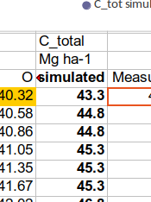

3. **Some suggestions for tinkering**

* **Examine carefully each cell and try to recognize each formula, connecting it with the theory you have been explained during the lectures. And ask us, whenever you think we might help!**
* **Thought (and simulated) experiment: what happens if you move rom a climate where r is around 1-1.5 (Sweden) to one where r is 3-4 (close to tropical)?**
* **Thought (and simulated) experiment: what happens if you stop adding manure after 10 years? And after 100?**
* **Thought (and simulated) experiment: what are the consequences of changing completely the initialization (keeping everything else the same), for example with an initialization very very far from steady state with only 20% in the old pool and the rest in the young pools? What happens in the first years, and what after 100 years? What are the differences between the two initializations, and what do you think they represent?**

Calibrate a model

This is a simple calibration example you can execute in Excel. Excel has a function called “solver” which is an optimization algorithm. It Is used to find the value in certain cells (“decision cells” in Excel parlance) that through a series of calculations in other cells can give the minimum (or maximum) value in another rcell (the “objective” cell). In out case we use as objective a model cost function connected with the model fitness, like RMSE, with the aim at minimizing it by varying parameter values.

This is pretty much how any model calibration is performed, the principle is always minimizing the model error based on the calibration data by varying one or more parameters (there are of course a lot more possibilities in choosing how to achieve that, including all the stochastic methods which have usually the aim at finding more local optima. But the principle stays the same).