Soil Carbon Accumulation in Agroforestry Systems - A metanalysis study based on Bayesian statistics

Thiago A. A. Pinto1; Lorenzo Menichetti2; Remí Cardinael3

# Abstract

Agroforestry Systems (AFS) are based on the presence of trees in consortium with other tress, croplands, or animals in productive plots. The classification of the AFS depends on the use of the trees and interest in the other productive activities of the system.

The amount of soil carbon is directly influenced by the climate parameters, tree species and the age of the AFS.

The aim of this paper is to estimate the soil carbon accumulation rate in different AFS based on Bayesian statistics.

# Introduction: problem, solution

Agroforestry Systems (AFS) are complex agro-ecosystems based on the presence of trees in consortium with other tress, croplands, or animals (Nair et al., 2021). It can be classified in 8 major types: Alley cropping, Fallow, Hedgerows, Multistrata Systems, Parklands, Shaded perennial-crop systems, Silvoarable systems and Silvopastures (Cardinael et al., 2019; Nair et al., 2009).

The amount of Soil Organic Carbon (SOC) in the AFS is directly related to the climate parameters, especially air temperature and precipitation regime, the diversity of tree species, and the age of the AFS.

PROBLEM: At this moment, the information about SOC Stocks in AFS is spread and not normalized, and the variability of SOC distribution in depth, for different AFS types, makes difficult to develop a method to predict the effect of such AFS and its impact on SOC accumulation on different AFS type.

The AFS are frequently located in the bottom line of human intervention level in the nature. And even AFS that do not include intensive fertilizing technics, like parklands, are better, in the climate change mitigation perspective, than other traditional systems that do not include trees among the vegetal species. references

Accumulate carbon in the soil, especially in deeper depths is one of the most important strategies to reduce for longer periods the emissions to the atmosphere. And especially ancient AFS, acts as carbon sink regions when compared to monoculture croplands or extensive cattle graze.

The sub soil, is the main compartment of SOC storage, been responsible for the long-term soil carbon accumulation. When the AFS is considered stable, reaching the carbon balance equilibrium between the topsoil and the atmosphere, the sub soil of the AFS represents the ballast of SOC, that makes this kind of system so important.

The IPCC Reports have different models to describe the soil parameters. And some TIERS do not consider time in the estimation of the SOC. These protocols sub estimates the importance of the ancient AFS in the climate change mitigation scenario, creating a gap of information that are not well explained.

This way, a strategy to properly associate the AFS to their role in the climate change mitigation perspective is to estimate the SOC accumulation rate, based in the age of the different systems and the SOC Stocks based on the climate classification. But a challenge that rise in this process is the high variability of information regarding the different AFS.

To bring light to this discussion, this study, using data extracted from 174 references from the recent literature, aims to compilate the SOC Stocks information in the soil profile for every the 8 different AFS type, considered in this study. ADD references.

As part of the process, firstly it was used a RandomForest model that predicts the SOC accumulation over the profile, from parameters defining the AFS, ecological factors (soil type) and abiotic factors (climate, average temperature). After this, the SOC/depths database from all the papers used in this study was standardized. Considering the SOC Stocks from different AFS and calculating the yearly SOC accumulation rate, based on the stocks of the control areas and age of the AFS, we used a RandomForest model to estimate the distribution of the SOC in the first 50 cm of soil.

One of the results of these process includes an estimative of the SOC accumulation/loss rates, based on five scenarios of previous land use of the AFS: cropland, forest, grassland, plantation, and shrubland. The Land Use Change (LUC) is probably one of the main drivers of this SOC accumulation. By other side, the total SOC Stocks, based on the same parameters was also estimated.

# Materials and Methods

## Data mining

This study was initially conducted with a literature review aiming studies related to AFS and SOC Stocks, including SOC Content and bulk density. Among the research engines, for this study it was used: ISI—Web of Knowledge, Google Scholar, Scopus, Research Gate, and Scielo.org.

In order to increase the number of potential references, it was used the following keywords: soil AND (‘carbon stock*’ OR ‘carbon pool*’ OR ‘carbon sequestration’ OR ‘carbon concentration’) AND (agroforest* OR parkland* OR homegarden OR multistrata OR hedgerow OR windbreak OR shelter-belt OR ‘live fence’ OR ‘tree intercrop*’ OR silvo*arable OR silvo*pasture OR ‘rotation*wood*’ OR tree*fallow* OR fallow OR (tree* AND ‘improve* fallow*’) OR (tree* AND relay*crop*) OR (tree* AND alley*crop*)) (Cardinael et al., 2019).

Them it was filled a table with several parameters found in the papers, including Location, Climate Classification according to Köppen, Physical Property of the Soil, AFS Description, Previous Land Use, Age of System, SOC Stock from the AFS and from the Control plot, following the IPCC guidelines (IPCC, 2022).

Over 400 peer reviewed papers have been examined and 174 have been considered adequate for this study. The eligibility of the papers was the presence of SOC Stocks data, measured in the AFS and a control area (synchronic); or SOC data sampled before and after the AFS implementation (diachronic).

## SOC Stocks Considerations

Almost all the papers considered in this study reported SOC Stock from the AFS. For the occasions of SOC content and bulk density report, it was calculated the SOC Stock. In the special cases where the bulk density information wasn’t available, the SOC Stock was calculated using the average bulk density per soil type (Batjes, 1996), keeping the same approach used by Cardinael et all, (2018).

The diachronic approaches are more significant, when compared to the synchronic one, receiving the priority of treatments in the sites that both were present. This selection was based on fact that the scientific literature considers the diachronic approach as most widely reliable (Costa Junior et al 2013). For the sites with more than one date of observation, it was selected the most recent measurements of SOC Stock, aiming to avoid changes in the first years of the AFS implementation (Smith 2004).

All the SOC Stocks values of the soil profile were considered in this study. A function in the RStudio® program was created to describe the distribution of SOC Stocks for every cm until the depth of 50 cm.

To calculate the SOC rate (positive values for accumulation and negative for loss) it was considered the difference between the SOC Stocks of the AFS and the SOC Stocks of the Control site, divided by the years since the implementation of the AFS (equation 1):

${SOC }_{rate}=\frac{{SOC Stock}_{AFS}- {SOC Stock}_{Control}}{{Age}_{AFS}}$ (1). The values are expressed in in t C ha-1 (Cardinael et al., 2019).

## Agroforestry Classification

In this study were considered 8 types of AFS, proposed by Cardinael et al. (2019) and presented in the Table 1. The papers that presented more than one type AFS type, it was created more than one entry in the database. And for the cases that a classification doubt existed, the paper wasn’t considered.

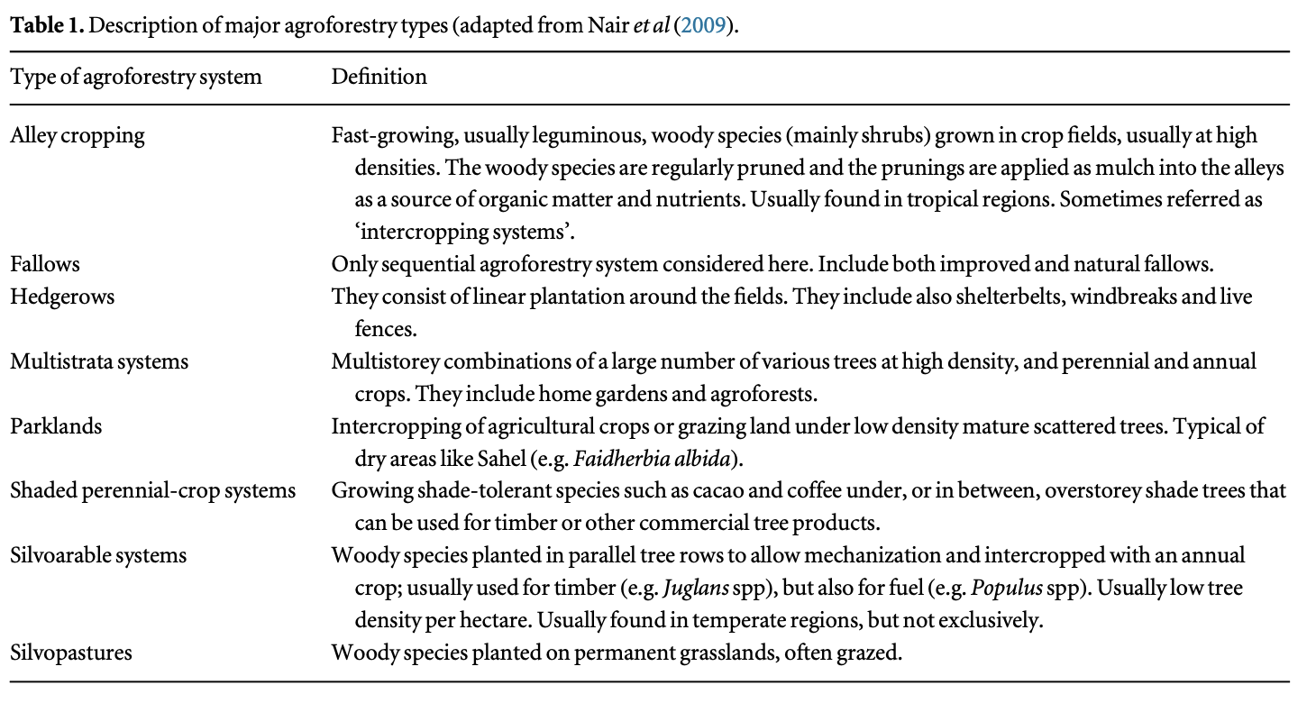

Table : Definition of Agroforestry types (adapted from Cardinael et all, 2019)

## Previous Land Use

For the 174 papers considered in this study, the previous land use of the AFS area, was classified according to the Table 2.

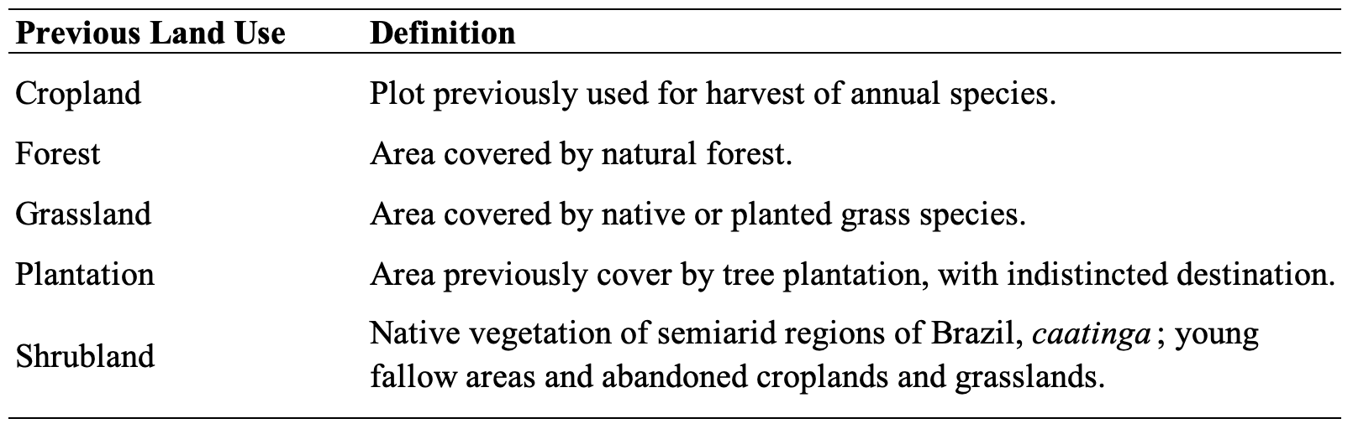

Table : Previous Land Use Definition

## Random Forest

Test different. Models, trying to find the balance between complexity(amount of parameters) and fitness(R2 – rmse).

The best model is the one that better explain the question. Not so much complexity, but with best fitness

## Data analysis

The Random Forest model that predicts SOC accumulation over the profile, from parameters defined by the AFS type, ecological factors (soil type) and abiotic factors (climate, average temperature).

The SOC Stocks profile were separated by the AFS classification. Then, it was calculated an average per cm. The soil profiles that do not have all the SOC Stock values until the depth of 50 cm, had the values estimated by a machine learning script aiming to increase the reliability of the data used in this study.

The RStudio software version 2019.09.2 Build 382 (R Development Core Team 2013), at a significance level of <0.05, was used for statistical analyses and graphs presentation.

# Results

# Discussion

# References

Batjes, N. H. (1996). Total carbon and nitrogen in the soils of the world. In *European Journal of Soil Science* (Vol. 47).

Cardinael, R., Umulisa, V., Toudert, A., Olivier, A., Bockel, L., & Bernoux, M. (2019). Revisiting IPCC Tier 1 coefficients for soil organic and biomass carbon storage in agroforestry systems. In *Environmental Research Letters* (Vol. 14, Issue 3). Institute of Physics Publishing. https://doi.org/10.1088/1748-9326/aafce0

IPCC. (2022). Summary for Policymakers. In H.-O. Pörtner, D.C. Roberts, E.S. Poloczanska, K. Mintenbeck, M. Tignor, A. Alegría, M. Craig, S. Langsdorf, S. Löschke, v. Möller, & A. Okem (Eds.), *Climate Change 2022: Impacts, Adaptation, and Vulnerability. Contribution of Working Group II to the Sixth Assessment Report of the Intergovernmental Panel on Climate Change*. IPCC.

Nair, P. K. R., Kumar, B. M., & Nair, V. D. (2009). Agroforestry as a strategy for carbon sequestration. In *Journal of Plant Nutrition and Soil Science* (Vol. 172, Issue 1, pp. 10–23). https://doi.org/10.1002/jpln.200800030

Nair, P. K. R., Kumar, B. M., & Nair, V. D. (2021). *An Introduction to Agroforestry - Four Decades of Scientific Developments* (Second). Springer Cham. https://doi.org/https://doi.org/10.1007/978-3-030-75358-0