Shell application coding exercise.
Expectations.
Please implement an interactive console application which will allow user to execute few commands as described below. The application should be implemented using Java8 SDK without any 3rd party libraries, and without using Runtime.exec() or ProcessBuilder APIs.
This exercise is NOT about using any external toolsets or OS capabilities. Only JDK classes and good OO design are needed to provide a successful solution.
Please create a repository in GitHub and send us the link to it, so we can observe your progress.
Functional requirements.
After starting the application, it will present its own command prompt to the user:
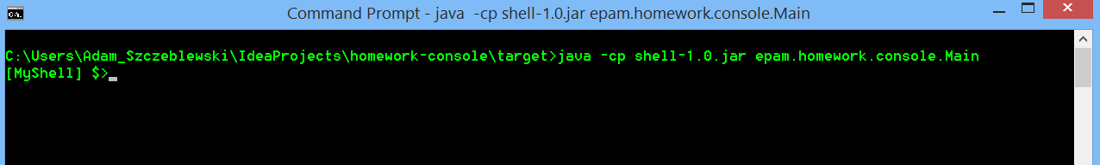

User can customize the presented prompt using a ‘prompt’ command with a parameter. Possible values of the parameter:
- ‘$cwd’, will result in displaying a path to current working directory in the prompt
- ‘reset’, will reset the prompt to default ($ sign)
- Any other string, will display the parameter in the prompt
Examples:
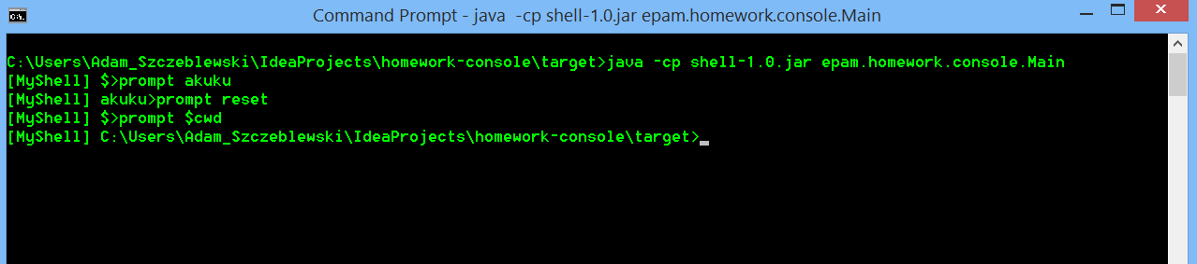

User can display the content of current working directory using a ‘dir’ command. Format of the display: type of the item (DIR|FILE) and name of the item:
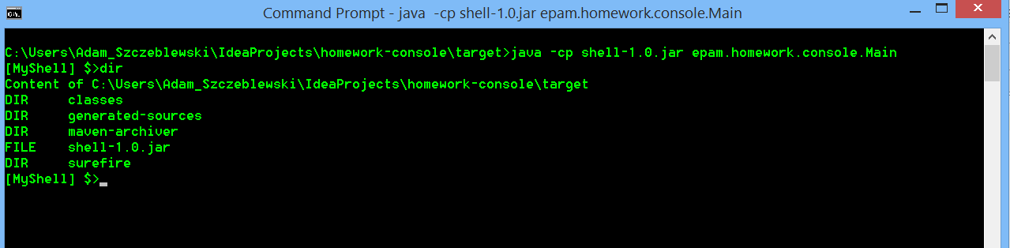

User can display the directory structure of current working directory and its subdirectories using a ‘tree’ command (please note the indentation with ‘-‘ for subdirectories):
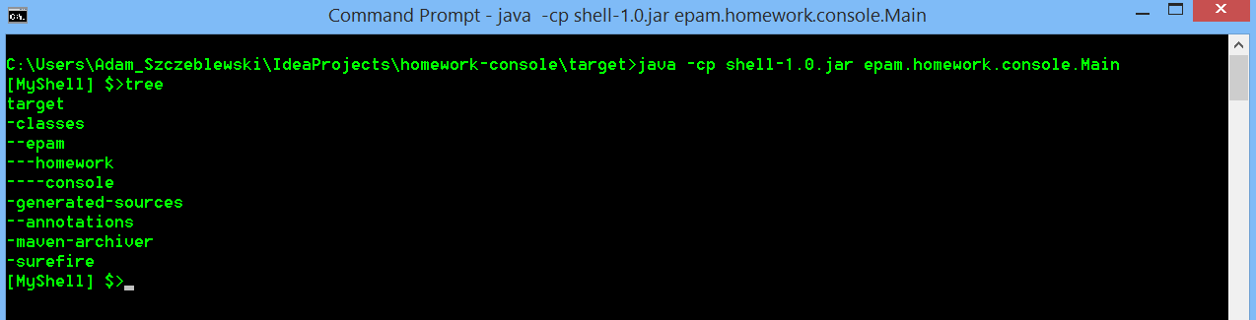

User can change the current working directory using a ‘cd’ command with a parameter:
- ‘..’, for parent directory
- Name of existing subdirectory
Examples:
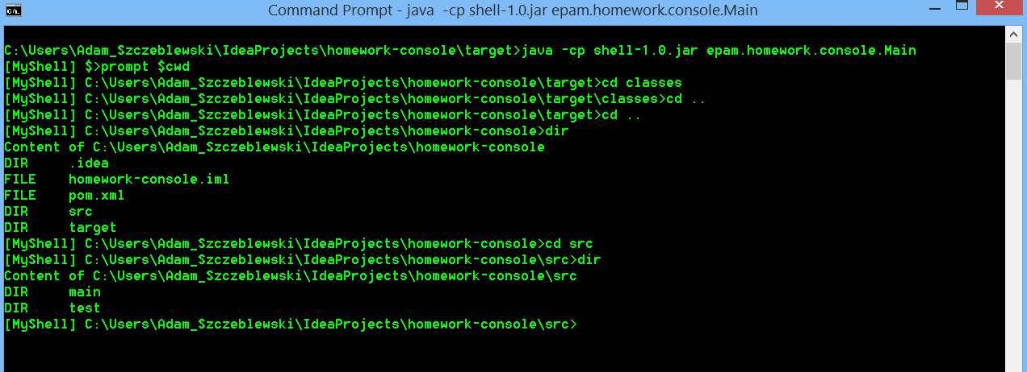

User can terminate the application by using ‘exit’ command. Any other command shall result in displaying ‘[command] : unknown command’ message:
