made by Nagi

ilo sama RAIL

German Decal Library

Documentation

v1.0

# Table of Contents

# Requests and Suggestions

Missing something? In case you have any requests or suggestions for additional decals for this library, you may create an issue with the "request" label in our GitHub repository, or ping our team in the TSC discord with your request. If possible, please include appropriate reference material for the decal you want represented.

# Usage Rights

You may utilise the files in this repository for your own train liveries. However, while doing so, you must follow the following rules unless disclosed in a prior agreement.

1. Do not use the files without crediting us (ilo sama RAIL)
2. Do not use the files outside of train simulators
3. Do not use the files commercially

# Known Issues

## Fonts in DB WLS decals

The fonts in our DB WLS decals are inaccurate due to the real font (DB WLS) not being available. For now, as a replacement, we are using Nimbus Sans L, a free alternative to Helvetica. We may attempt to recreate DB WLS in the future, though we cannot confirm anything quite yet.

# Naming Scheme

## Suffixes

|  |  |
| --- | --- |
| Suffix | Explanation |
| _NBG | No background |
| _NBGw | White only |
| _NBO | No border |
| _n / _o | New/old |
| _v# | Variant # |

# Decals

## DB WLS

### Pictograms

Please note that other (newer) symbols may be found in other categories (e.g. TSI PRM wheelchair or ISO 7010 arrows)

|  |  |  |
| --- | --- | --- |
| Decal | Name | Notes |
|  | !!Blank |  |
|  | !ArrowDiagonal | Rotate UV map (or texture) for other orientations |
|  | !ArrowDiagonal_NBO | Rotate UV map (or texture) for other orientations |
|  | !ArrowStraight | Arrow always aligned with left or bottom (see example)  Rotate/mirror UV map (or texture) for other orientations |
|  | !ArrowStraight_NBO | Arrow always aligned with left or bottom (see example)  Rotate/mirror UV map (or texture) for other orientations |
|  | 1stClass |  |
|  | 1stClass_NBO |  |
|  | 2ndClass |  |
|  | 2ndClass_NBO |  |
|  | Bike |  |
|  | Bike_NBG |  |
|  | Bistro |  |
|  | Bistro_NBG |  |
|  | CCTV_o |  |
|  | CCTV_o_NBG |  |
|  | Coach |  |
|  | DoorClosingWarning_v1 |  |
|  | FallHazard |  |
|  | FallHazard_NBG |  |
|  | FamilyArea |  |
|  | FamilyArea_NBG |  |
|  | Information_n |  |
|  | Information_o |  |
|  | LuggageRack |  |
|  | NoBike |  |
|  | NoBike_NBGw |  |
|  | NoPhone |  |
|  | NoPhone_NBGw |  |
|  | NoSmoking |  |
|  | NoSmoking_NBG |  |
|  | NoSmoking_NBGw |  |
|  | Phone |  |
|  | Phone_NBG |  |
|  | QuietArea |  |
|  | QuietArea_NBG |  |
|  | Smartphone |  |
|  | Smoking |  |
|  | Smoking_NBG |  |
|  | Stroller |  |
|  | Stroller_NBG |  |
|  | ToddlerArea |  |
|  | ToddlerArea_NBG |  |
|  | ValidTicket |  |
|  | WC |  |
|  | Wheelchair |  |
|  | Wheelchair_NBG |  |

#### Example for Arrow Alignment

The DB WLS arrows should be aligned as shown here:

### TSI PRM

Please note that other (older) symbols may be found in other categories (e.g. regular DB WLS wheelchair)

|  |  |  |
| --- | --- | --- |
| Decal | Name | Notes |
|  | Pregnant |  |
|  | ReducedMobility |  |
|  | Wheelchair |  |

## ISO 7010

### Emergency

Please note that other (older) symbols may be found in other categories (e.g. DB WLS arrows)

|  |  |  |
| --- | --- | --- |
| Decal | Name | Notes |
|  | !E-ADa_ArrowDiagonalA | Rotate UV map (or texture) for other orientations |
|  | !E-ASa_ArrowStraightA | Rotate UV map (or texture) for other orientations |
|  | E003_FirstAid |  |
|  | E004_EmergencyTelephone |  |
|  | E059_EscapeLadder |  |

### Fire Protection

Please note that other (older) symbols may be found in other categories (e.g. DIN 4844-2 fire extinguisher or DB WLS arrows)

|  |  |  |
| --- | --- | --- |
| Decal | Name | Notes |
|  | !F-ADa_ArrowDiagonalA | Rotate UV map (or texture) for other orientations |
|  | !F-ASa_ArrowStraightA | Rotate UV map (or texture) for other orientations |
|  | F001_FireExtinguisher |  |

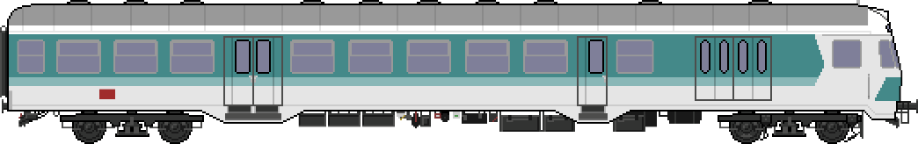

[rail.ilosama.com](http://rail.ilosama.com/)

(c) ilo sama RAIL, 2025