1. **What is feasibility Study. Explain different types of feasibility study.**

**Ans:** A feasibility study is an assessment of the practicality of a proposed plan or project. A feasibility study analyzes the viability of a project to determine whether the project or venture is likely to succeed.

**Types of Feasibility Study:**

**Technical Feasibility:**

**Economic Feasibility:**

**Legal Feasibility:**

**Operational Feasibility:**

### **Scheduling Feasibility:**

**2. What is SRS. Write the features of SRS.**

Ans: A Software Requirements Specification (SRS) is a document that describes the nature of a project, software or application. In simple words, SRS document is a manual of a project provided it is prepared before you kick-start a project/application.

Features of SRS:

Correctness

Completeness

Consistency

Unambiguousness

Ranking for importance and stability

Modifiability

Verifiability

Traceability

Testability

3.Phases of Spiral Model

Objectives determination:

Requirements are gathered from the customers and the objectives are identified, elaborated, and analyzed at the start of every phase

Identify and resolve Risks:

During the second quadrant, all the possible solutions are evaluated to select the best possible solution

Develop next version of the Product:

During the third quadrant, the identified features are developed and verified through testing. At the end of the third quadrant, the next version of the software is available.

Review and plan for the next Phase:

In the fourth quadrant, the Customers evaluate the so far developed version of the software. In the end, planning for the next phase is

Started.

Advantages of Spiral Model:

Software is produced early in the software life cycle.

Disadvantages of Spiral Model:

It is not suitable for small projects as it is expensive.

Phases of prototype model:

Requirements gathering and analysis:

the system’s desires are precisely defined. During the method, system users are interviewed to determine what they expect from the system.

Quick design :

the system’s basic design is formed. However, it is not a complete design. It provides the user with a quick overview of the system.

Build a Prototype :

During this stage, an actual prototype is intended to support the knowledge gained from quick design. It is a small low-level working model of the desired system.

Initial user evaluation :

The proposed system is presented to the client for preliminary testing at this stage. It is beneficial to investigate the performance model’s strengths and weaknesses. Customer feedback and suggestions are gathered and forwarded to the developer.

Refining prototype :

If the user is dissatisfied with the current model, you may want to improve the type that responds to user feedback and suggestions. When the user is satisfied with the upgraded model, a final system based on the approved final type is created.

Implement Product and Maintain :

The final system was fully tested and distributed to production after it was developed to support the original version. To reduce downtime and prevent major failures, the programmer is run on a regular basis.

Advantages of prototype model:

This model is flexible in design

Disadvantages of prototype model :

This model is costly.

Phases of Waterfall Model:

Requirements analysis and specification phase:

he aim of this phase is to understand the exact requirements of the customer and to document them properly

Design Phase:

This phase aims to transform the requirements gathered in the SRS into a suitable form which permits further coding in a programming language.

Implementation and unit testing:

During this phase, design is implemented. If the SDD is complete, the implementation or coding phase proceeds smoothly, because all the information needed by software developers is contained in the SDD.

Integration and System Testing:

This phase is highly crucial as the quality of the end product is determined by the effectiveness of the testing carried out.

Operation and maintenance phase:

Maintenance is the task performed by every user once the software has been delivered to the customer, installed, and operational.

Advantages of Waterfall model:

This model is simple to implement also the number of resources that are

required for it is minimal.

Disadvantages of Waterfall model

This model cannot accept the changes in requirements during development.

Risk is handle in Spiral model:

The most important feature of the spiral model is handling these unknown risks after the project has started. Such risk resolutions are easier done by developing a prototype. The spiral model supports coping up with risks by providing the scope to build a prototype at every phase of the software development.

Risk is handle in prototype model:

the risks must be identified completely before the start of the development work of the project. But in real life project risk may occur after the development work starts, in that case, we cannot use the Prototyping Model.

4. Which model can be adopted for technically challenging software product that are prone to several kind of risks. Explain the model with diagram.

Ans: Spiral model can be adopted for technically challenging software product that are prone to several kind of risks.

Spiral model is one of the most important Software Development Life Cycle models, which provides support for Risk Handling

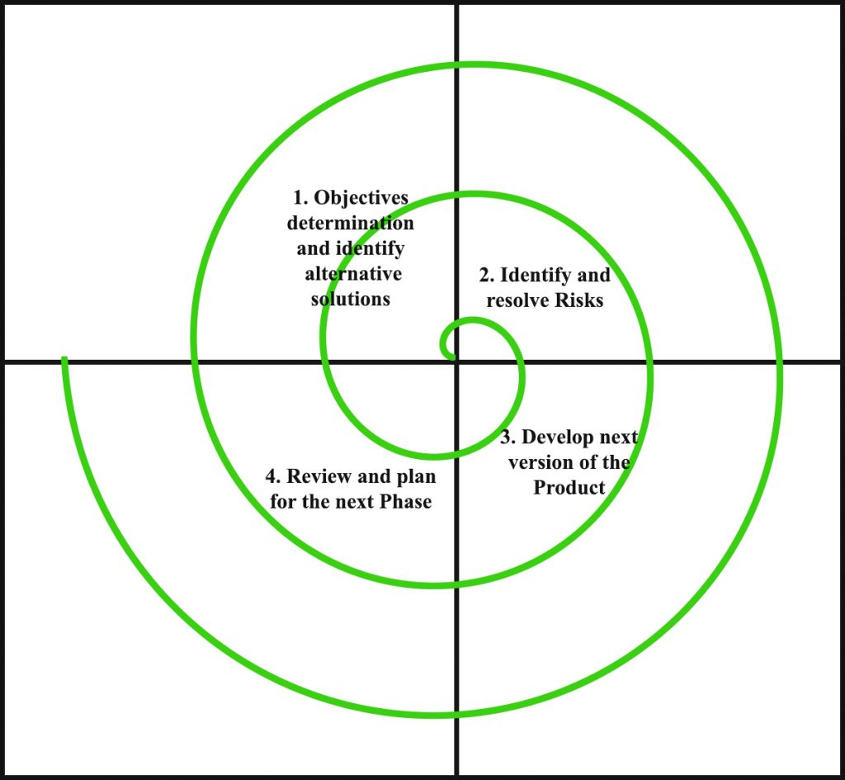

Each phase of the Spiral Model is divided into four quadrants

Objectives determination:

Requirements are gathered from the customers and the objectives are identified, elaborated, and analyzed at the start of every phase

Identify and resolve Risks:

During the second quadrant, all the possible solutions are evaluated to select the best possible solution

Develop next version of the Product:

During the third quadrant, the identified features are developed and verified through testing. At the end of the third quadrant, the next version of the software is available.

Review and plan for the next Phase:

In the fourth quadrant, the Customers evaluate the so far developed version of the software. In the end, planning for the next phase is

Started.

5. Describe the role of a ‘System Analyst’.

Ans: Systems analysts analyze how well software, hardware and the wider IT system fit the business needs of their employer or of a client. They write requirements for new systems and may also help implement them and monitor their effectiveness.

**Completeness**

**Completeness**