**Data Types**

Python provides various standard data types that define the storage method on each of them. The data types defined in Python are given below.

1. Numbers
2. Sequence Type
3. Boolean
4. Set

Dictionary

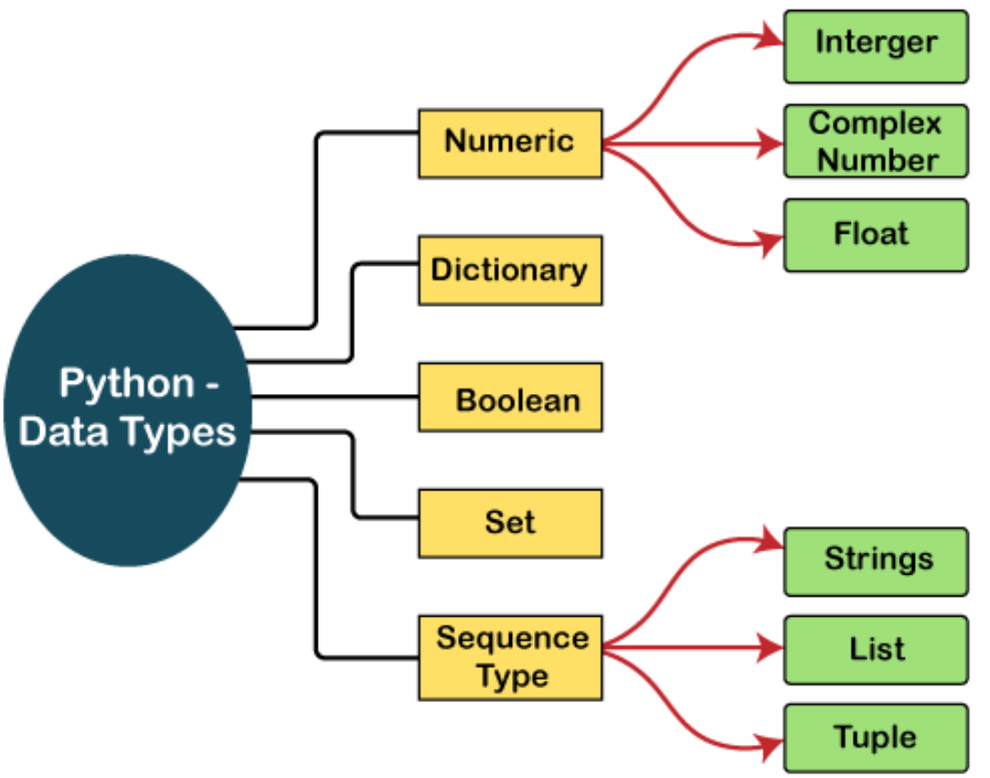

he **isinstance()** function is used to check an object belongs to a particular class