Screenshots of graphs
http://127.0.0.1:8000/vega-lite/
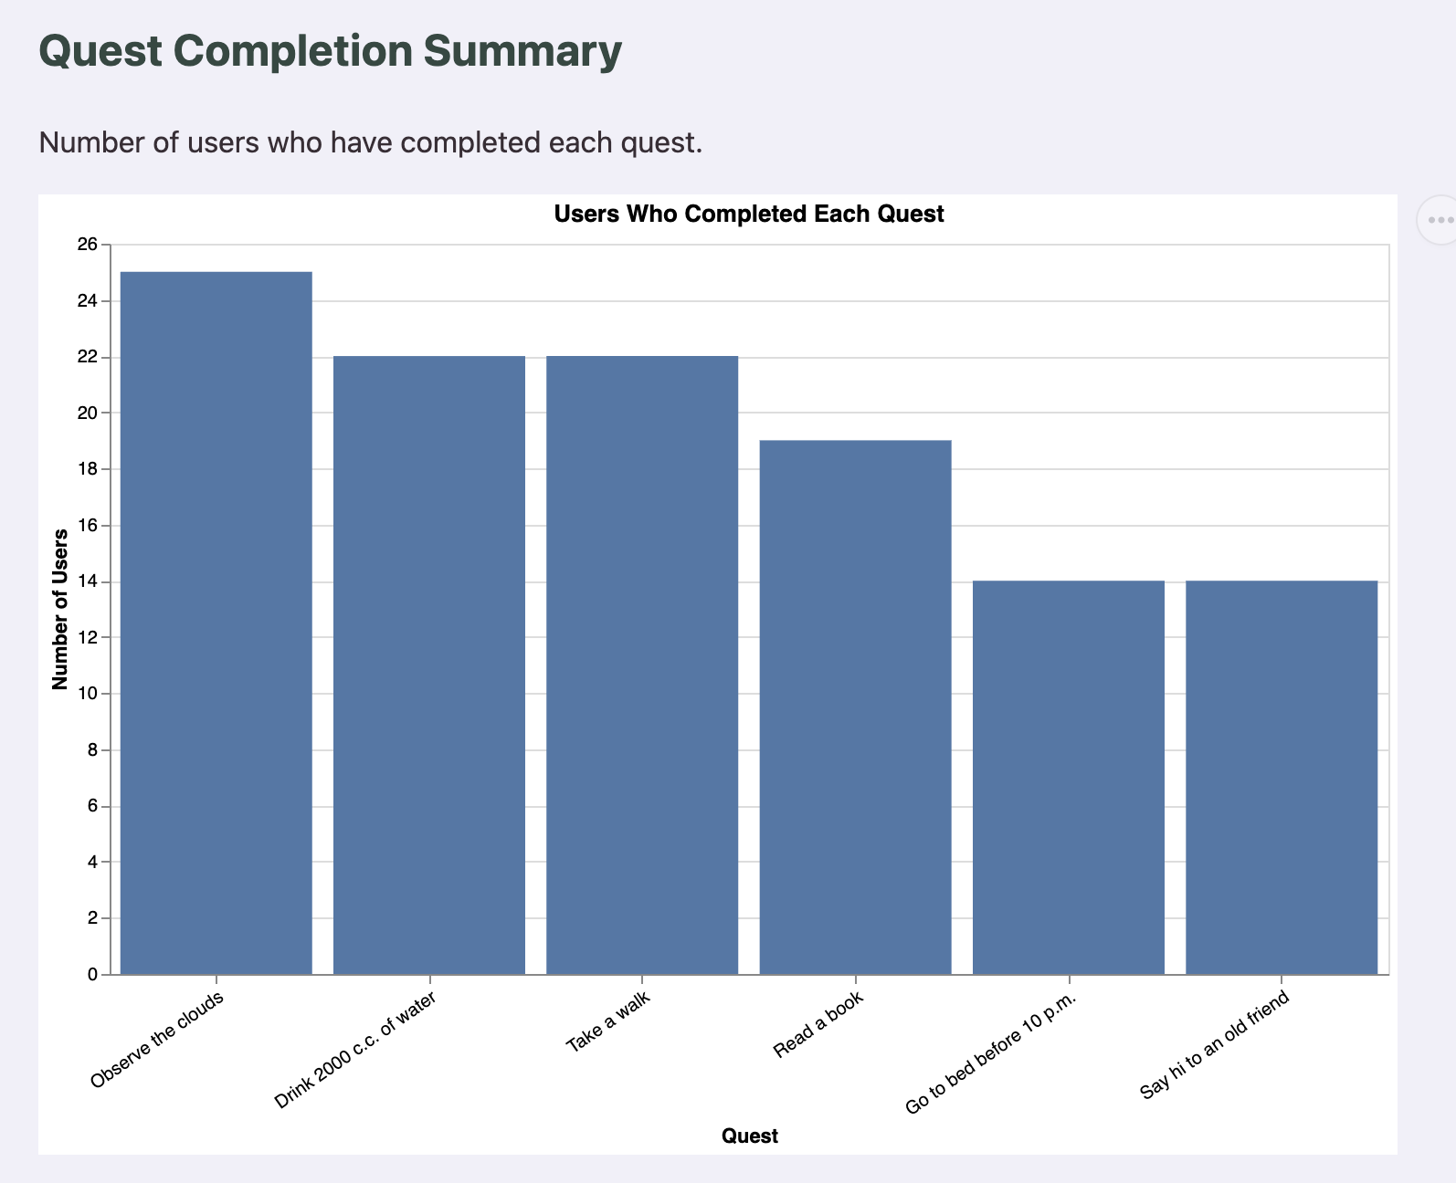

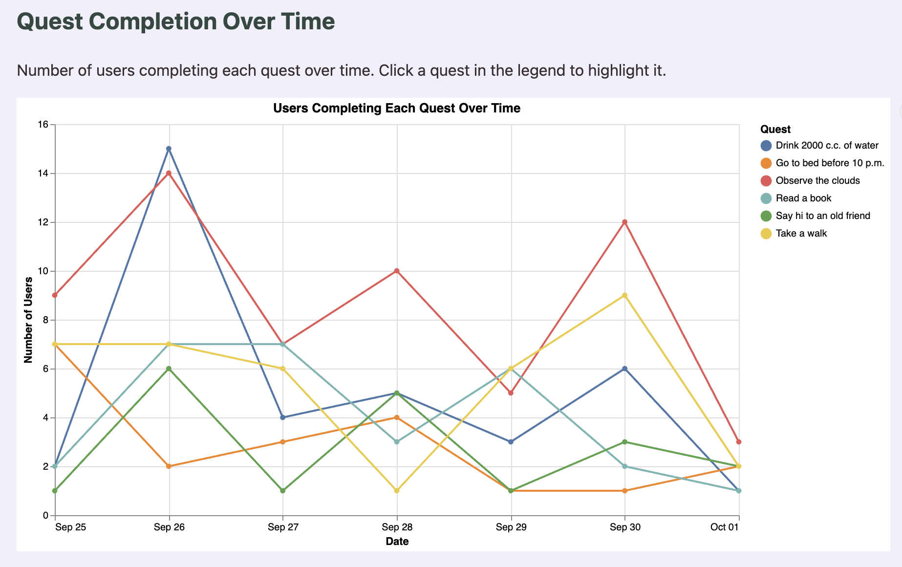

JSON
http://127.0.0.1:8000/api/quest-summary/

http://127.0.0.1:8000/api/completion-timeline/

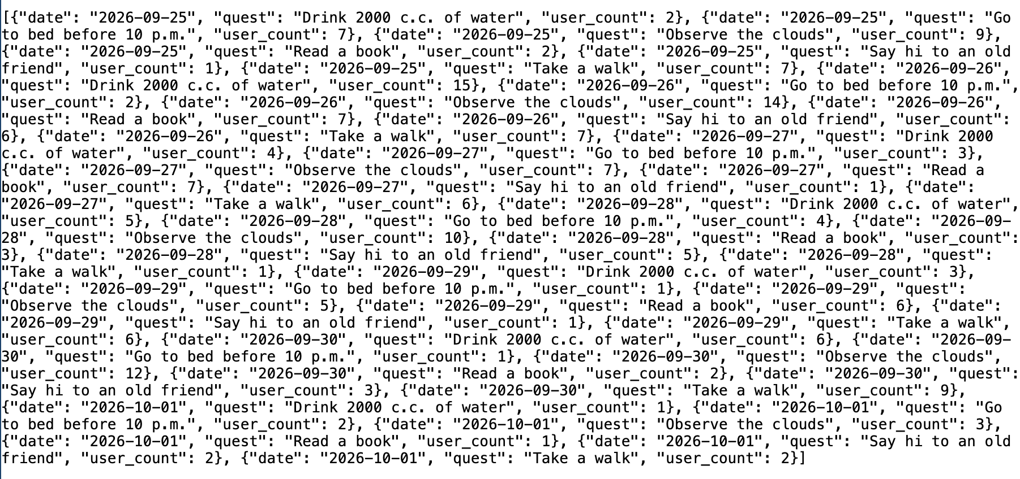

Expose chart outputs through dedicated endpoints
http://127.0.0.1:8000/vega-lite/bar.png
{
"$schema": "https://vega.github.io/schema/vega-lite/v6.json",
"title": "Users Who Completed Each Quest",
"width": 700,
"height": 400,
"data": {
"url": "https://ilona.pythonanywhere.com/api/quest-summary/"
},
"mark": {
"type": "bar"
},
"encoding": {
"x": {
"field": "quest",
"type": "nominal",
"sort": "-y",
"title": "Quest",
"axis": {
"labelAngle": -35
}
},
"y": {
"field": "user_count",
"type": "quantitative",
"title": "Number of Users",
"scale": {
"zero": true
}
},
"tooltip": [
{
"field": "quest",
"type": "nominal",
"title": "Quest"
},
{
"field": "user_count",
"type": "quantitative",
"title": "Users"
}
]
}
}

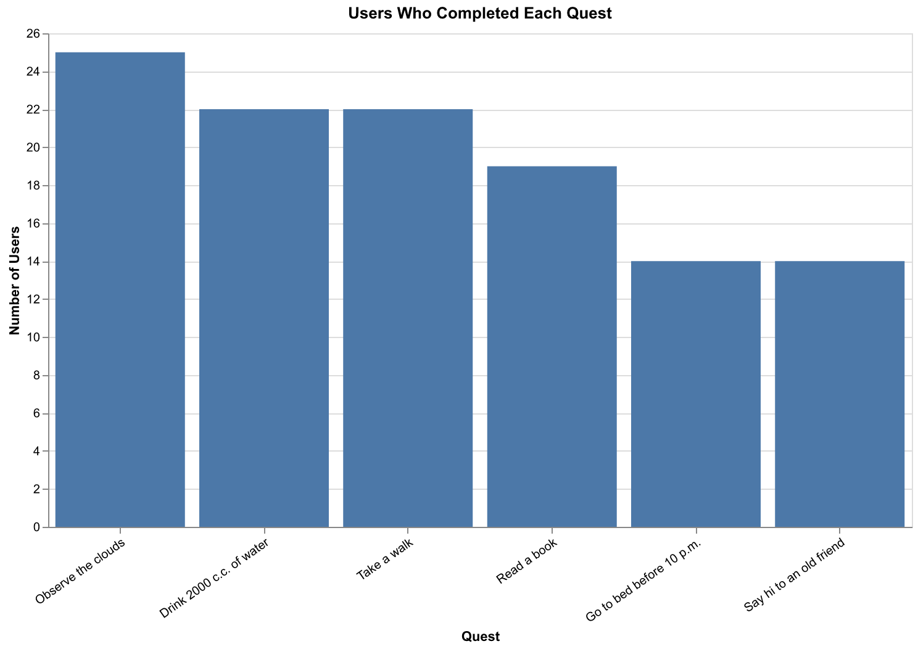

http://127.0.0.1:8000/vega-lite/completion-timeline.png

Json spec
{
"$schema": "https://vega.github.io/schema/vega-lite/v6.json",
"title": "Users Completing Each Quest Over Time",
"width": 700,
"height": 400,
"data": {
"url": "https://ilona.pythonanywhere.com/api/completion-timeline/"
},
"params": [
{
"name": "quest_selection",
"select": {
"type": "point",
"fields": [
"quest"
]
},
"bind": "legend"
}
],
"mark": {
"type": "line",
"point": true
},
"encoding": {
"x": {
"field": "date",
"type": "temporal",
"title": "Date",
"scale": {
"type": "utc"
},
"axis": {
"format": "%b %d",
"tickCount": "day"
}
},
"y": {
"field": "user_count",
"type": "quantitative",
"title": "Number of Users",
"scale": {
"zero": true
}
},
"color": {
"field": "quest",
"type": "nominal",
"title": "Quest"
},
"tooltip": [
{
"field": "date",
"type": "temporal",
"title": "Date",
"format": "%Y-%m-%d"
},
{
"field": "quest",
"type": "nominal",
"title": "Quest"
},
{
"field": "user_count",
"type": "quantitative",
"title": "Users"
}
]
}
}

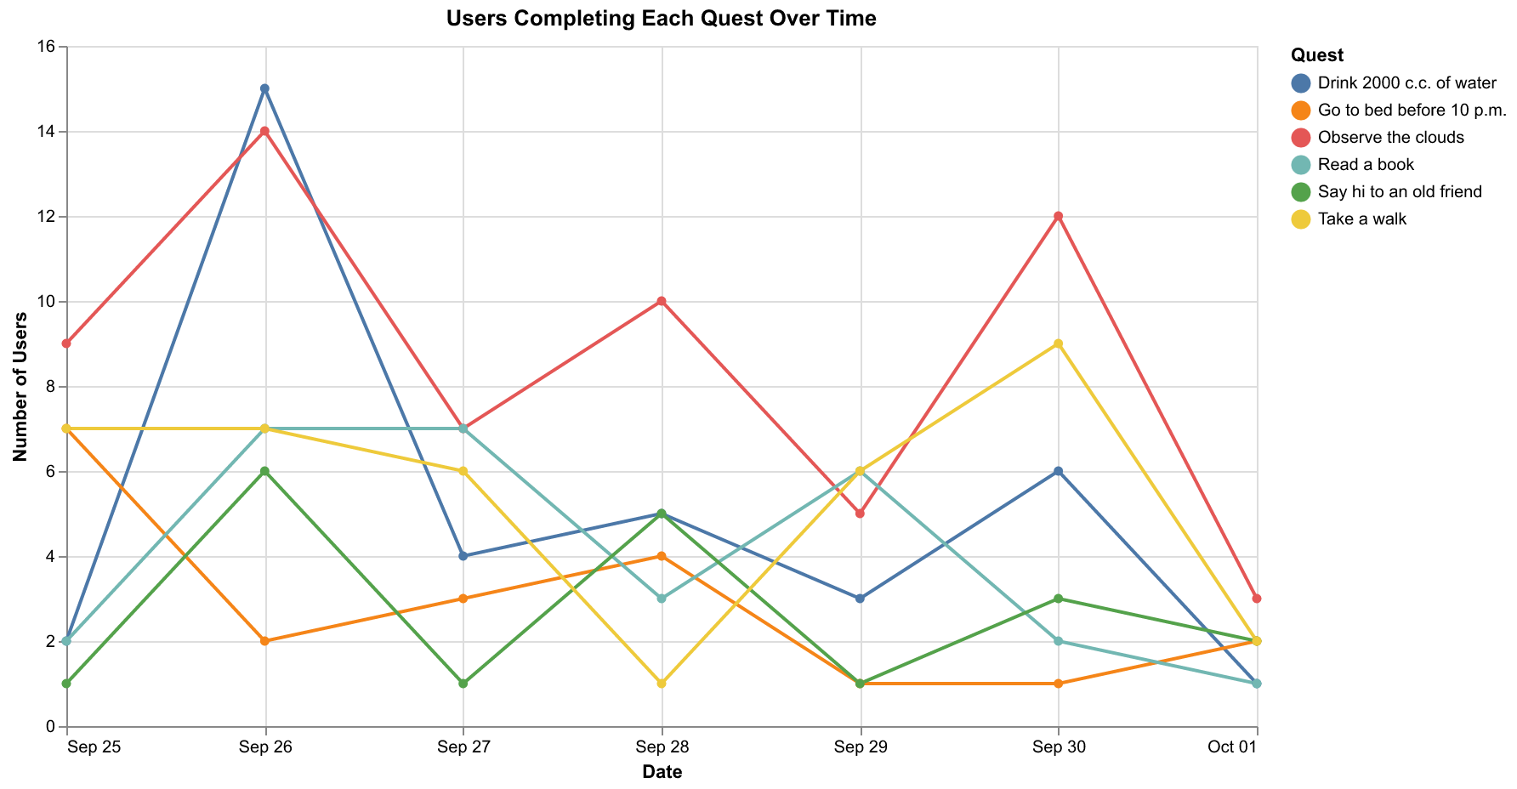

External API functioning
External API used
We used the external API, OpenStreetMap’s Nominatim API, which is a free, keyless, geocoding API that converts a place name into traceable coordinates (lat/long). So when you type in a location, say Chicago, you would get all the relative coordinates besides its county, state, and country.
Endpoint + Request
Within core/views.py, we added a new view called location_search. It is exposed at the route /api/location/?q=<place name>. The view reads the search term from the q GET parameter and passes it to a geocode() helper, which sends a request to Nominatim using requests.get() with params (q, format=json, limit=1, addressdetails=1), a custom User-Agent header (required by Nominatim’s usage policy), timeout=5, and raise_for_status() to catch failed requests. The view returns a JSON response with the display name, latitude, longitude, city, state, and state code of the best match.
Error
If Nominatim cannot find a match for the search term, the view returns a 404 error, stating “Location not found”. If the user does not input any search term at all, the view returns a 400 error, this time saying “No location provided”. If the request to Nominatim fails or times out, the view returns a 502 error, saying “Location service unavailable”. The 404 and 400 cases are confirmed to work (check screenshots).
Triangulation w/ Internal Data
The resolved place is matched against our Forum model’s location field, which is stored as “City, ST” (e.g. “Champaign, IL”). A match_forums() helper splits each post’s location into city and state, then groups posts into a same-city bucket and a same-state bucket using the city, state name, and state code returned by Nominatim. For each bucket it reports the number of posts, the number of distinct users, and the communities (groups) involved, plus the state’s share of all posts that have a location. This is exposed as JSON at /api/forum-nearby/?q=<place name> and as an HTML page with a search form at /forums/nearby/?q=<place name>. The lookup is fresh with every new search, and searches are not saved to the database.

Test (input location): http://127.0.0.1:8000/api/location/?q=Chicago
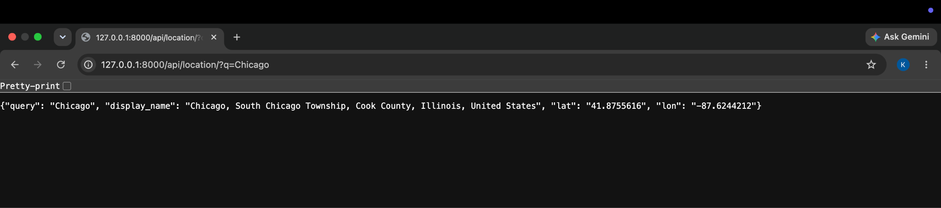
https://ilona.pythonanywhere.com/forums/nearby/?q=Chicago
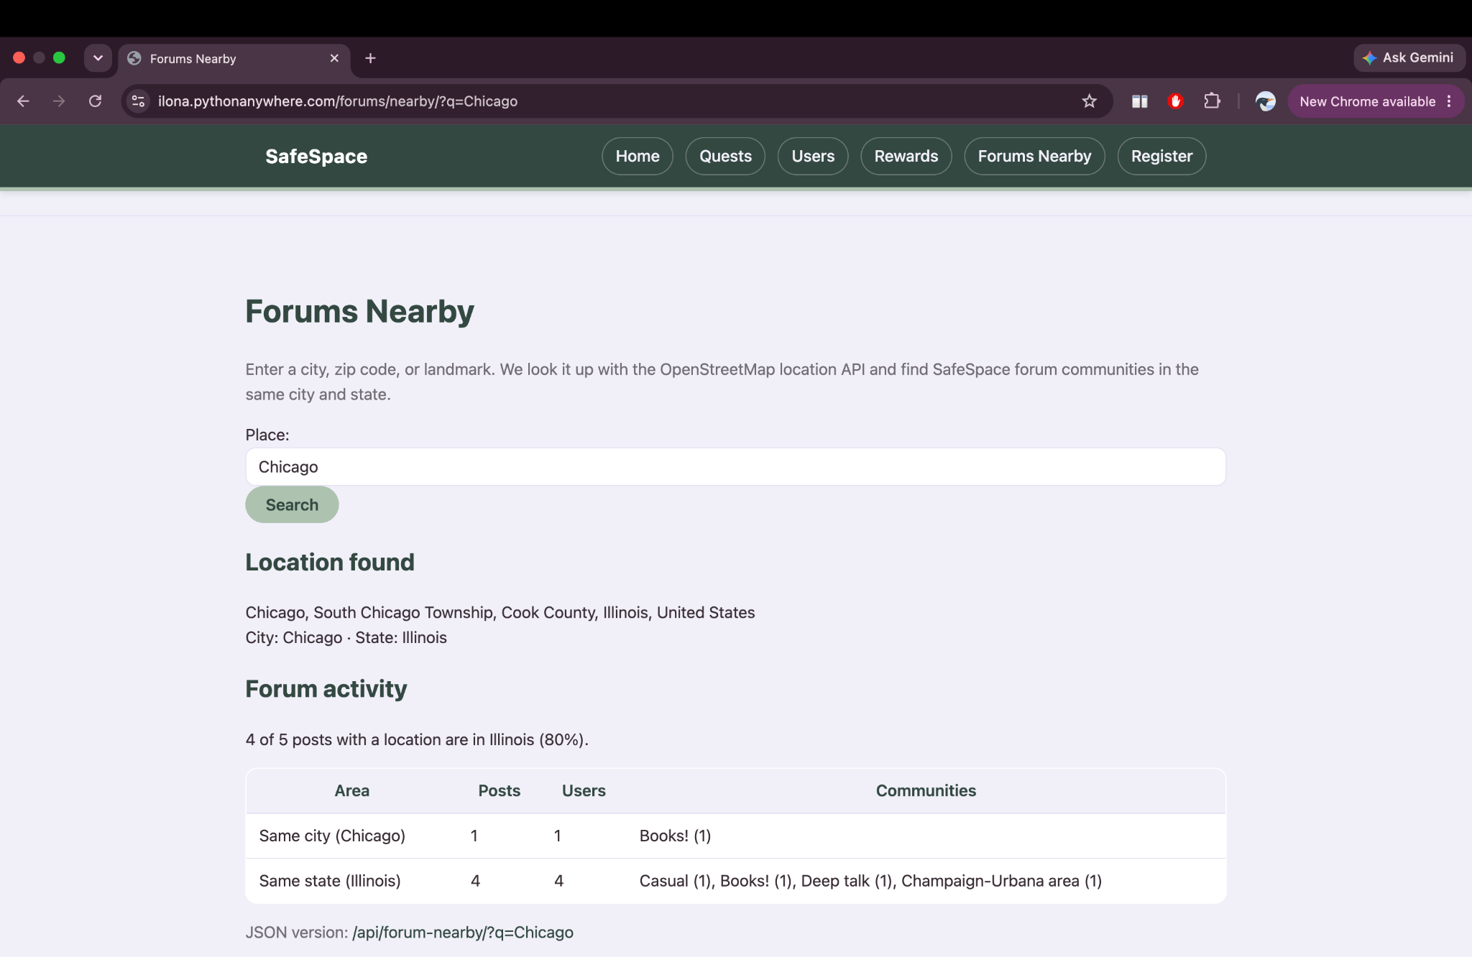

Test (nonexistent location): http://127.0.0.1:8000/api/location/?q=asdfghjkl123
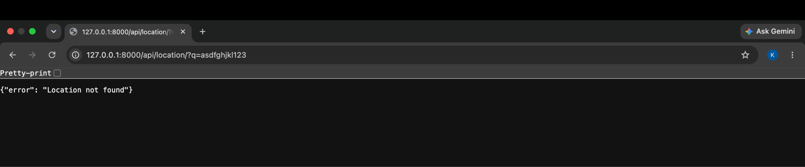
https://ilona.pythonanywhere.com/forums/nearby/?q=asdfghjkl
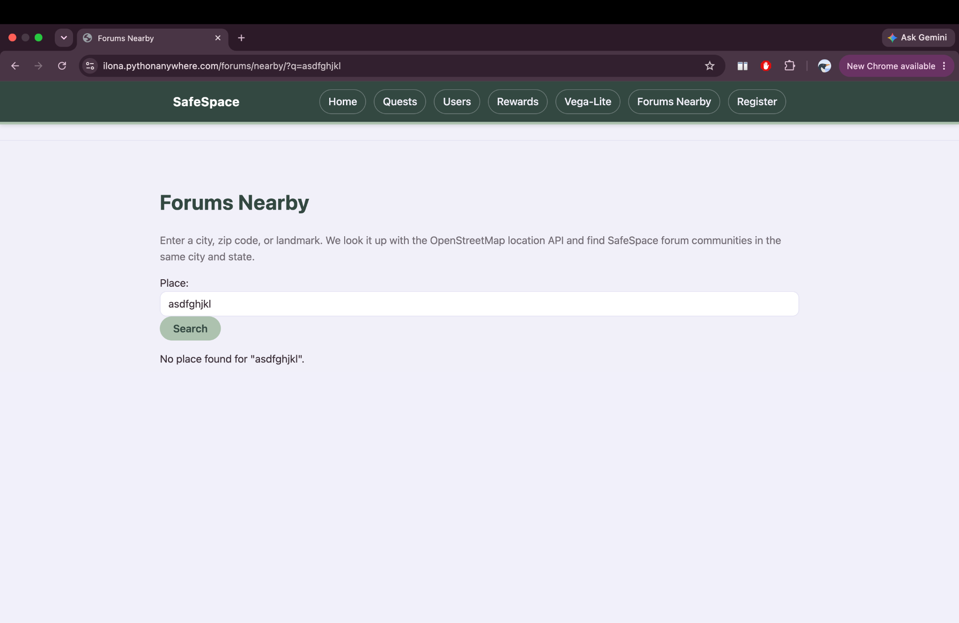

Test (no location):
https://ilona.pythonanywhere.com/api/location/
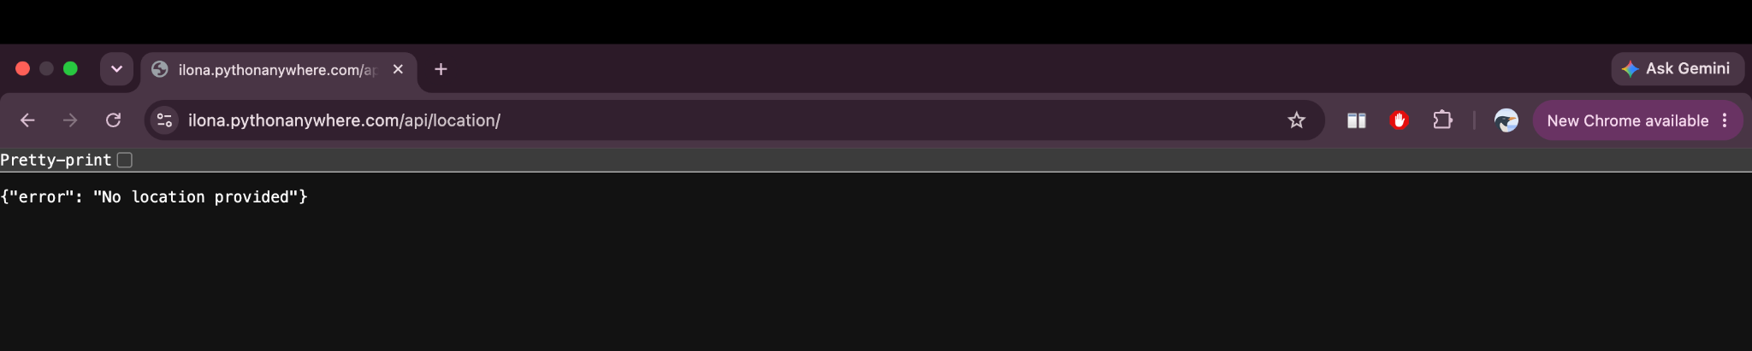
Test (triangulation JSON):
https://ilona.pythonanywhere.com/api/forum-nearby/?q=Chicago

[ADD SCREENSHOT]

Reports
http://127.0.0.1:8000/reports/

