**Query 1:**

Query: “ KENNEDY ADMINISTRATION PRESSURE ON NGO DINH DIEM TO STOP SUPPRESSING THE BUDDHISTS . “



MAP average= (.86 + .93 + .95 + .96 + .97) / 5 = .934

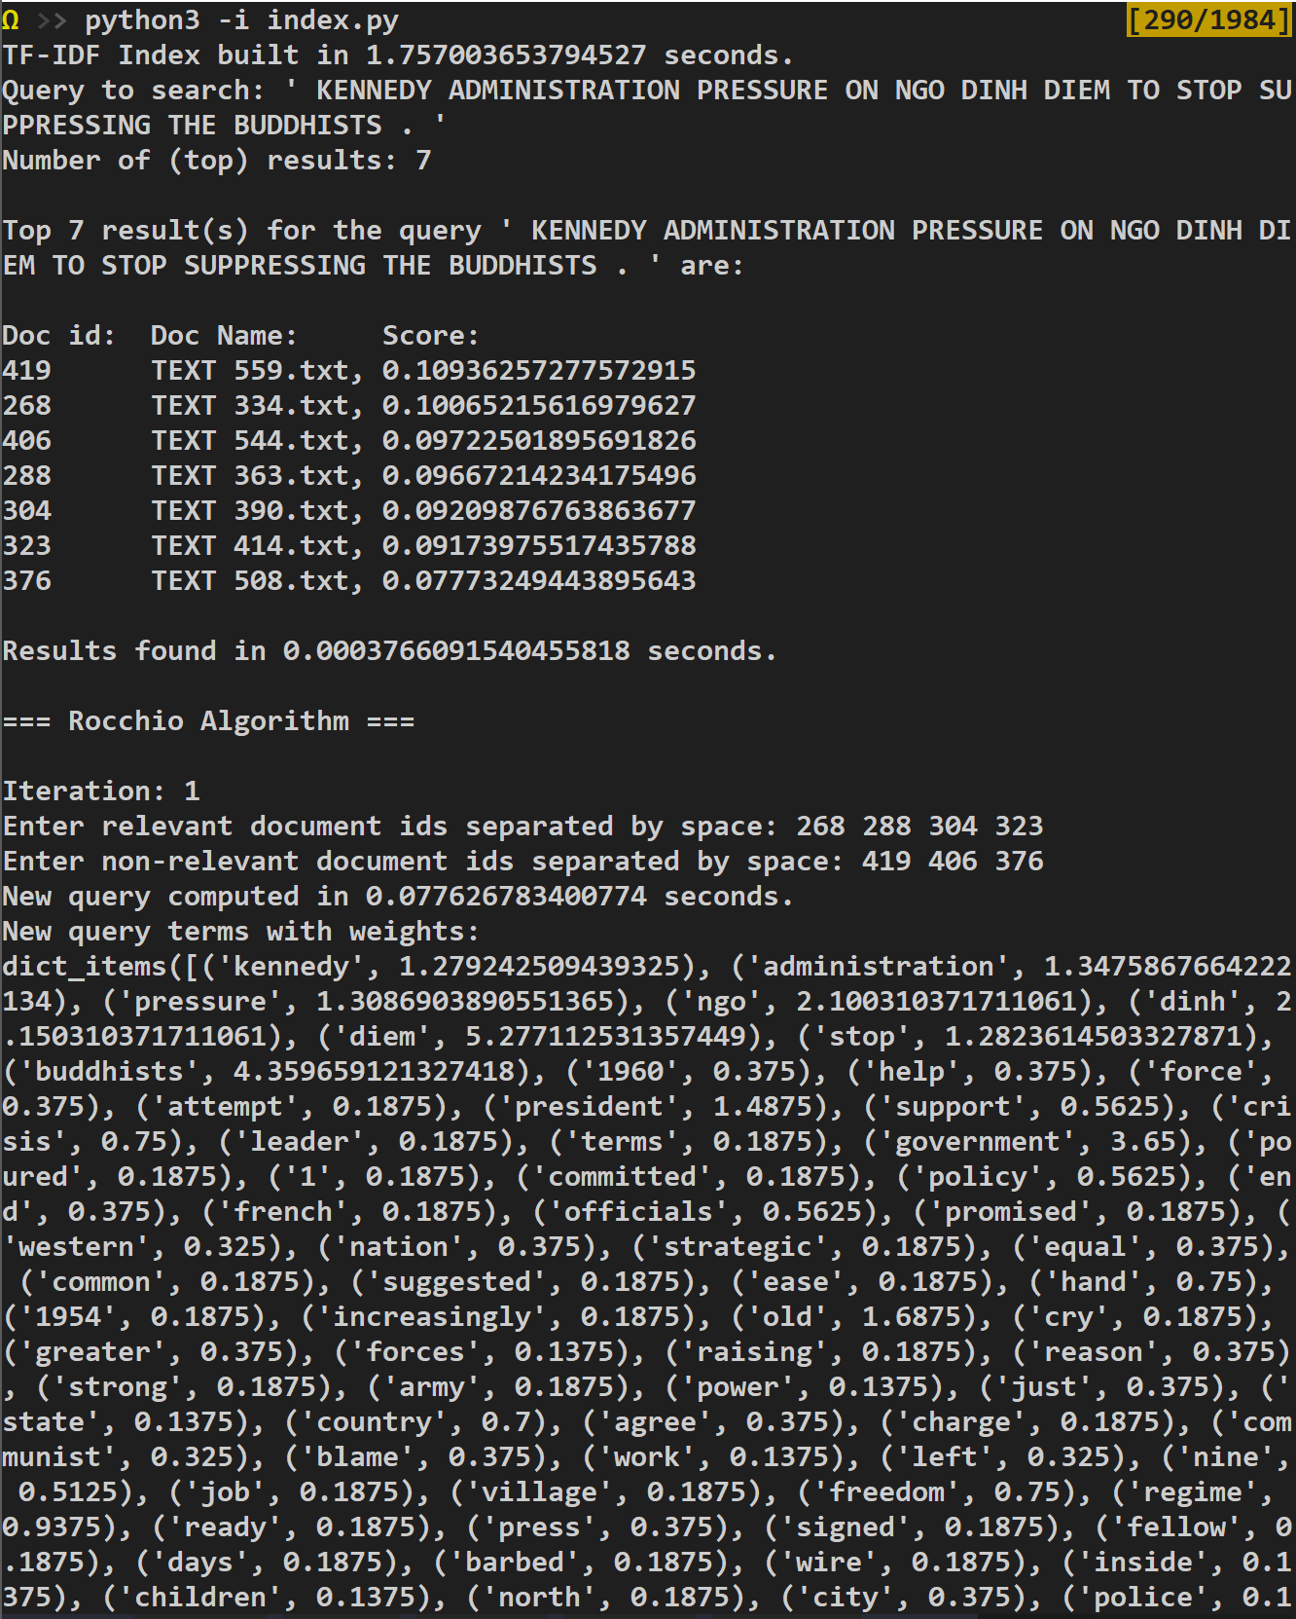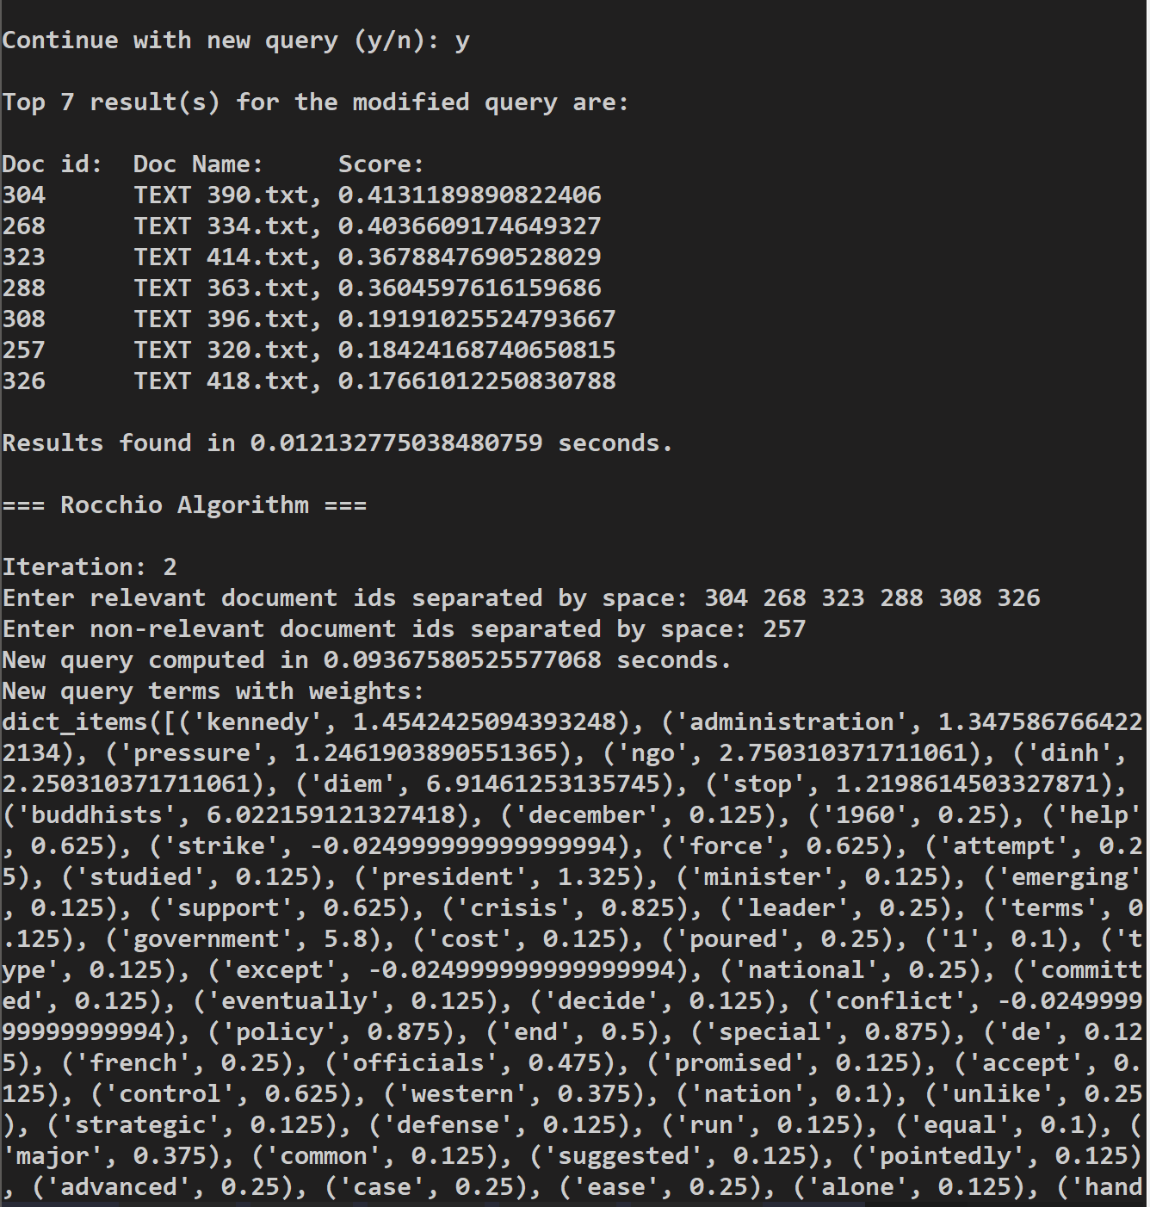We see that after 2 rounds of feedback, we get all relevant documents.

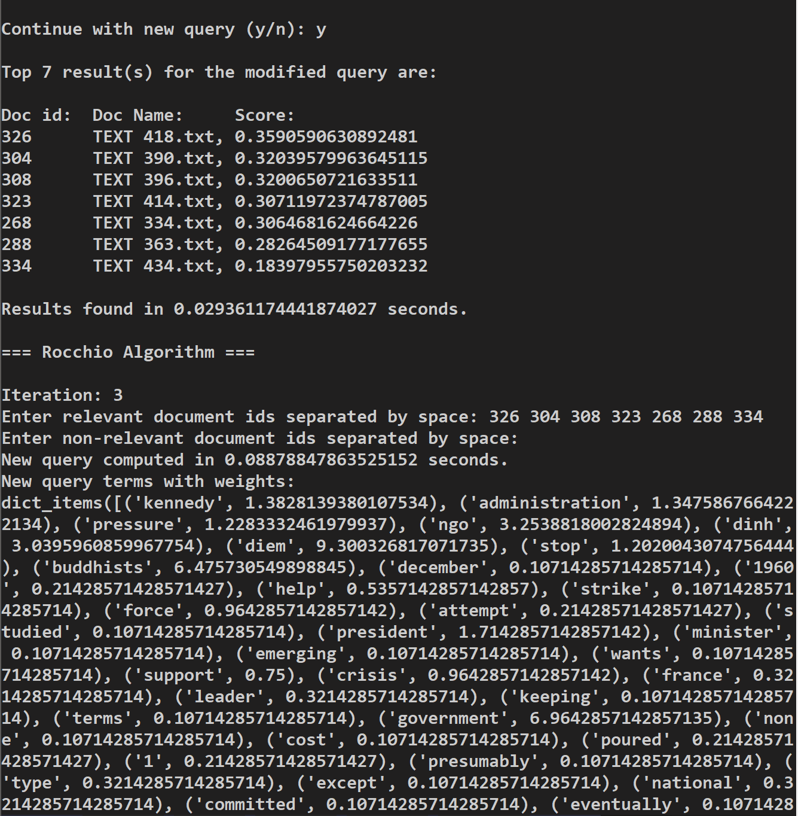After this, the feedback was the same so the modified query was the same.

**Query 2:**

Query text: “ ELECTION OF PARK CHUNG HEE AS PRESIDENT OF SOUTH KOREA . “



MAP = (.8 + .8 + .8 + .8 + .8) / 5 = .8

We see that despite ruling Document 422 and 419 as non-relevant, we could not produce the last relevant document, number 424.

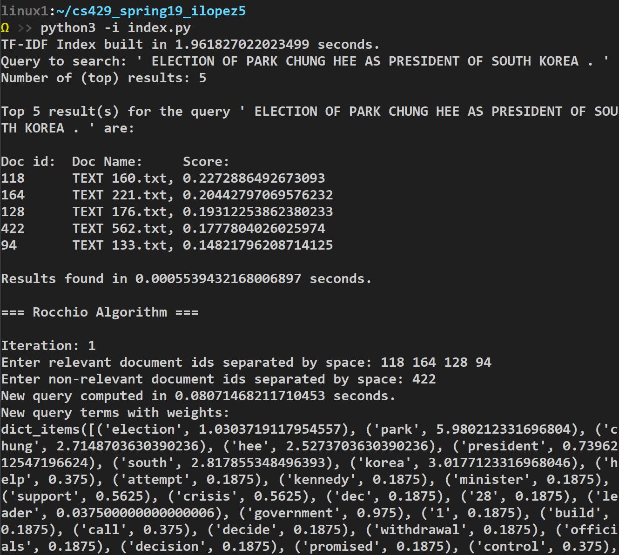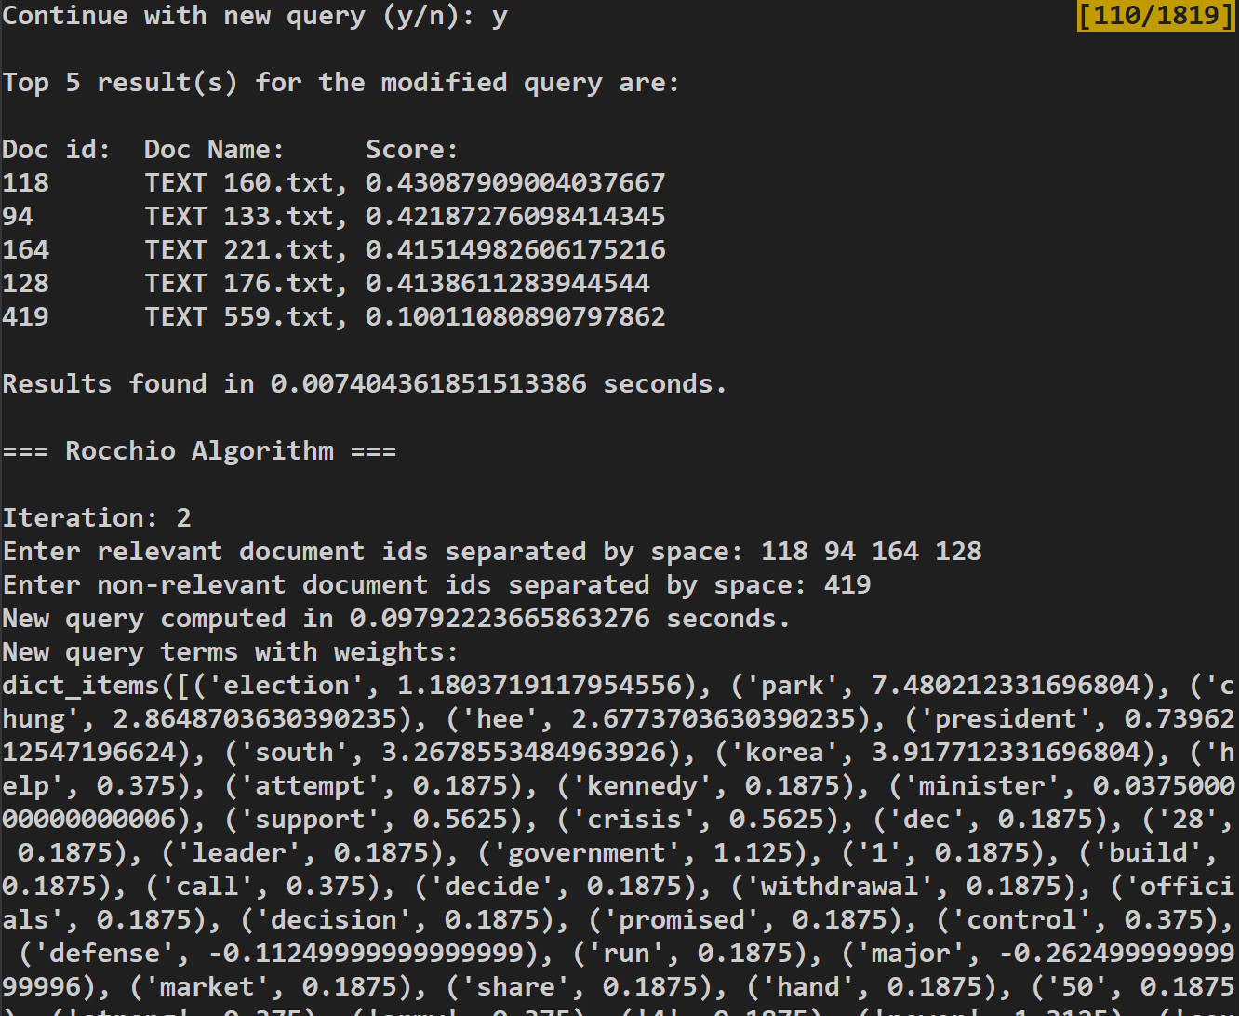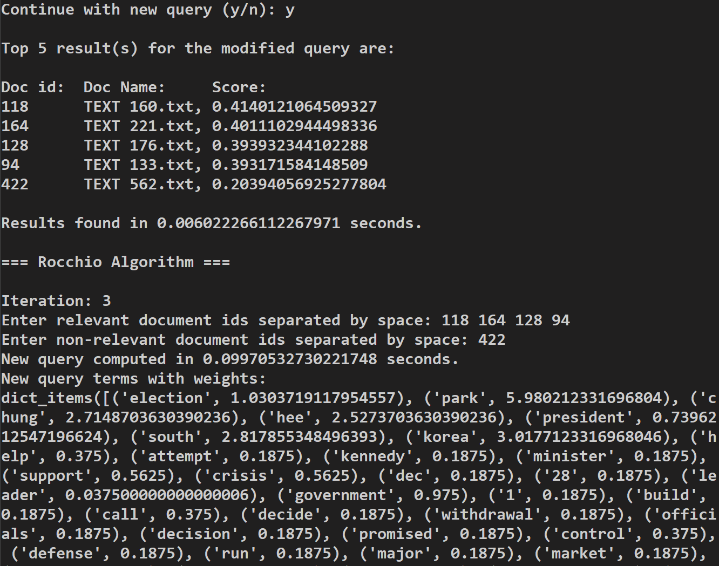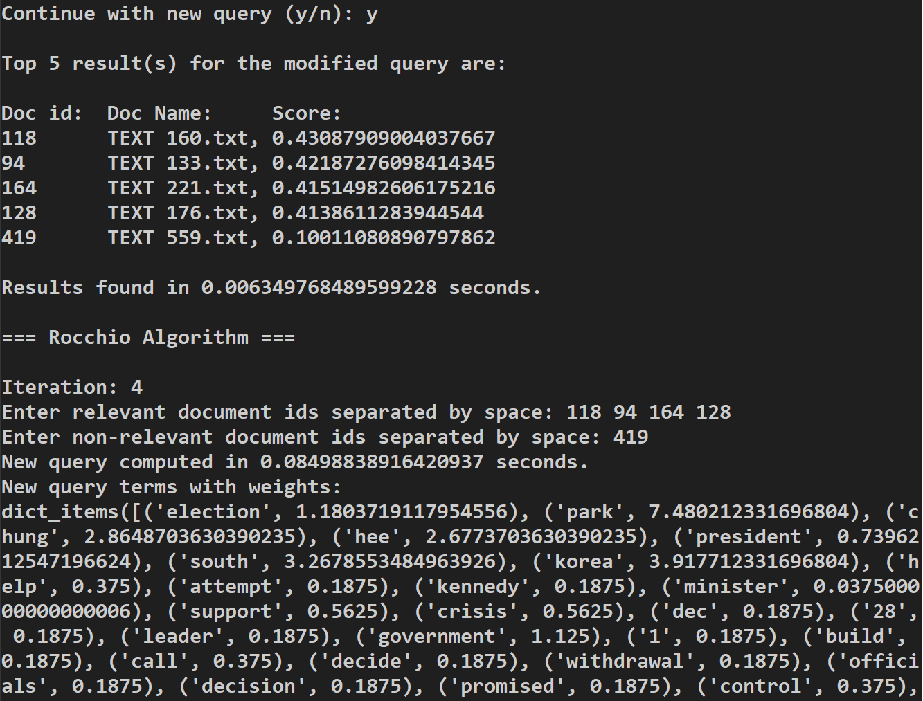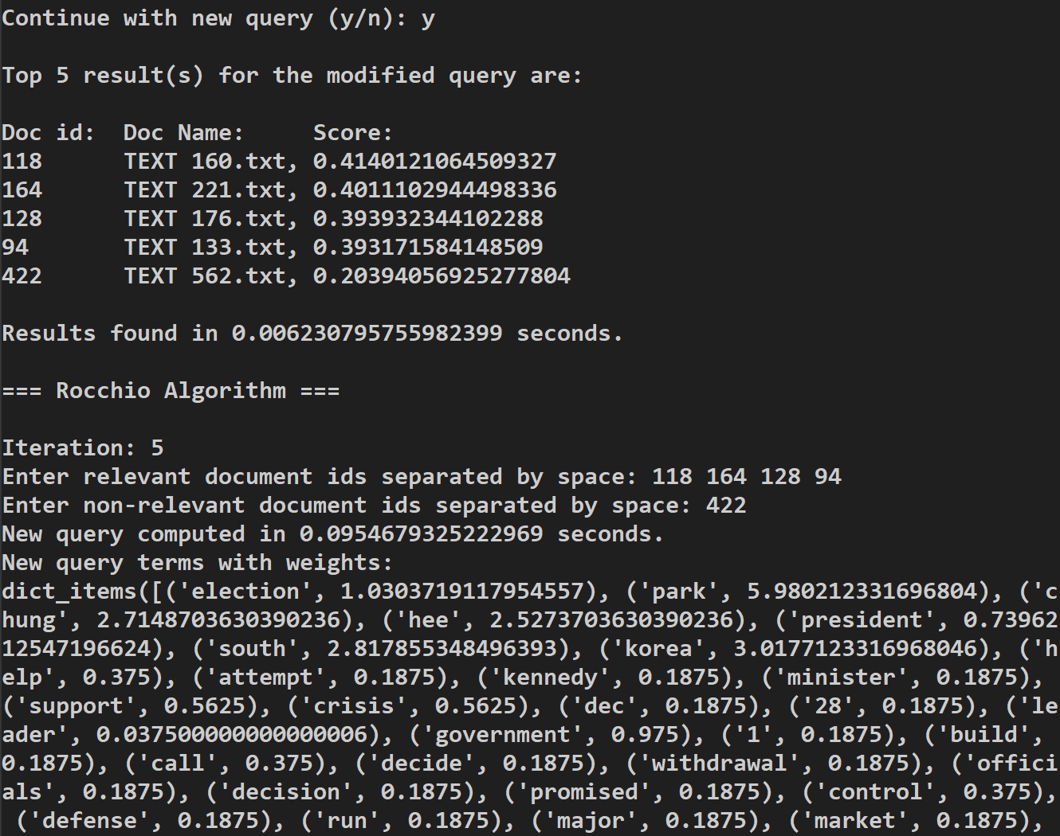

**Query 3:**

Query Text: “AGREEMENT BY THE UNITED ARAB REPUBLIC AND SAUDI ARABIA TO WITHDRAW THEIR FORCES FROM YEMEN, WHICH INVOLVES OBSERVERS FROM THE UNITED NATIONS EXPEDITIONARY FORCE BEING SENT TO YEMEN . “



MAP = (.8 + .9 + .93 + .95 + .96) / 5 = .908

We see that after 2 iterations, we produce all relevant documents.

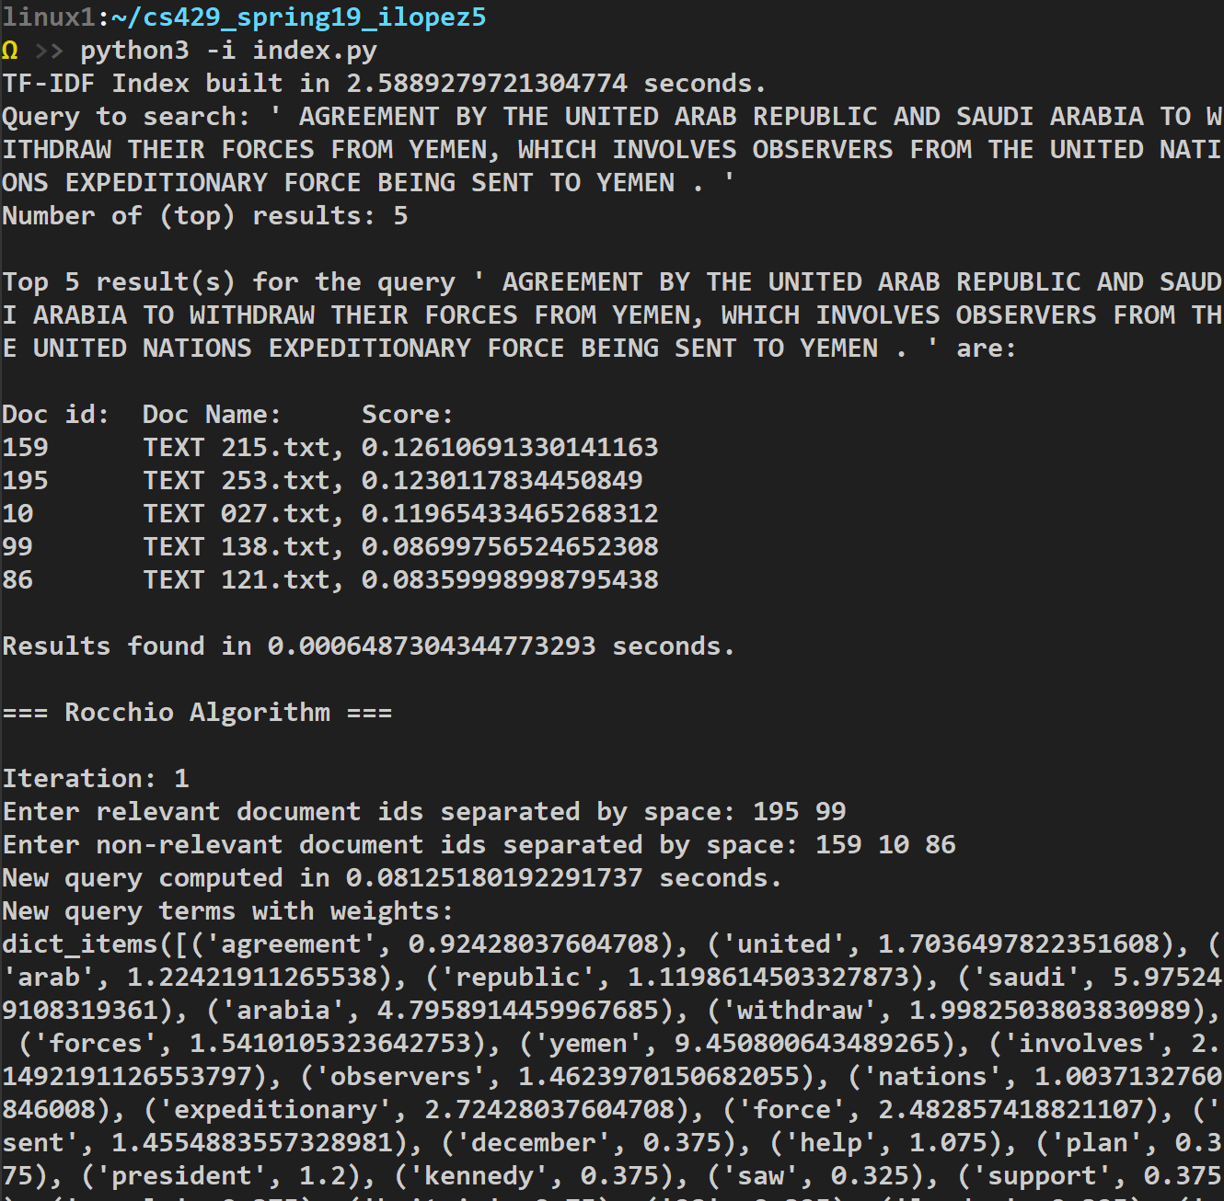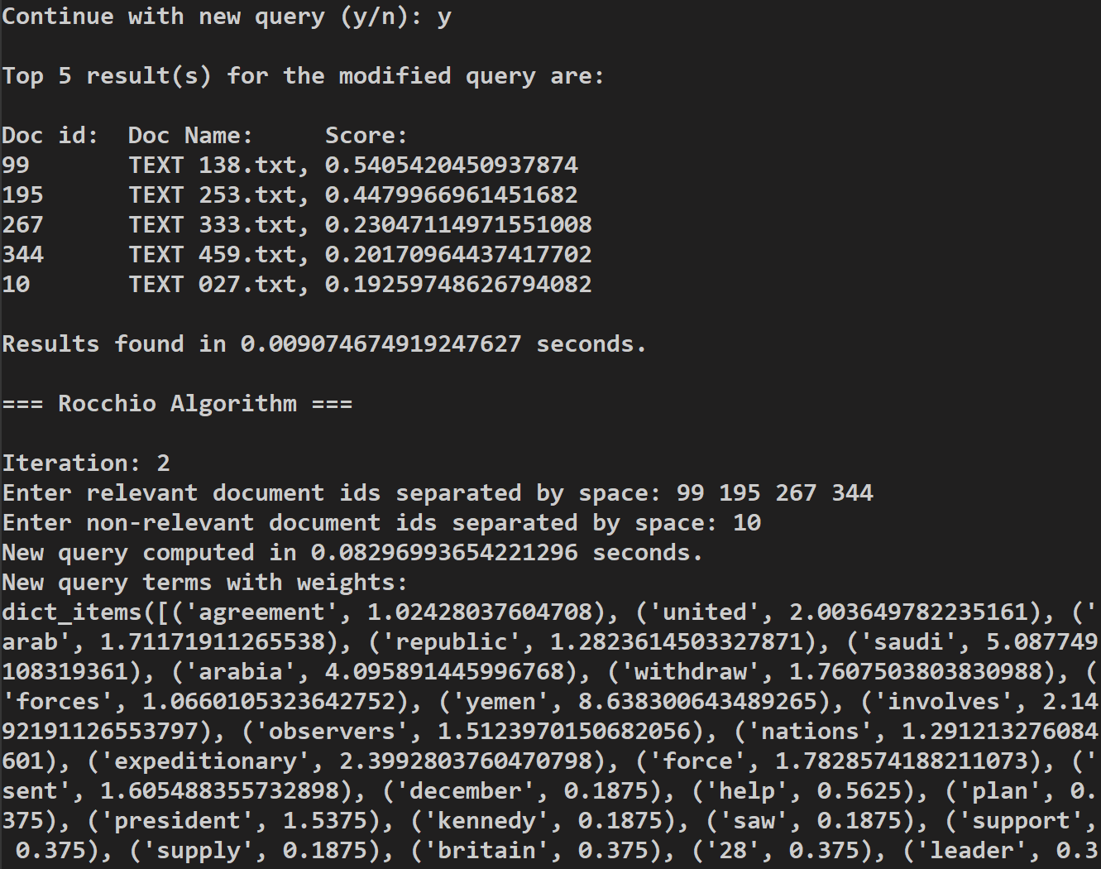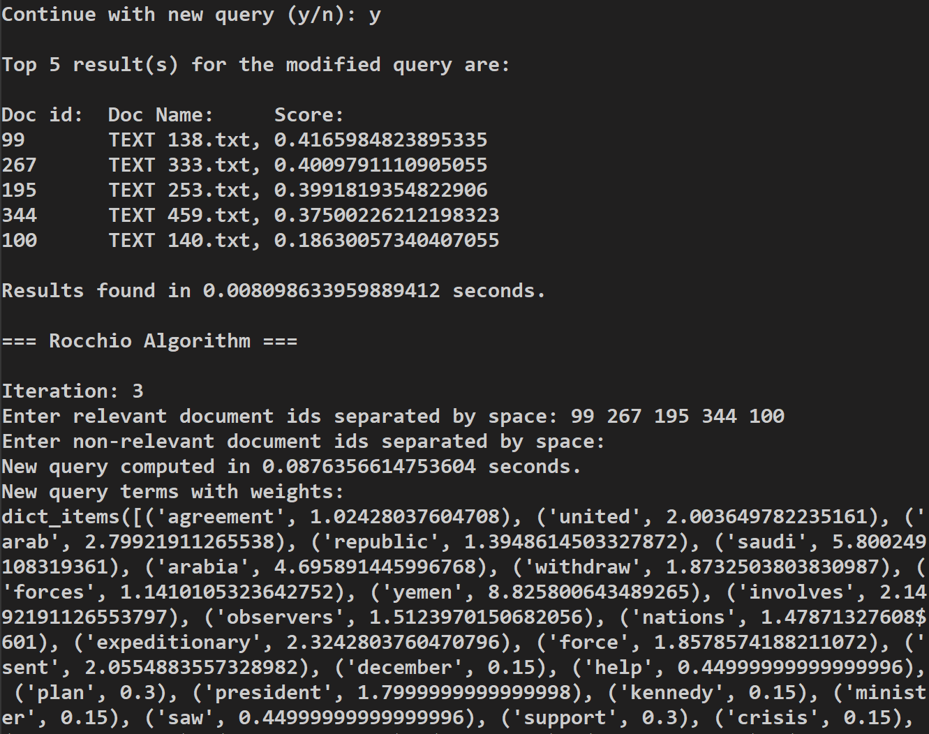 Feedback/Query same after this point

**Pseudo Relevance – Query 15:**



MAP = (.8 * 5) / 5 = .8

Now it seems that there was no inherent change, however, if you observe the scores from Exact Top K vs Rocchio (iteration 1), you will see that there was a change, but it was not enough to score the bottom two documents below the documents below them.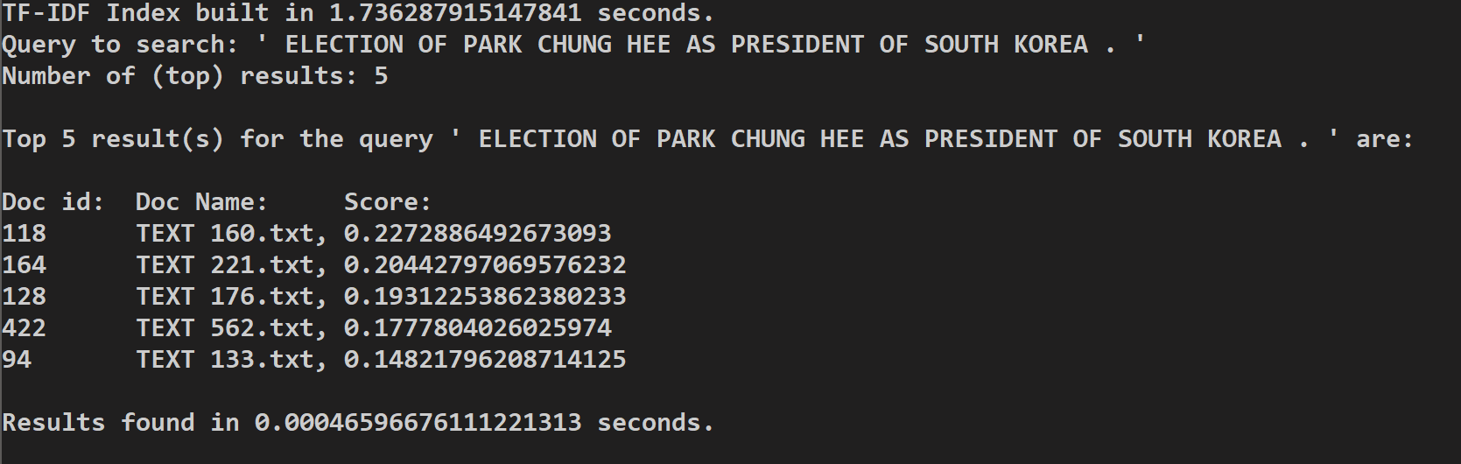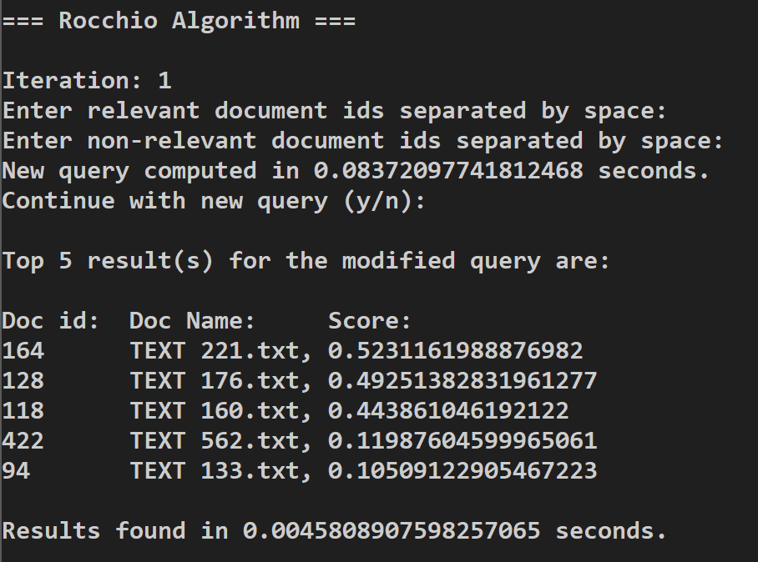

So our Pseudo algorithm of arbitrarily marking the top 3 as *relevant* and the bottom k-3 documents as *nonrelevant* is not as great as we hoped. Consider as well that document 94 is marked as nonrelevant despite being a ‘relevant’ document from our test bed. So this algorithm will work but not well.

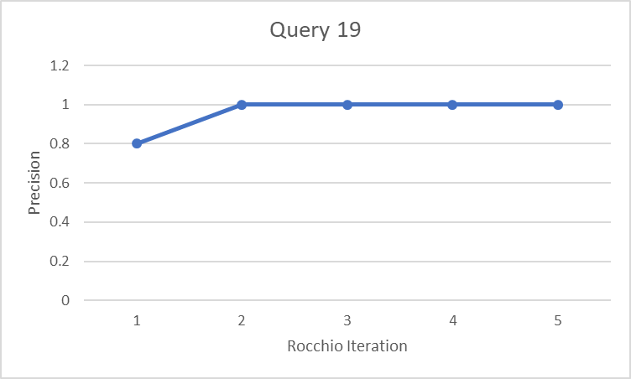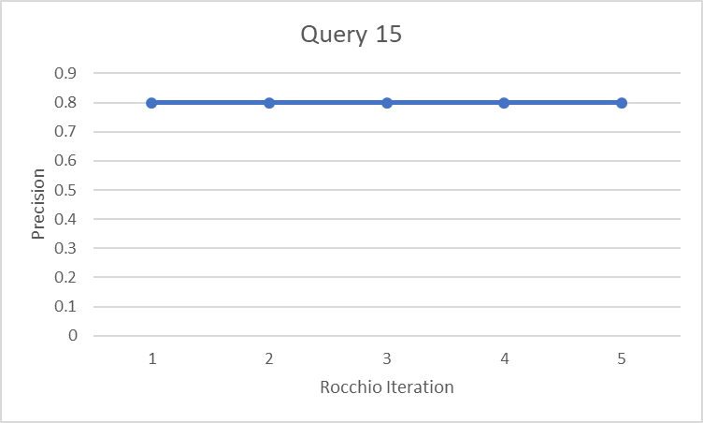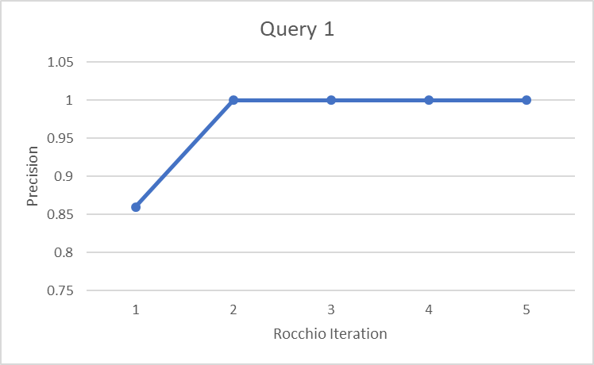Precision Graphs:

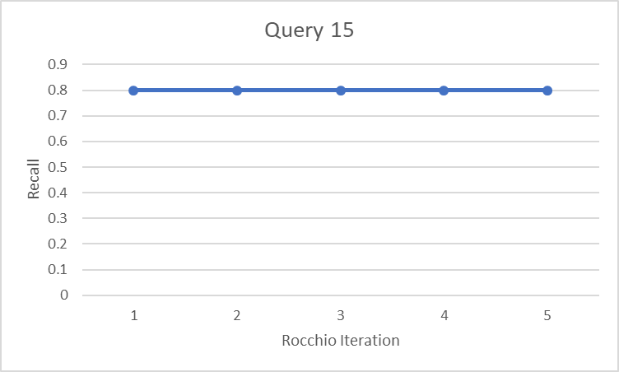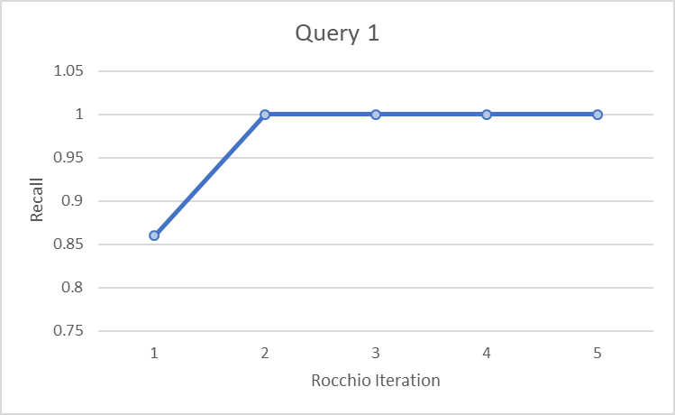Recall:

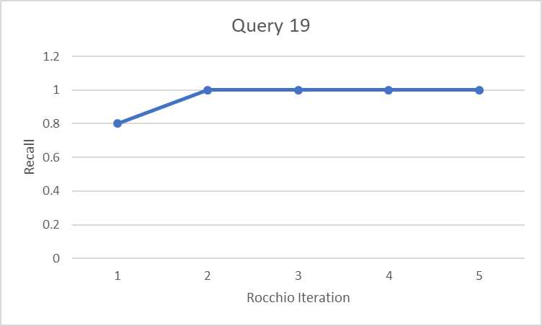

MAP:

