Russians VS Zombies

v1.0, 14/03/2017

Alexey Mukhin, Arseniy Poyezzhayev, Alexander Elizarev, Dmitriy Kapitun, Nikolay Yushkevich

Bravo Team

2017

Table of Contents

Section I - Game Overview 5

Game Concept 5

Genre 5

Target Audience 5

Look and Feel 5

Project Scope 5

Glossary 5

Section II — Gameplay and Mechanics 6

Gameplay 6

Short overview 6

Game Modes 6

Mission Structure 7

Mechanics 8

General Game Mechanics 8

General Actions 8

Combat 8

Economy 10

Global World Mode 10

Short description 10

Objects 11

Actions 12

Local Defence Mode 12

Physics 12

Movement 13

Objects 13

Actions 31

Side Missions 33

Screen Flow 34

Screen Flow Chart 34

Game Options 38

Replaying and Saving 38

Section III – Story, Setting and Character 39

Story and Narrative 39

Backstory 39

Game Progression 40

Game World 40

General look and feel of world 40

Characters 40

Dmitrii Ivanov 40

Garry Mason 41

Plot elements 41

Section IV – Levels 42

1st level 42

Mission #1 42

Mission #2 42

Mission #3 42

Mission #4-5 42

2nd level 42

Mission #1 42

Mission #2 42

Mission #3 43

Mission #4 43

Mission #5 43

3rd level 43

Mission #1 43

Mission #2-5 43

4th level 43

Mission #1 43

Mission #2 43

Mission #3 43

Mission #4 43

Mission #5 44

5th level 44

Mission #1 44

Mission #2 44

Mission #3 44

Mission #4 44

Mission #5 44

6th level 44

Mission #1-5 44

7th - … level 44

Section V - Interface 45

Visual System 45

HUD - What controls 45

Menus 45

Rendering System 45

Camera 45

Lighting Models 45

Control System 45

Audio 45

Music 46

Section VI – Technical 47

Target Hardware 47

Development hardware and software 47

Game Engine 47

Network 47

Scripting Language 47

Section VIII - Management 48

Detailed Schedule 48

Section IX - Lenses 49

Lens 31 - The Lens of Action 49

Lens 41 - The lens of Skill vs Chance 50

Lens 55 - The Lens of Visible Progress 50

Lens 100 - The Lens of Love 51

Lens 94 - The Lens of Atmosphere 53

Lens 68 - The Lens of Moments 53

# 

# 

# Section I - Game Overview

## Game Concept

Russians VS Zombies — tower defence game, that tells a player the story of evil person trying to make all living creatures on the planet become zombies, but facing with russian village Kukuevo, which successfully repels his attacks by throwing vodka in zombies.

## Genre

Tower Defence

## Target Audience

Casual russian gamers

## Look and Feel

We are inspired by the look and feel of flash games (“Happy Farmer”, similar to “FarmVille” in Facebook), russian cartoons ([The Three Bogatyrs](https://en.wikipedia.org/wiki/The_Three_Bogatyrs)), casual tower defence games such as “Zombie VS Plants”. Also, we are inspired by the style of [Tipping Point](https://joegrainger.itch.io/tippingpoint) and [Rok](https://stitchgames.itch.io/rok). We identify the style as low poly, our game world is isometric (is in so-called 2.5 dimensions).

## Project Scope

The project is limited by time (3 month) and art assets (we have no designers in our team). Regarding that, we plan to deliver a final artifact in form of MVP — minimum viable product. That is, the number of levels is limited to the first one, the assets may change due to the fact that we depend on external game designer, who might deliver assets later than expected.

We are to create and deliver in game at least following art assets:

* One enemy asset (basic zombie)
* One tower
* A map of one location for first levels

This doesn’t mean however that it would influence game mechanics proposed in the section of this document.

## Glossary

* Level - a chapter in the storyline of the game. Levels are presented in the Campaign mode of the game.
* Mission — is a subdivision of the level which is played on the certain location or is represented with a mini-game. Every mission has its description, rewards and technologies that are available after accomplishment.
* Global World Mode (GWM) - is one of the modes in the game when the player makes strategic actions, chooses locations and minigames.
* Local Defence Mode (LDM) - is one of the modes in the game. It is played on the certain location and has a classical tower defence mechanics.
* Location - area where the tower defence takes place. In our case we have 8 locations.
* The Village - central object of the Game World. That could be developed by the player.
* Wave - a zombie set where one zombie comes after another which player has to eliminate
* Tower - a defencive unit which player can put on the map in order to protect the village. This unit can attack zombies.
* Trap - a defencive unit which player can place on the road.
* Buff - special enhancement or improvement of the unit. Can be temporary or permanent.
* Debuff - special effect on the unit that degrades some its characteristics.
* Garrison - the towers which appears on the map before level starts.
* Ultimate ability - very powerful ability that can be applied by the player once a mission.

# Section II — Gameplay and Mechanics

## Gameplay

### Short overview

The game is built around the conflict of villagers and citizen “zombies”. Zombies attack the Village and the player should protect it from them. It is a classic tower defence with some strategical elements in Campaign mode.

Objectives

To win the mission player must kill all the zombies on game map before they destroy the Village. He builds towers and traps to prevent zombies from reaching the Village entrance.

### Game Modes

The game has 4 different modes. Campaign is a primary mode and 3 additional modes for fun: Survival, Tower attack and 1VS1.

#### Campaign

Campaign has a storyline, which evolves during game process. The game gradually introduces all the concepts and mechanics’ features of the game with help of virtual assistant (one of the game characters). With the plot development, player gets previously unavailable powerful towers and traps, novel technologies and learns new strategical features. At the same time enemies become stronger too. Attacks of zombies are connected with storyline events. The Village can be upgraded during the Campaign that gives additional bonuses in missions.

Primary missions promotes the player through the game story. After ending them the game story finishes and only side missions become available.

#### Survival

It is a game mode for competing with other players. It has no any restrictions on available towers and upgrades. It is organized as infinite sequence of enhancing waves of zombies. The goal is to survive as many waves as you can. The results are recorded into score table and are compared with other players. Survival mode doesn’t consider upgrade bonuses of player’s Village.

#### Tower attack

[TDB]

#### 1VS1

[TDB]

In following chapters, all the information is related to Campaign mode by default. Special cases of other modes are described in Game Options chapter.

### Mission Structure

#### Storyline

A primary storyline mission may start with cutscene, where the changes of the surrounding game world are described.

After this a player chooses one of eight locations - surroundings of the Village.

Then, chosen location is loaded. The player must prevent zombies from entering the village. He builds “towers” that could attack zombies that come close to them. Every tower costs different amount and type of resources, therefore the player decides what types of towers to build. If the strategy is successful all zombies will die while moving through rows of towers.

Every mission is divided to rounds - “waves”. After surviving the wave player has some time to restore and build new towers. A mission starts with weak enemies, during the flow of the game enemy units become stronger. The level ends with final wave of the most powerful monsters or with boss.

#### Side mission

A side mission are represented with question marks on the map. When he taps on it, he can see the additional information about the mission: story (if present), detailed objectives and description, rewards. If player accepts the mission, it goes to certain mini-game or location. After finishing the mission player gets reward or penalty.

## Mechanics

### General Game Mechanics

The game consists of two interconnected modes: global world and local defence mode. In the global world mode (GWM) a player should perform strategic actions and specify locations where he wants to play the local defence mode (LDM). Besides, he could enter the Village or find side missions in this mode. LDM has classical tower defence mechanics. It is responsible for protection of the specific areas. Missions of the game includes actions in both modes.

### General Actions

Actions are the way of interaction of the player with game world. They are performed, by tapping and sliding on the screen. There are several modes in the game, therefore actions related to the specific game mode are described in chapters devoted to the mode’s description.

* Progress bar is used in actions with long duration. It displays the current status of the action time progress. Commonly it is shown below the icon of the action or below a unit (if it’s action on the unit).

##### Cancel the action

If the player entered some action he could tap on the place on the screen that is not related to this action (icon, highlighted objects or window with options) and cancel the action execution. State of the object will return to its previous value.

If the action was unit action than the player can touch the unit and icon of cancellation arises. Player touching it denies the started action.

### Combat

Each tower has its range of attack and type, which determines which zombies the tower can attack. Besides towers there are traps, that are located on the roads, they activates when zombie treads on it.

Each game mission is divided to short rounds - waves. Every wave of zombie starts with spawning. Spawn spots are on the beginnings of the roads to the Village (paths of zombies).

After spawning zombies move towards the entrance of the Village. If zombie reaches it than population decreases on 1. Enemy units have hit points that are decreasing on every attack of the tower. The player gets resources from killing zombies.

#### Attack types

1. Standard (STA) - basic attack that deals damage only to one target
2. Splash (SA) - deals 100% damage to primary target and partial damage to targets within some range of primary target
3. Piercing (PA) - upon collision with its primary target deals 100% damage and then goes directly through it without changing its trajectory for some range and deals partial damage to targets upon its way
4. Chain (CA) - deals less damage than standard attack but will bounce to the closest target within some range for a number of times.
5. Splitting multi-target (MTA) - deals damage to all units in range of attack. Number of projectiles is equal to number of units.

All attack stats depend on tower type and level of upgrade. Not all attacks can reach flying units (just with label ANY)

#### Buffs

Has 3 characteristics: increased property, amount of gain, visual effect

##### Towers

1. Increase attack speed - attack speed, 30%, glow red
2. Increase attack damage - attack damage, 25%, become bigger
3. Attacks slow enemy - zombie movement speed decrease, 30%, glow violet
4. Battle fury - attacks damage and attack speed, 50% and 100%, orange furious aura

##### Zombies

1. Increase movement speed - movement speed, 30%, have lightnings coming from their feet
2. Increase evasion chance - probability to be hit decrease, 40%, become transparent

#### Debuffs

Has 3 characteristics: affected property, amount of affect, visual effect

##### Towers

1. Decrease tower accuracy - tower accuracy, 20%, clouds around the tower
2. Disable tower - tower functioning, 100%, humane towers become sleepy and other towers look abandoned

##### Zombies

1. Decrease movement speed - movement speed, 30%, have violet aura
2. Suffocation - zombie functioning, 100%, stand still and suffocate (grasping throat, trying to breath). Affected zombie stands still and losses all buffs
3. Poison - additional damage per second + movement speed, ?, have swamp green clouds around. Affected zombie gets additional damage per second and decreased movement speed + infects nearby zombies (?)
4. Burn - additional damage per second + movement speed, ?, burn. Affected zombie gets additional damage per second and increased movement speed + damages nearby zombies
5. Oiled - может быть подожжен
6. Radioactive - теряет здоровье со временем (с ускорением), зеленый

### Economy

Economical model of the game is quite simple, it has only 2 resource types and different bonuses (enhancements for towers or for the Village as a whole). Resources are spent on buying and upgrading towers/traps, upgrading the Village.

#### Resources

The Village has 2 resources – villagers and rubles.

* Villagers are used when a tower or a trap is bought. Besides, villagers represent health bar of the Village, when the number of villagers reaches zero game is over. A player can increase his number of villagers by natural population growth or by accomplishing missions. The number of villagers will decrease whenever zombie reaches the Village. One zombie kills one villager. A player can not use all villagers for building, there is a limit of 40 villagers to stay at the village (untouchable reserve).
* Rubles are used for buying towers, traps and upgrades. Rubles are earned by killing zombies. Amount of rubles earned depends on type of a zombie.

Resources can be awarded to player for finishing mission.

There are also 3 types of additional resources required for towers construction:

* Vodka - used to build vodka-dependent towers
* Water - used to build water-dependent towers
* Oil - used to build oil-dependent towers

These resources can be obtained by building special resource towers which do require coins and villagers.

Each tower require different amount of resources. If tower is removed, then the resources it used are returned in the available resources pool

There is one more.

* Garrison - another strategic resource. It consists of towers and traps that stays at certain location after mission is complete. If there is a mission on the same location (that has garrison) then player will have advantage. The garrison provides free initial units (not requiring resources) for the player. He just has to arrange the garrison on the map. Moreover they save all bonuses and upgrades gained in previous missions. After each mission player should decide which towers and traps will stay at the location. He can not retain all the towers there because every tower requires villagers for building, which are taken from the whole Village pool.

Rubles and villagers are common for the whole Village. It means that if we get gold in location 1, we can spend it after in location 5. And if number of villagers decreased when we were on location 9, we can not maintain the garrison of 20 towers in location 2.

## Global World Mode

### Short description

It is represented as a map with the Village in the center and 8 locations - surrounding areas. In the global view player must select the certain location to protect. The Village is attacked from several directions by different groups of zombies. Therefore player should decide where his direct participation is necessary, while other regions will defend automatically (by calculating balance of armies in the region with slight randomization).

Besides main areas there are 3 additional locations: Bridge, Life Road and Warehouses. Side missions are generated randomly beth primary storyline missions. Player could choose them when they are generated. Side missions are not compulsory to finish.They give the player extra bonuses, resources or technologies.

On the map, missions are represented as small icons of zombie (protect the Village) or question mark (side mission).

After selecting specific location game goes to local defence mode.

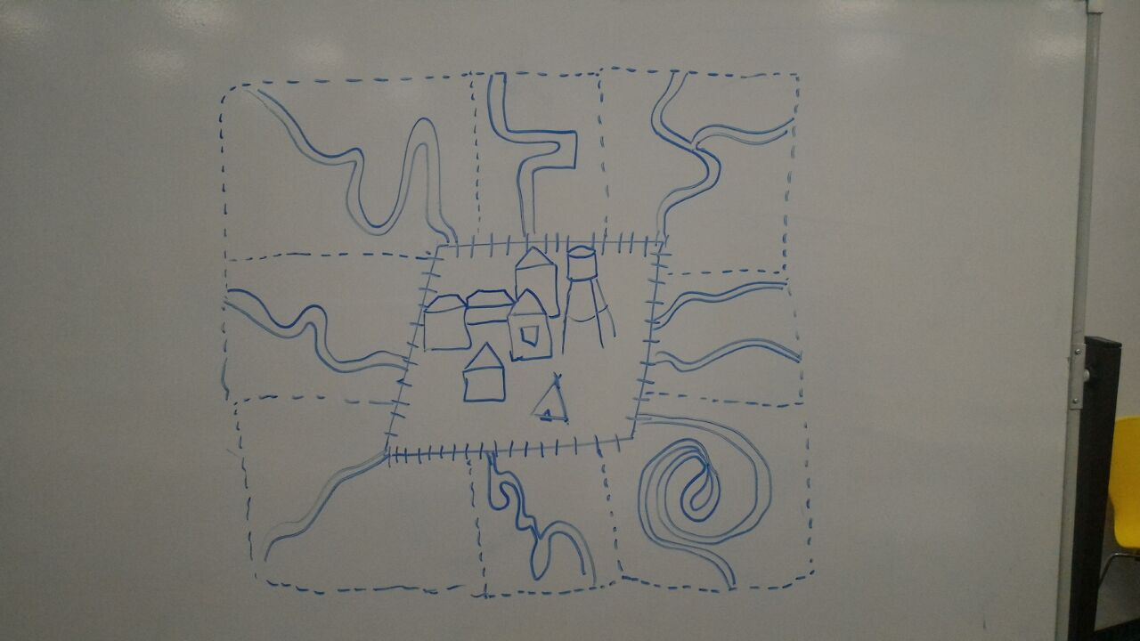

### Objects

#### The Village

The Village is a central region of the game world. It has 8 entrances from 8 locations near it. It could grow or decrease with changes in population. There are houses, church, windmill, forge, square and wall. The Village is not a playable location (can not enter LDM) however it could be upgraded by the player.

#### Zombie mark

Zombie mark on the map means that there is a group of zombies. It could be of different size according to the size of group.

#### Question mark

Question mark represents side mission on the map.

### Actions

#### General actions

##### Investigate

This action investigates the mark. It shows detailed information about the group of zombies or side mission.

1. Player taps on the mark
2. A window with detailed information popups. There are two options in the popup: “accept” and “decline”
   1. If player chooses “accept” game goes to local defence mode or to minigame of side mission
   2. If player chooses “decline” game returns to the map

## Local Defence Mode

The game enters Local Defence Mode (LDM) when a player has chosen the certain location. It’s a tower defence mode. The map size is restricted to one location.

Zombies attack the village. They move along the road through rows of towers and traps. Zombies start their route from spawn spots which are predefined and end with entrance of the Village. If they reach the Village then a player loses population (decrease by one). If population reaches zero then player loses. Zombies are spawned in groups which have name waves. After each wave, a player has some intermission to think and to build new towers.

A player has some initial amount of resources and towers on the location. He has to build towers and traps on the zombies’ route to prevent them from entering the Village. Towers and traps are protective units that kill zombies by different ways.

Every LDM session has 3 stages:

1. **Arrange garrison** - disposition of the garrison towers. They don’t cost any resource, but their number and types are limited. Garrison’s size depends on tactical decisions of the player (described later in garrison chapter). It has no time limits and ends with clicking the “Ready!” button.
2. **Defence** - the main part of the game. During defence stage player should build and upgrade tower/traps and withstand zombies in real-time (without tactical pauses). Player must survive all the waves of the mission. Each wave starts with sound signal. The defence stage ends with last zombie on the map.
3. **Retain garrison** - choose towers and traps that will stay at the location. Player should remove all other towers with “remove” action, he will get resources back. Stage has no time limits and ends with clicking the “Ready!” button.

### Physics

The LDM has primitive physics and collision system.

* Projectile is a separate unit, that follows the target until it reach it.
* The collision system is required for calculating the tower’s projectiles collisions with zombies and among zombies themselves. Boundary boxes are used for calculating collisions with units. Boundary boxes have slightly smaller size than actual size of unit to neglect sticking out limbs.

### Movement

#### Zombies

There are 2 categories of enemy units: flying and ground. Flying units can not be attacked by land-attack-towers and don’t activate traps. Enemies move by predefined paths.

All types of enemy units move with different constant speeds. Predefined paths for zombies are generated before mission start. Zombies appear at several spawn-points on the map and move towards the Village entrance by these paths.

Optional - replace predefined paths with shortest path real-time calculation. Then one could extend the tactical side of the game (paths for zombies will be formed by natural obstacles and built towers).

### Objects

#### Resource Tower

Resource tower - basic resource collector unit. It has type of resource and amount. It is necessary for building towers.

1. Oil derrick - mines oil (10)
2. Alcohol machine - produces vodka (10)
3. Well - mines water (10)

#### Towers

Tower - basic defensive unit that may have different attack types, amount and attack range. Tower could be upgraded to different towers according to the hierarchy (t.1).

They could be built everywhere on the map except paths and natural obstacles (rocks, lakes etc.). Towers remain at the position where they were built during the game.

##### Table of upgrades:

Abbreviation used in following tables: p - person, r - rubles, v - vodka, w - water, o -oil, ST - single target, MT - multiple targets, SA - splash attack, PA - piercing attack, CA - chain attack. Types of attack: Land - only land units, Any - land and flying units. Projectile represents the model of projectile used for the certain tower’s attack. Attack speed means number of seconds required to finish one attack.

###### T1 - basic towers

* **Muzhik - basic STA tower with medium range.**

|  |  |
| --- | --- |
| Cost | 1 p, 1v, 2sec |
| Attack | 3 |
| Attack speed | 1 |
| Attack range | 600 |
| Attack type | ST, Any |
| Projectile | Vodka |

Upgrades: “Mighty muzhik”

* **Woman with bucket - basic MTA tower with medium range.**

|  |  |
| --- | --- |
| Cost | 1 p, 3w, 2sec |
| Attack | 2 |
| Attack speed | 1.5 |
| Attack range | 400 |
| Attack type | MT, Land |
| Projectile | Water splash |
| Abilities | Slow (attack has 20% chance to apply slow debuff on enemy) |

Upgrades: Woman with buckets

* **Windmill - basic PA tower with long range.**

|  |  |
| --- | --- |
| Cost | 3 p, 2v, 10r, 5sec |
| Attack | 12 |
| Attack speed | 3 |
| Attack range | 600 (1200) |
| Attack type | PA, Land |
| Projectile | Grain |

Upgrades: Stone windmill

* **Hunter - basic ST tower with long range.**

|  |  |
| --- | --- |
| Cost | 1p, 1v, 3r, 3sec |
| Attack | 10 |
| Attack speed | 2 |
| Attack range | 1200 |
| Attack type | ST, Any |
| Projectile | Bullet |
| Abilities | Headshot (attack has 30% chance to make 2x damage) |

Upgrades: Hunter with double-barreled gun OR Trap Setter

* **Little football player - basic CA tower with medium range.**

|  |  |
| --- | --- |
| Cost | 1p, 1v, 1w, 2sec |
| Attack | 3 |
| Attack speed | 2 |
| Attack range | 400 |
| Attack type | CA, Land |
| Projectile | Soccer ball |
| Abilities | Miss, oops! - tower has 50% chance to miss the target (no damage to primary target and chain isn’t initialized in case of miss) |

Upgrades: Football player

* **Uncle Vanya - basic SA tower with medium range.**

Rustic technocrate. He sits on the stool near his mechanism and sets up it. The mechanism is an air gun which fires cabbages.

|  |  |
| --- | --- |
| Cost | 1p, 1v, 1w, 5r, 2sec |
| Attack | 10 |
| Attack speed | 3 |
| Attack range | 800 |
| Attack type | SA, Land |
| Projectile | Cabbage |

Upgrades: Tractor

* **Misha (bear) - basic MT tower with melee attack.**

|  |  |
| --- | --- |
| Cost | 1p, 1v, 1w, 2sec |
| Attack | 5 |
| Attack speed | 3 |
| Attack range | 200 |
| Attack type | MT, Land |

Upgrades: Mikhail

###### T2 - 2nd level upgrade of basic towers:

* **Mighty muzhik - T2 STA tower with medium range.**

|  |  |
| --- | --- |
| Cost | 5v, 2sec |
| Attack | 5 |
| Attack speed | 0.8 |
| Attack range | 600 |
| Attack type | ST, Any |
| Projectile | Vodka |

Upgrades: “Muzhik on barrel”

* **Smart muzhik - T2 tower with ability to enhance nearest units.**

|  |  |
| --- | --- |
| Cost | 2v, 2w, 10r, 2sec |
| Attack | 2 |
| Attack speed | 1 |
| Attack range | 600 |
| Attack type | ST, Any |
| Projectile | Vodka |
| Abilities | Leadership - increase attack speed on 30% of the nearest towers in range 600. |

Upgrades: “Head of the Village”

* **Woman with buckets - T2 MTA tower with medium range.**

Woman has 2 buckets on a rocker on her shoulders.

|  |  |
| --- | --- |
| Cost | 1 p, 3w, 2sec |
| Attack | 2 |
| Attack speed | 1.5 |
| Attack range | 400 |
| Attack type | MT, Land |
| Projectile | Water splash |
| Abilities | Slow (attack has 30% chance to apply slow debuff on enemy) |

Upgrades: “Woman with oil” OR “Woman with Samovar”

* **Stone Windmill - T2 PA tower with long range.**

|  |  |
| --- | --- |
| Cost | 3 p, 2v, 10r, 5sec |
| Attack | 25 |
| Attack speed | 2 |
| Attack range | 600 (1200) |
| Attack type | PA, Land |
| Projectile | Grain |

Upgrades: Defensive tower

* **Hunter with double-barreled gun - T2 ST tower with long range.**

|  |  |
| --- | --- |
| Cost | 5v, 3r, 3sec |
| Attack | 10 |
| Attack speed | 2 |
| Attack range | 1200 |
| Attack type | ST, Any |
| Projectile | Bullet |
| Abilities | * Headshot (attack has 30% chance to make 2x damage) * Double attack (every time the hunter attacks he makes two shots) |

Upgrades: Hunter with double-barreled long gun

* **Hunter with trap - T2 ST tower with long range.**

|  |  |
| --- | --- |
| Cost | 5v, 5r, 3sec |
| Attack | 10 |
| Attack speed | 2 |
| Attack range | 1200 |
| Attack type | ST, Any |
| Projectile | Bullet |
| Abilities | * Headshot (attack has 30% chance to make 2x damage) * Set a trap - every 3 attacks hunter randomly sets a trap on the road, in the range of 600. Trap description is in Traps chapter. If trap is activated all hunters that are in range 1200 from the trap make an extraordinary shot to the target. |

Upgrades: Trap master

* **Football player - T2 CA tower with medium range.**

He has lower chance to miss the primary target.

|  |  |
| --- | --- |
| Cost | 3v, 3w, 2r 2sec |
| Attack | 7 |
| Attack speed | 1.5 |
| Attack range | 400 |
| Attack type | CA, Land |
| Projectile | Soccer ball |
| Abilities | Miss, oops! - tower has 20% chance to miss the target (no damage to primary target and chain isn’t initialized in case of miss) |

Upgrades: Local Karshavin

* **Tractor - T2 SA tower with medium range.**

Tractor fires with cabbages through its exhaust pipe.

|  |  |
| --- | --- |
| Cost | 3v, 1o, 10r, 2sec |
| Attack | 25 |
| Attack speed | 2 |
| Attack range | 800 |
| Attack type | SA, Land |
| Projectile | Black cabbage |
| Abilities | Fume - 20% chance that black cabbage will produce a cloud of smoke on the place of falling. It applies suffocate debuff in range of 300. |

Upgrades: Cannon

* **Mikhail - T2 MT tower with melee attack.**

|  |  |
| --- | --- |
| Cost | 10v, 10w, 2sec |
| Attack | 50 |
| Attack speed | 3 |
| Attack range | 200 |
| Attack type | MT, Land |

Upgrades: Mikhail Ivanovich

###### T3 - 3rd level upgrade of basic towers:

* **Muzhik on barrel - T3 STA tower with medium range.**

|  |  |
| --- | --- |
| Cost | 2v, 2w, 10r, 2sec |
| Attack | 4 |
| Attack speed | 0.9 |
| Attack range | 800 |
| Attack type | ST, Any |
| Projectile | Vodka |

Upgrade: Paratrooper (VDV)

* **Head of the Village - T3 STA tower with medium range.**

|  |  |
| --- | --- |
| Cost | 2v, 2w, 10r, 5sec |
| Attack | 2 |
| Attack speed | 1 |
| Attack range | 600 |
| Attack type | ST, Any |
| Projectile | Vodka |
| Abilities | Leadership - increase attack speed and attack amount of towers in range 600 on 30% |

Upgrade: Yell-cin

* **Woman with oil - T3 MTA tower with medium range.**

|  |  |
| --- | --- |
| Cost | 1 p, 2w, 3o, 6sec |
| Attack | 8 |
| Attack speed | 1.5 |
| Attack range | 400 |
| Attack type | MT, Land |
| Projectile | Oil splash |
| Abilities | Slow and oil (attack has 30% chance to apply slow and oil debuffs on enemy) |

* **Woman with samovar - T3 MTA tower with medium range.**

|  |  |
| --- | --- |
| Cost | 1 p, 10w, 1o, 5r, 2sec |
| Attack | 25 |
| Attack speed | 1 |
| Attack range | 400 |
| Attack type | MT, Land |
| Projectile | Cloud of vapor |
| Abilities | Slow (attack has 30% chance to apply slow debuff on enemy) |

Upgrade: Big Samovar

* **Defensive Tower - shoots with ballista**

|  |  |
| --- | --- |
| Cost | 5v, 5w, 25r, 5sec |
| Attack | 45 |
| Attack speed | 1.7 |
| Attack range | 600 (1200) |
| Attack type | PA, Land |
| Projectile | Bolt |

Upgrade: Red tower

* **Hunter with double-barreled long gun - T3 ST tower with long range.**

|  |  |
| --- | --- |
| Cost | 5v, 10r, 3sec |
| Attack | 25 |
| Attack speed | 2 |
| Attack range | 1400 |
| Attack type | ST, Any |
| Projectile | Bullet |
| Abilities | * Headshot (attack has 30% chance to make 2x damage) |

Upgrade: Sniper

* **Trap master - T3 ST tower with special abilities.**

Number of traps is increased, he has 3 traps.

|  |  |
| --- | --- |
| Cost | 3v, 5r, 10sec |
| Attack | 10 |
| Attack speed | 2 |
| Attack range | 1200 |
| Attack type | ST, Any |
| Projectile | Bullet |
| Abilities | * Headshot (attack has 30% chance to make 2x damage) * Set traps - every attack hunter randomly sets a trap on the road, in the range of 600. Trap description is in Traps chapter. If trap is activated all hunters that are in range 1200 from the trap make an extraordinary shot to the target. Maximum 3 traps. |

* **Local Karshavin - T3 CA tower with medium range**

|  |  |
| --- | --- |
| Cost | 1v, 5w, 50r 2sec |
| Attack | 10 |
| Attack speed | 1.2 |
| Attack range | 600 |
| Attack type | CA, Land |
| Projectile | Soccer ball |

Upgrade: Karhsavin

* **Cannon - T3 SA tower with medium range.**

|  |  |
| --- | --- |
| Cost | 3v, 10o, 20r, 2sec |
| Attack | 50 |
| Attack speed | 2 |
| Attack range | 800 |
| Attack type | SA, Land |
| Projectile | Black ball |
| Abilities | Fume - 20% chance that black ball will produce a cloud of smoke on the place of falling. It applies suffocate debuff in range of 300. |

Upgrade: Missile silo

* **Mikhail Ivanovich - T3 MT tower with low range.**

|  |  |
| --- | --- |
| Cost | 1p, 25v, 25w, 2sec |
| Attack | 100 |
| Attack speed | 2.5 |
| Attack range | 200 |
| Attack type | MT, Land |

Upgrade: Mikhail from North

###### T4 - 4th level upgrade of basic towers:

* **VDV (paratrooper) - T4 STA tower with medium range.**

|  |  |
| --- | --- |
| Cost | 10v, 3w, 15r, 2r, 2sec |
| Attack | 15 |
| Attack speed | 0.5 |
| Attack range | 800 |
| Attack type | ST, Any |
| Projectile | Tracer bullet |

Upgrade: VVP

* **Yell-cin - T4 STA tower with medium range.**

|  |  |
| --- | --- |
| Cost | 25v, 100r, 5sec |
| Attack | 6 |
| Attack speed | 1 |
| Attack range | 600 |
| Attack type | ST, Any |
| Projectile | Vodka |
| Abilities | Leadership 2 - increase attack speed and attack amount of towers in range 1000 on 50% |

* **Big Samovar - T4 MTA tower with medium range.**

|  |  |
| --- | --- |
| Cost | 1 p, 25w, 2o, 25r, 2sec |
| Attack | 100 |
| Attack speed | 1 |
| Attack range | 500 |
| Attack type | MT, Land |
| Projectile | Cloud of vapor |
| Abilities | Slow (attack has 30% chance to apply slow debuff on enemy) |

* **Red Tower - shoots with ballista**

|  |  |
| --- | --- |
| Cost | 5v, 5w, 25r, 5sec |
| Attack | 65 |
| Attack speed | 1.7 |
| Attack range | 800 (1600) |
| Attack type | PA, Land |
| Projectile | Bolt |

Upgrade: Kremlin Tower

* **Sniper - T4 ST tower with long range.**

|  |  |
| --- | --- |
| Cost | 5v, 15t, 10sec |
| Attack | 50 |
| Attack speed | 1.0 |
| Attack range | 1600 |
| Attack type | ST, Any |
| Projectile | Bullet |
| Abilities | * Headshot (attack has 50% chance to make 2x damage) |

Upgrade: Sputnik

* **Karshavin - T4 CA tower with medium range**

|  |  |
| --- | --- |
| Cost | 10w, 70r, 40o, 2sec |
| Attack | 35 |
| Attack speed | 1 |
| Attack range | 600 |
| Attack type | CA, Land |
| Projectile | “Lays” chips |

* **Rocket - T4 SA tower with medium range.**

|  |  |
| --- | --- |
| Cost | 45o, 50r, 2sec |
| Attack | 80 |
| Attack speed | 2 |
| Attack range | 1200 |
| Attack type | SA, Land |
| Projectile | Rocket |
| Abilities | Nuclear - radioactive cloud is produced on the place of falling. It applies radioactive debuff in range of 300. |

Upgrade: Nuclear submarine

* **Mikhail from North - T4 MT tower with low range.**

|  |  |
| --- | --- |
| Cost | 1p, 100v, 100w, 2sec |
| Attack | 150 |
| Attack speed | 2 |
| Attack range | 200 |
| Attack type | MT, Land |

###### T5 - 5th level upgrade of basic towers:

* **VVP - T5 STA tower with medium range.**

|  |  |
| --- | --- |
| Cost | 10w, 100r, 100o, 5sec |
| Attack | 70 |
| Attack speed | 0.5 |
| Attack range | 900 |
| Attack type | ST, Any |
| Projectile | Tracer-bullet |
| Abilities | I’m watching you - increases attack speed and damage of one of the randomly chosen tower in range 1000 on 100%. |

* **Kremlin Tower - shoots with red star**

|  |  |
| --- | --- |
| Cost | 5v, 5w, 25r, 5sec |
| Attack | 90 |
| Attack speed | 1.5 |
| Attack range | 800 (1600) |
| Attack type | PA, Land |
| Projectile | Red start |

* **Sputnik - T4 ST tower with long range.**

|  |  |
| --- | --- |
| Cost | 5v, 10o, 25t, 3sec |
| Attack | 50 |
| Attack speed | 0.25 |
| Attack range | 1600 |
| Attack type | ST, Any |
| Projectile | Laser |
| Abilities | * Headshot (attack has 50% chance to make 2x damage) |

* **Nuclear submarine - T4 SA tower with medium range.**

|  |  |
| --- | --- |
| Cost | 3v, 10o, 20r, 2sec |
| Attack | 80 |
| Attack speed | 0.5 |
| Attack range | 1200 |
| Attack type | SA, Land |
| Projectile | Rocket |
| Abilities | Nuclear - radioactive cloud is produced on the place of falling. It applies radioactive debuff in range of 300. |

##### The diagram of updates

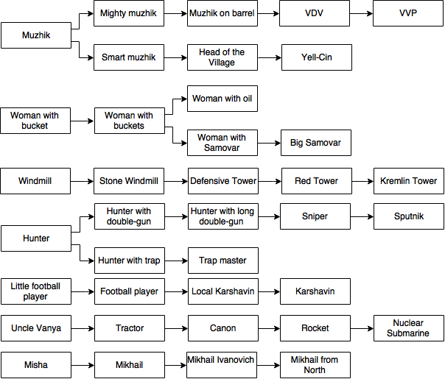

#### Traps

Trap - basic defensive unit that is located on the path. It activates only when some unit reaches it. Traps could be upgraded according to the table (t2).

TABLE OF UPGRADE [TBD]

DIFFERENT TYPES OF TRAPS

1. Name
2. Description
3. Cost
4. Damage
5. Effect
6. Range.

p - person, r - rubles, v - vodka, w - water, ST - single target, MT - multiple targets, d - damage points, S-standard damage (flying + land), L-land damage

##### T1 - basic traps:

###### Pit - basic trap which slows zombies

###### Mantrap - basic hunters trap, stops zombie for 2 seconds, all hunters in range shoot at stopped zombie (even if they are on reload)

###### Matryoshka (1 lvl) - basic proximity mine, lowest level of matryoshka

##### T2 - 2nd level of traps

###### Spike pit - T2 upgrade of Pit with spikes in it

###### Vodka Puddle - T2 upgrade of Pit that can be lit and apply Burn on zombies

###### Swamp - T2 upgrade of Pit that poisons zombies

###### Electrical mantrap - T2 upgrade of Mantrap, works as basic Mantrap but also stuns 4 nearby zombies with electrical charge

###### Matryoshka (2 lvl) - T2 upgrade of Matryoshka, second level of matryoshka, upon explosion degrades 1 lvl

##### T3 - 3rd level of traps

###### Radioactive puddle - T3 upgrade of Swamp

###### Matryoshka (3 lvl) - T3 upgrade of Matryoshka, third level of matryoshka, upon explosion degrades 1 lvl

#### Zombies

Zombies are the main enemy of the villagers. Zombies are different in their hit points amount, movement speed and additional skills.

Classification:

###### Hipster

|  |  |
| --- | --- |
| Name | Hipster |
| Hit Points |  |
| Special Ability | none |

###### Vaper - upgrade of Hipster

|  |  |
| --- | --- |
| Name | Vaper |
| Hit Points |  |
| Special Ability | Has 20% chance to decrease tower accuracy due to the steam of his vape |

###### Longboard Hipster - upgrade of Hipster

|  |  |
| --- | --- |
| Name | Longboard Hipster |
| Hit Points |  |
| Special Ability | Has increased movement speed (+30%) because of his longboard |

###### Clerk

|  |  |
| --- | --- |
| Name | Clerk |
| Hit Points |  |
| Special Ability | Has decreased affection of debuffs (-75%), since he just doesn’t care because of his miserable life |

###### Street Dancer

|  |  |
| --- | --- |
| Name | Street Dancer |
| Hit Points |  |
| Special Ability | Has 30% chance to dodge attacks due to his high dance skills |

###### Teacher

|  |  |
| --- | --- |
| Name | Teacher |
| Hit Points |  |
| Special Ability | Has 30% urge to go educate “stupid” tower forcing it to stop attacking |

###### Scientist - upgrade of Teacher

|  |  |
| --- | --- |
| Name | Scientist |
| Hit Points |  |
| Special Ability | Knows stuff, so he has 10% chance to disable T3+ towers permanently |

###### Couch Expert

|  |  |
| --- | --- |
| Name | Couch Expert |
| Hit Points |  |
| Special Ability | Levitates across the map on his couch talking about everything that is wrong with this World (he’s expert after all). All attacks damage his couch first. When the couch is destroyed Couch Expert gets furious and receives speed buff (+40%) |

###### Duck Face

|  |  |
| --- | --- |
| Name | Duck Face |
| Hit Points |  |
| Special Ability | Has Pumpkin Spice latte in one hand and iPhone in another. Has 50% urge to take selfie with a tower blinding it with flash, so it would miss everything for some time. |

###### Police Officer

|  |  |
| --- | --- |
| Name | Police Officer |
| Hit Points |  |
| Special Ability | Fat. Has increased amount of HP. |

###### S.W.A.T. - upgrade of Police Officer

|  |  |
| --- | --- |
| Name | S.W.A.T. |
| Hit Points |  |
| Special Ability | Has body armor and with 20% chance throws smoke grenade, covering all other zombies with the smoke, so towers have 80% chance to miss them. |

###### Soldier - upgrade of S.W.A.T.

|  |  |
| --- | --- |
| Name | Soldier |
| Hit Points |  |
| Special Ability | Has body armor, increased movement speed (+20%). When under heavy fire from towers, starts to crawl reducing their chance to hit him by 50%. Also knows how to avoid traps. |

###### Lada

|  |  |
| --- | --- |
| Name | Lada |
| Hit Points |  |
| Special Ability | Has increased speed (+50%). Goes fast, periodically shoots AK from a window. |

###### Gelandewagen - upgrade of Lada

|  |  |
| --- | --- |
| Name | Gelandewagen |
| Hit Points |  |
| Special Ability | Has increased speed (+50%). Goes fast, periodically (25%) stops near a tower, then 3 grunts go out and disable tower by beating it. |

###### Immigrant

|  |  |
| --- | --- |
| Name | Immigrant |
| Hit Points |  |
| Special Ability | When at low health (<30%) calls for his family (spawning 5 more zombies) |

###### Glider

|  |  |
| --- | --- |
| Name | Glider |
| Hit Points |  |
| Special Ability | Flying unit, ignores the road, goes straight to the Village. Only ranged towers can attack it. Can never be trapped. |

###### Helicopter - upgrade of Glider

|  |  |
| --- | --- |
| Name | Helicopter |
| Hit Points |  |
| Special Ability | Same as glider + has far more HP. |

#### Bonus things

Bonuses falls out from dying zombies. There are two types of bonuses: resources and enhancements. Chance of getting the enhancement depends on the strength of certain zombie.

Resources:

* Rubles (random number of rubles)

Enhancements:

* Amplify damage (increase damage of towers). Could be multiplied.
* Slowing attack (decreases movement speed of attacked unit by 30%)
* Speed up attack (increases attack speed of the tower). Could be multiplied.

#### Obstacles

Natural or artificial barriers that prevent zombies from moving and the player from building on that place. Every obstacle has specific size and time to be removed.

* Rock
* Tree
* Burnt building
* Water (unremovable)

### Actions

#### General actions

Could be applied from main view of local defence mode

##### Build a tower/trap

1. Click to one of two icons (bottom of the screen) to build a basic tower or basic trap. If player has enough resources for this type of defensive unit the transparent model of it appears on the screen.
2. Player should decide where to build the new tower/trap. If the place is not suitable (obstacle, etc.) for building the model become red.
3. After finding a good place player clicks on the screen and building process starts. Time bar appears, during building there is a box model on the place
4. Building finished (time bar is full), model of the tower/trap displayed on the place. The unit could protect the Village.

##### Pick up bonus

After monster dies he may generate some bonus. It will be displayed as small mystery box.

1. Player touches the mystery box model.
2. The actual bonus leaps out from the box.

If the bonus was resource:

3.1 Resource added to player’s treasury.

If the bonus was enhancement:

3.2 The icon of the enhancement appears.

##### Apply enhancement

1. Player touches the enhancement icon. It disappears
2. Player clicks on certain tower/trap the enhancement activates. It could be applied only to one tower or trap. While the enhancement is chosen player can not click on other enhancement icon if there is one.
3. Model of the unit supplemented by the special effect of the enhancement. The unit acquires special modifier on the attack.

##### Apply ultimate power

If the status bar of ultimate is ready player can apply the ultimate power.

1. Player touches the “Ulti” icon. If it is ready than icon become gray.
2. Ulti activates.

#### Object actions

Could be applied after clicking on the specified tower/trap/obstacle/etc. from unit actions view (popup icons). If the object was tower or trap then it’s range of attack is displayed as a green circle around the object.

##### Remove a tower/trap

Could be used on every tower/trap

1. Player chooses the “Remove tower/trap” icon.
2. 50% of the unit’s cost and 100% of “villager” resource returns to the player. If the tower has permanent enhancement than it gets additional 50% of cost per enhancement. The model disappears on the place of the unit. The space becomes free for building new towers.

##### Upgrade a tower/trap

Could be used on every tower/trap, except maximally upgraded

1. Player chooses the “Upgrade tower/trap” icon.
2. Menu with available upgrades shows up. Player selects the certain upgrade.
3. If players has enough resources, the process of upgrading starts. During upgrading there is a box model in place of unit.
4. Upgrading finished, model of the upgraded tower/trap is displayed on the place and unit changes its characteristics.

##### Attack the point / Stop attack the point - switch

Only for towers

1. Player selects the point inside the range of attack.
2. The tower starts shooting at pointed position. “Stop attack” icon appears.
   1. If he pointed to another object (trap/obstacle/tower)
      1. If there is a way of interacting between them then hidden strategic action occurs (e.g. shooting with burning projectile to the puddle of vodka sparks it off)
      2. If objects cannot interact then nothing happens and tower goes to standard mode.

While the tower is in attack the point mode, “Stop attack” icon is showed.

1. Player chooses the “Stop attack” icon.
2. The tower stops attacking the point and “Stop attack” icon disappears.

##### Remove a barrier

Could be used on every barrier

1. If player pointed to the barrier to the barrier touches the barrier object. Icon with shovel appears.
2. Player taps the shovel icon. The barrier becomes red with time bar below. When time bar is full the barrier disappears.

#### Strategic actions

Spark off

Empower other towers

#### Ultimate ability

It’s one of big additions to the game mechanics of the classic tower defence. Ultimate ability is a very powerful action which could drastically change the outcome of the game. It could be used only once per mission. It takes time to charge the ultimate ability. A player sees a bar of ultimate on the upper side of the screen. To fill the bar the player should kill zombies (80). There are 3 ultimate abilities:

1. Rage - player can attack zombies by tapping on them. Every tap deals some amount of damage. In rage mode the screen becomes reddish and player can not build or upgrade units, only tap on zombies. It’s duration is 15 seconds.
2. Earthquake - it produces destructive earthquake that deals huge damage to zombies and slows them by 50%. The screen shakes. It takes 10 seconds.
3. Fighting spirit - the morale of defenders is boosted. Every tower gets battle fury buff (their attacks increase by 50% and attack speed grows by 100%) for 10 seconds.

## Side Missions

There 2 type of side missions in the game

First one we have a mini game. The main goal of a game is to fill three glass with eaqual amount of vodka by tapping the screen in the right moment.

Second game is to prevent goats from eating from garden. Simple tap on the goat kill it.

## Screen Flow

### Screen Flow Chart

Game start slides

Everytime player, entering the game, will see the story line represented by 6 slides. There is a possibility to skip this slides, but this option will be disabled for the very first time player opens the game.

The following schema represents the idea of the future design and plot of the slides. It will be redesigned and changed in the final version. Each slide goes one after another and player has a possibility to swipe further or backward.

So the main idea of this images is to show the story to our players in a short way and keep them’s attention on the plot.

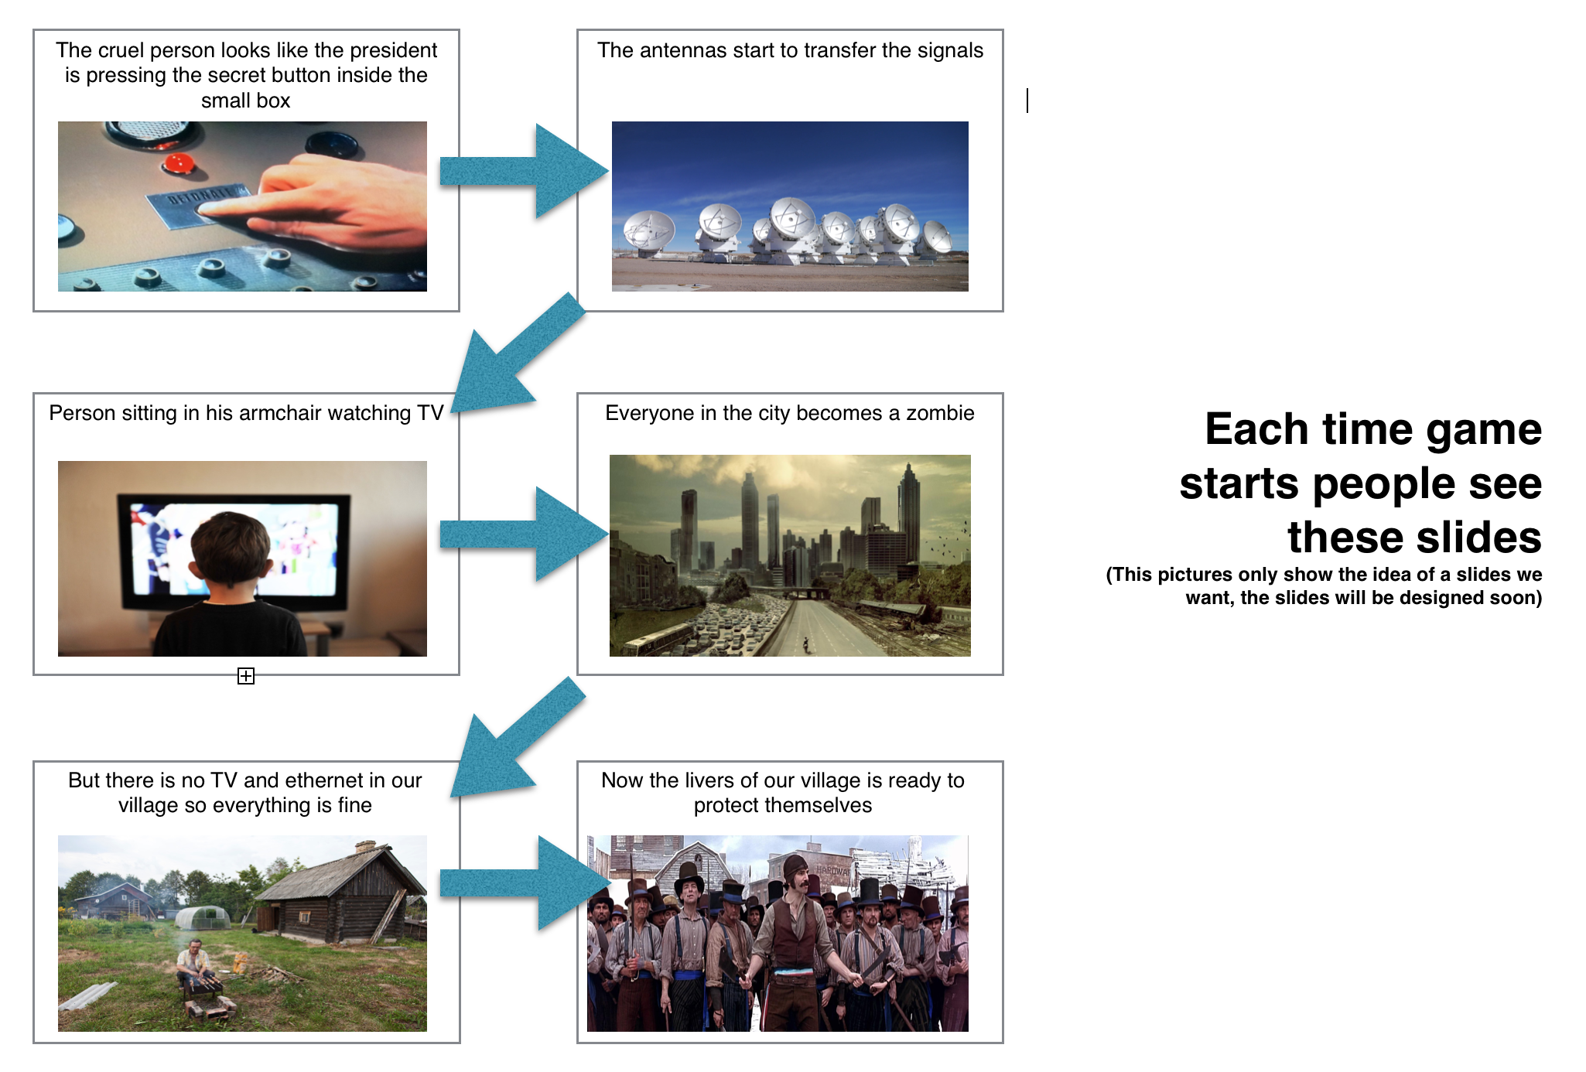

#### Main Menu Screen

Main menu screen will look simple consisting of 3 buttons and sound enable-disable button. Furthermore there will be two art: first one - the zombie, second one - the village. 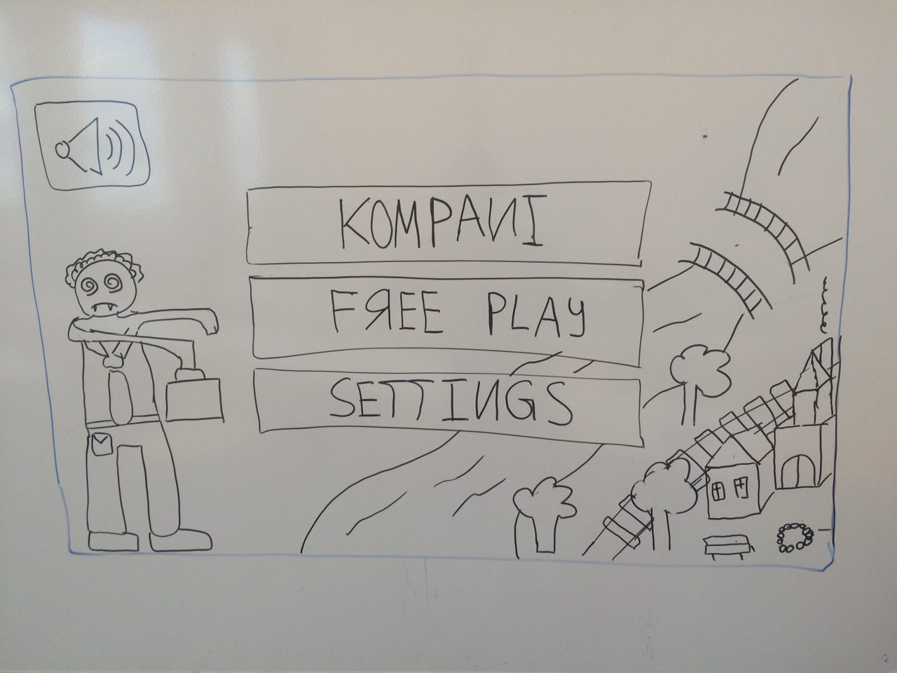

#### Free Play Menu Screen

Free Play menu screen will be represented by a table with rows inside of it. Each row has a small image of the level the player can play, the name of the level and play or locked button. 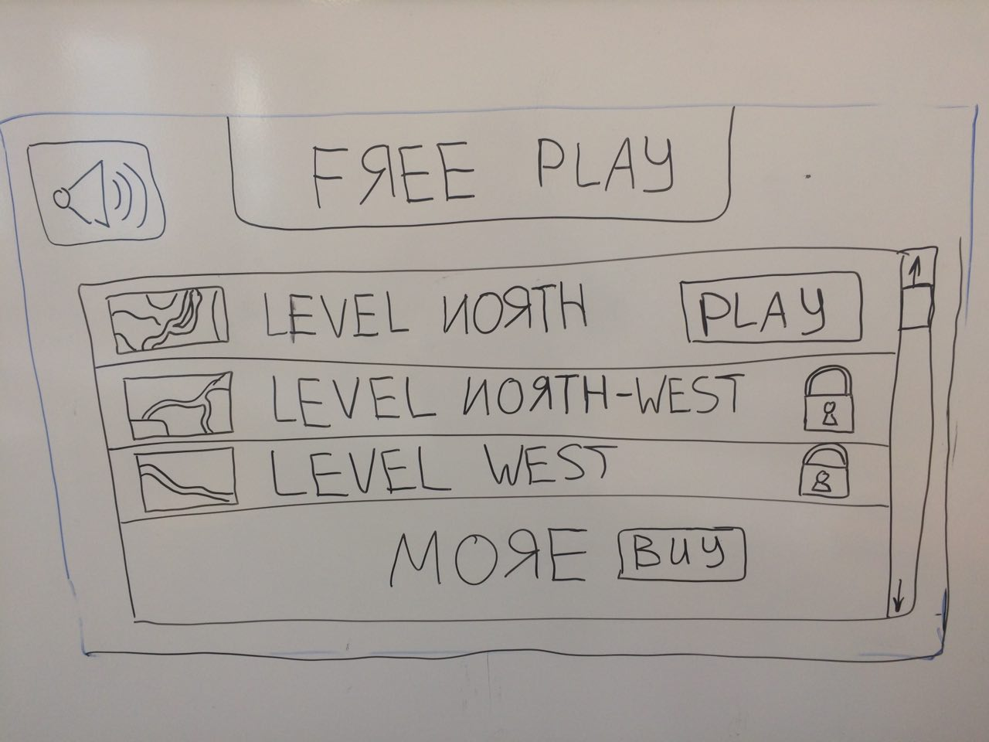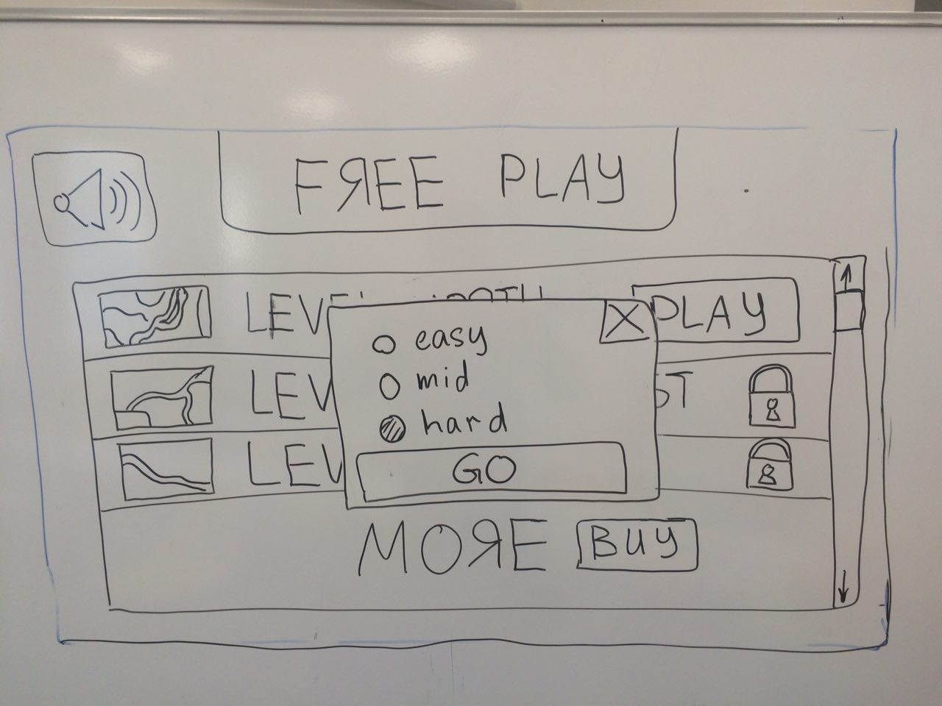

#### Company Menu Screen

Company menu screen will be represented by a map of our village. So the player will see some statistic and the actual condition of his village and the locations around it. So by simple tap on the location player interesting in the button “Play” will be shown. So the navigation will be intuitive.

By pressing the location player starts the game, by pressing the village player goes to village building mode.

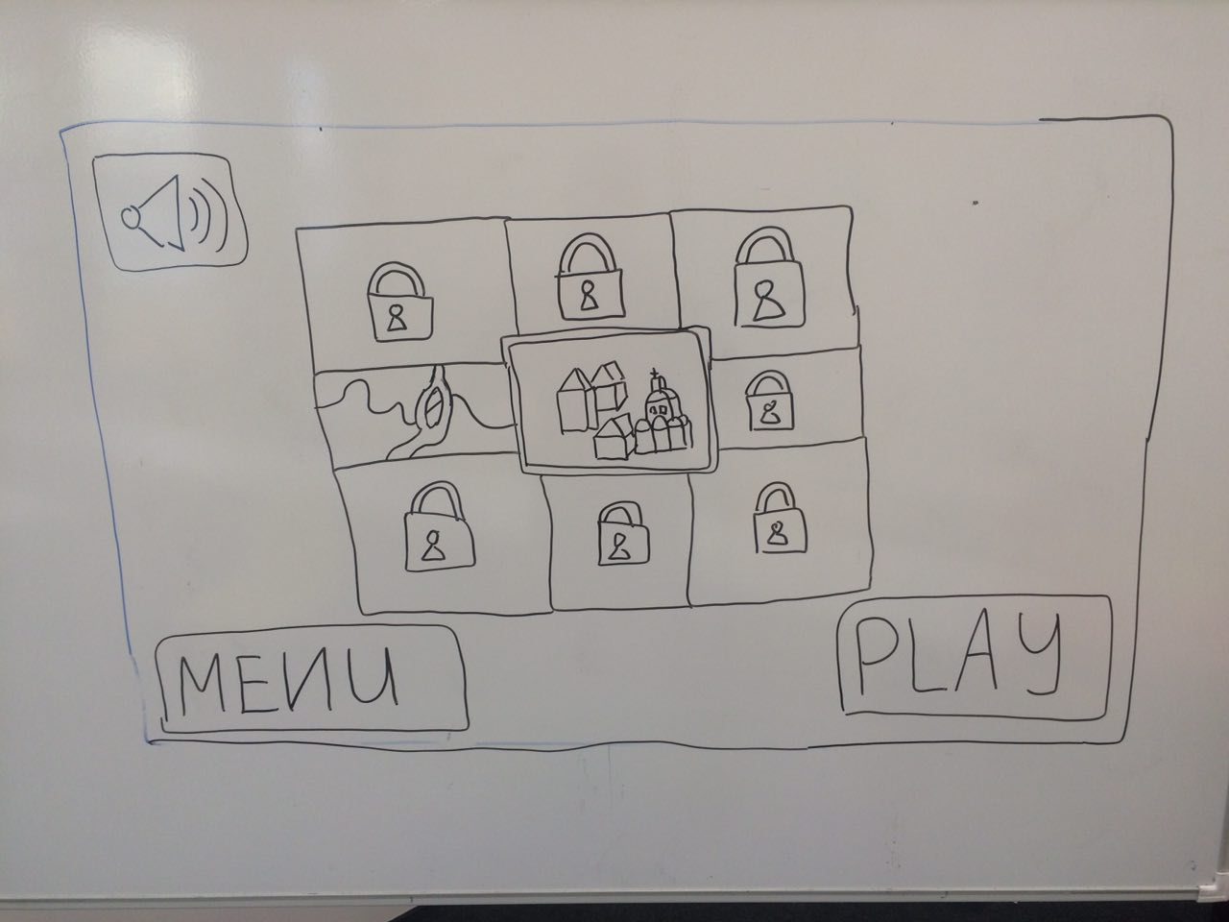

#### Game Menu Screen

Game menu screen will be represented by a small icons around the play area.



## Game Options

The game has 2 levels of difficulty: normal and hardcore. It has quite different balancing in terms of amounts of zombies and number of rewards.

## Replaying and Saving

If player lose the storyline mission he must replay it. If he lost side mission he just lost resources.

Replay is available in local defence mode - it restarts the mission with the same resources as before starting previous game.

The game saves automatically before each mission in global world mode. There is no possibility to save during mission.

If Home button was pressed the game state is saved and game appears to be in Pause mode.

# 

# 

# Section III – Story, Setting and Character

## Story and Narrative

### Backstory

The story begins with a kid, who was abandoned by his parents. His name was Garry Mason. Garry was a boy, who was always bullied at his school and college. That resulted in his misanthropy and firm conviction that he is exceptional. He was a hard-working person: he studied hard at school, worked a lot, being employed to three different jobs right after his graduation. He managed to earn enough money to open his company named Pineapple, that was developing and producing consumer electronics such as players, PCs and phones, which eventually became an industry standard after a revolutionary presentation in 2007.

He had a lot of money and his company had worldwide recognition of technology leadership, but it was not enough for him. He was investing a huge amount of money into communication business, and thereafter he acquired networking, TV and radio broadcasting, cellular companies all over the world. He became a “king” of world communication.

He also had a massive research department, that figured out how to influence people's minds and consciousness. Their technology could turn anyone to “zombie”, (person with only a limited subset of available actions due to affected consciousness), by just letting them hear an infrasonic frequency that would cause humans to lose control of their mind.

Having all that in his arsenal, he thought of turning everyone across the globe into his own army of loyal zombies in order to prove his exceptionalism and excellence, which was always doubted during his childhood.

On a summer day of 2016, suddenly all means of communications started transmitting this tune over the speakers, while most of the people were in front of their television sets, or talking over the phones. The whole world then turned to zombie nation of Garry, except for a small village in Russia…

The village named Kukuevo, located in Northeast Siberia, had no TVs, no phones, nothing were there to connect them to the outer world. The only news available to them were newspapers, which were put into central newsstand every week by a paperboy Ivan Dolgiy.

When Ivan went into a neighboring village for some fresh newspapers, he found nobody there, but a small group of people frightened by some villagers, they described as zombies. The zombies were not sleeping, aggressively attacking others with an urge to eat their brains. The only thing that helped to sober zombies and bring them to the real world was a shot of Vodka, forcibly poured in their throats.

When Ivan came back to Kukuevo, he told this story to the head of village, Dmitrii Ivanov. Dmitrii brought together all the villagers into town hall to discuss what they need to do. Some of villagers proposed Dmitrii to save as many people as they can with Vodka, the others suggested to kill zombies if they invade Kukuevo. Dmitrii decides to choose both options, the villagers start to collect vodka to the city tower and this is how the game starts…

### Game Progression

The idea is that with every new level (which is not a wave — levels consist of enemy waves!) the game changes a bit in terms of game mechanics and visual look. With every level the population of village becomes bigger (the objective is to have at least 1 villager).

Game has story mode — and it changes according to tables of upgrades. After finishing story mode, a player can start endless mode.

## Game World

Game world consists of the village in the center of world and 8 locations, surrounding the village. Each location corresponds to the cardinal directions.

Level takes place at only one location at once. As the game progresses and if all 8 locations have towers on it, levels take place at multiple locations at a time.

### General look and feel of world

Look and feel is similar to cartoons and low-detailed animated games. Maps are usually full of greenery and natural obstacles.

## Characters

### Dmitrii Ivanov

Head of the village. He is resolute and unhesitating, very humane. His decisiveness helped to take fast actions to prevent zombie invasion.

He is helping a player throughout the game with hints and pop-up messages.

### Garry Mason

The head of PineApple. He is on the side of evil — as he was the one to decide to turn all the people into zombies. He is hard-working, misantropic, thinks that he is exceptional. He is very rich and powerful. His childhood memories greatly influenced the character.

He becomes angry when you repel all the waves of zombies, and tells it via pop-up messages to the player.

## Plot elements

Prior to each level transition, villagers acquire new technologies or new means of healing/killing zombies, that become available from former zombie city residents, as they cure them with healing vodka powers. So, that is how the football players, paratroopers, rockets, double-barreled guns, cannons, and other possible towers become available to a player to place on map.

# 

# 

# Section IV – Levels

Maps have static maze along the path of attack of enemies — it means that a player cannot change maze and should adapt to the peculiarities of the map’s landscape.

In this context we have mission, levels and locations: missions have 5 waves of zombies on a single location. Each level has 5 missions in it.

So, for now the progress is the following:

## 1st level

### Mission #1

Basic resource tower is available to the player: Alcohol machine. Defencive Towers, which are available to the player: T1 STA (Muzhik). Zombies there are few zombies and they are easy to kill.

### Mission #2

Well is found in the village, so now villages have source of water to build new tower — woman with bucket! (T1 MTA). More zombies are incoming.

### Mission #3

Windmills (PA) now are used to kill zombies. More zombies are incoming.

### Mission #4-5

Again, more zombies are incoming.

## 2nd level

### Mission #1

It turned out that black gold is under the village! Oil derrick was found in the village and now villagers can use truck — “tractor” tower.

### Mission #2

A hunter was found in a village — basic ST tower with long range. Now player can build them to shoot from a long distance.

### Mission #3

Mighty muzhik – T2 STA tower with medium range is available.

### Mission #4

Woman with buckets – T2 MTA tower is now available.

### Mission #5

Stone Windmill – T2 PA tower now is available.

As usual, level progresses with more zombies coming towards the village.

## 3rd level

The football team of nearest city invades Kukuevo, but the villagers fill them up with vodka and football players now are helping to save the village.

### Mission #1

Little football player players are available in the village, with chain attack type — the ball will bounce to the closest target within some range for a number of times.

### Mission #2-5

As usual, level progresses with more zombies coming towards the village.

## 4th level

### Mission #1

The zombies become very hard to heal. Now the player should figure out that healing strategy is not an option.

### Mission #2

Misha — a wild bear, low range manual attack, but strong enough! (this is a bear, so this is evident).

### Mission #3

Truck tower upgrades to old cannon, that villagers found next to the village. An old man told, that this cannon left from the previous villagers.

### Mission #4

Windmill upgrades to stone windmill.

### Mission #5

Hunter upgrades to a hunter with double barreled gun.

## 5th level

### Mission #1

Hunter can now place traps and upgrades to hunter with trap.

### Mission #2

Little football players now play a way better (but still not enough to prove that there are people in Russia who are capable of playing football — so they miss 20% times) and upgrade to football players.

### Mission #3

Our bear named Misha grows. He is not a small boy now — his name is Mikhail.

### Mission #4

Smart muzhik — a new tower is available to enhance nearest units.

### Mission #5

A lot of zombies try to invade the village. Player should use all his or her arsenal to fight against them!

## 6th level

### Mission #1-5

As more people become the villagers and more technologies are brought to it with the help of cured former city residents, the village now looks urbanistic. The upgrades now are using this technologies.

## 7th - … level

As you can see above, the game progresses with updates of towers, new powerful zombies and plot elements, that transfigure our old-looking village to look like a city. So, during the game, the village becomes a city, Kremlin and eventually an International Space Station, bringing more local humour and jokes in the game.

# Section V - Interface

## Visual System

### HUD - What controls

The player will see all his statistic on the screen while he playing the tower defence. If he just want to develop the village everything will be the same. As in classic tower defense or strategic games we are going to display everything at the edges of a screen. Resource bar will be placed at the top of a screen.

Tower set will be placed at the right edge of a screen. Health points will be shown at the top of the towers and zombies. The HUDs in global game mode are different from HUDs in local game world.

We figure out that this kind of interface will not prevent player from playing the game.

### Menus

The player will see all his statistic on the screen while he playing the tower defence. If he just want to develop the village everything will be the same. As in classics tower defense or strategic games we are going to display everything at the edges of a screen. Resources bar will be placed at the top of a screen. It will not prevent player with his game.

### Rendering System

All images are going to be rendered by SpriteKit framework.

### Camera

The angle of a game camera will be fixed. The camera position on Z - axis, in other words the height of the camera above the level can be changed by the player using method of pinching the screen.

### Lighting Models

The angle of a light will be fixed the same as a camera. It will always be static.

## Control System

The control system is based on tapping, swiping and pinching - all this action are kind of a predefined by iOS system actions. We are going to use them in order to provide players with the interactions they are already know and make control system understandable and clear to audience of a game.

## Audio

There are will be no 8bit sounds, we are going to take sounds from the real world.

## Music

There are will be no 8bit music, we are going to take sounds from the real world and generate own music track for the game.

# Section VI – Technical

This may be abbreviated with most in the Technical Bible.

## Target Hardware

iOS devices, 9.0 and higher. Both iPad and iPhone. 32 and 64 bit processors.

## Development hardware and software

Mac OS pre installed devices will be used as the development stations. Xcode as IDE. Both iPad and iPhone devices will be used as the testing devices.

## Game Engine

SpriteKit as the game framework.

## Network

Build in purchases will use a network connection. However the first prototypes of the game will have no network multiplayer. But the architecture of the game will allow us to integrate the network multiplayer system in future.

## Scripting Language

Swift

# Section VIII - Management

## Detailed Schedule

3 weeks sprints

1 sprint game documentation preparation

2 sprint game engine programming

3 sprint mini games and game logic programming

4 sprint putting assets in our game programming

# Section IX - Lenses

## Lens 31 - The Lens of Action

To use this lens, think about what your players can do and what they can’t and why.

Ask yourself these questions:

* What are the basic actions in my game?
* What are the strategic actions?
* What strategic actions would I like to see? How can I change my game in order to make those possible?
* Am I happy with the ratio of strategic to basic actions?

One of the most interesting lenses in context of the game is Lense of Action. On the one hand, our game, as a representative of Tower Defence genre, has quite limited set of basic actions. On the other hand, we added many strategic actions and extensions of classical mechanics of this genre. To move forward we should consider all the actions of the game (their detailed descriptions are in the corresponding chapter).

For now, we will take into consideration only actions of Local Defence Mode. Basic actions include actions on towers (build/remove and upgrade tower, attack/stop attacking point) and actions on bonuses (pick it up, apply and apply ultimate power). We see that even basic actions with bonuses could rise emergence of the gameplay and may become strategic ones, because the player should decide to which tower he applies the permanent bonus. There are many kinds of bonuses and number of combinations with towers and other bonuses is huge. Some towers get much more than another from certain bonus type, e.g. splash or chain attack tower with slowing attack buff slows down the whole group of zombies.

Next category of strategic actions is connected with positioning of towers and traps. It especially concerns towers with multi-target attacks (MT, Splash, Chain), because they attack more effective if there is congestion of zombies in some place, e.g. a turn of the road or immobilizing traps.

There are many traps and towers which get synergy effect in case of working together. For example one hunter-trap-master tower can significantly empower other hunter towers, by its trap’s ability (extraordinary shot of all nearest hunters at trapped target).

Another category of strategic actions is applying ultimate ability. Before starting the Local Defence Mode player must carefully choose the ultimate ability. It is a new way of interacting of player with the game (not through building/removing towers). For example, a player can kill zombies by tapping on them during short period of time if he uses “Rage” ultimate. The ultimate abilities differ in their power and cost.

There were many examples of strategic actions in Local Defence Mode that give player feeling of emerging gameplay. Of course, we want to give even more freedom to player, but introducing new strategic actions requires a lot of balancing and debugging. Moreover, it sometimes makes the game overcomplicated that we are trying to avoid, because our target audience is common player (not hardcore gamer). We think that we have found the balance and more or less right strategic-to-basic actions ratio.

## Lens 41 - The lens of Skill vs Chance

To help determine how to balance skill and chance in your game, ask yourself these questions:

* Are my players here to be judged (skill) or to take risks (chance)?
* Skill tends to be more serious than chance: is my game serious or casual?
* Are parts of my game tedious? If so, will adding elements of chance enliven them?
* Do parts of my game feel too random? If so, will replacing elements of chance with elements of skill or strategy make the players feel more in control?

It is not a surprise to say that Tower Defence genre is more about strategic skills than chance. A common player of this type of games doesn’t look for primitive games and accepts the fact that his skill weighs more than chance in a final result of the game. Our game is more serious than casual in this sense.

Although we added a lot of randomization in many aspects of game mechanics, they separately affects the game course just slightly. This allows to make the game less predictable, and simultaneously saves the leading role of player’s skill. The player feels almost complete control of the game if he does things right. However, acquiring these skill takes much time. Moreover, some interesting strategic actions could be found only by chance. During learning the player may face problems with finding proper strategy, because randomization of level mechanics tries to hide tactical patterns of the game. It makes the gameplay more interesting and challenging.

The last part is about taking risks by player. Many decisions in the game are about balancing between possible profit and risks. For example, side missions could strengthen the player’s army and reward the player with resources or make it weaker, depending on the result. Garrison’s size affects the player’s chance to protect the location automatically, but bigger the size of garrison than less resources the Village could accumulate and etc.

Thus we could say that the game is quite interesting, despite the fact that a chance don’t play the crucial role in the game.

## Lens 55 - The Lens of Visible Progress

Players need to see that they are making progress when solving a difficult problem. To make sure they are getting this feedback, ask yourself these questions:

* ● What does it mean to make progress in my game or puzzle?
* ● Is there enough progress in my game? Is there a way I can add more interim steps of progressive success?
* ● What progress is visible, and what progress is hidden? Can I find a way to reveal what is hidden?

Our game named “Russians VS Zombie” delivers following progress to the players:

* Economy — the game is based on saving a population of your village. As the game proceeds, the population is a metric, showing to a player his or her progress in a game. Another point is that the player can earn Rubles as the internal currency to buy upgrades for towers and the budget change indicates a progress as well.
* Game mechanics — as mentioned before, there are possible upgrades of towers, which gain more attack power and health points with every upgrade. Their stats as well as visual representation indicate about a progress. Also, the stats of enemies become higher and the game becomes more challenging for the player.
* Levels and their visual style — as the player faces more waves of zombies, the game changes surroundings such as village outer look (up to Kremlin), and the possible upgrades of towers look more technically advance.

The game progress in terms of game mechanics is visible up to the beginning of new level. Until this moment, the player does not know what changes might be there — what kind of upgrades for towers and enemies to expect. This is a very important aspect of the game, helping to keep some interesting stuff for the late moment in order to intrigue the player.

## Lens 100 - The Lens of Love

* ● Do I love my project? If not, how can I change that?
* ● Does everyone on the team love the project? If not, how can that be changed?

Love isn't something you find. Love is something that finds you, and “Russians VS Zombies” is not an exception. We came up with an idea of the game during a long discussion just as a joke and suddenly fell in love with it — we liked the reflection of stereotypes about russians, sarcastic content, topic of village life, proposed game details and possible outcomes as tower attack/defence game. It appears that everyone on the team loves the project.

**Lens 86 - The Lens of Character Function**

* What are the roles I need the characters to fill?
* What characters have I already imagined?
* Which characters map well to which roles?
* Can any characters fill more than one role?
* Do I need to change the characters to better t the roles?
* Do I need any new characters?

The main roles of our characters is to provide player with lots and lots of fun. We wants to use characters in order to provide our game with a satiric humor and also show the culture tradition and particular qualities of Russians.

There are lots and lots of characters and there are lots and lots of ways to improve them, so we bet that players are going to like this. Even a small upgrade of a character is going to add lots of interesting and fun thing in character appearance. Game is keeping in a secret who will be the next character and how he will look like. Would like to investigate?

Characters roles are not strictly predefined. Characters from village protect themselves and have some unique aspects which we want to keep and not share between them. The “zombies” are too simple and of course they can be replaced by each other. Each character role maps to the specific functions and specific attacking way. We also would like to map a characters with the idea of who is living in villages nowadays and what special thing Russia is known for.

The center character of our game is the man with vodka, so it will be the minimal defence unit and we will try to build the game around this character.

Any new characters can be add soon. And we believe that we can hold player for much longer if we will do this in a feature updates.

**Lens 46 - The Lens of Rewards**

* What rewards is my game giving out now? Can it give out others as well?
* Are players excited when they get rewards in my game, or are they bore by them? Why?
* Getting a reward you don’t understand is like getting no reward at all. Do my players understand the rewards they are getting?
* Are the rewards my game gives out too regular? Can they be given out in a more variable way?
* How are my rewards related to one another? Is there a way that they could be better connected?
* How are my rewards building? Too fast, too slow, or just right?

The central idea of a game is about protection of a small village. Each player has a possibility to develop his small village into a kind of a postacalyptival town. We will use this village as a rewarding system.

Three things about the rewarding system you must know. So the higher level you have and more goods you extract a better and larger village you have. The better village you have the stronger towers you have. The stronger towers you have the more ability to open new characters and build new towers you have. In this case player always waiting for the next funny thing which our game will provide him. He has a strong motivation to see what will be next in this crazy game, absolutely have no time to be bored.

Players have a possibility to make own empire in the village they have. The rewards are too regular, but we don't think is too bad in the game genre like this. Also it is great opportunity to think about different rewards more in the future.

As it was said the connection between reward is depend on the level player have and the hours he play. They strongly connected between each other, too, because a special level you have the special kinds of related rewards it will provide to you with.

**Lens 45 - The Lens of Competition vs. Cooperation**

* If “1” is competition and “10” is cooperation, what number should my game get?
* Can I give players a choice whether to play cooperatively or competitively?
* Does my audience prefer competition, cooperation, or a mix?
* Is team competition something that makes sense for my game? Is my game more fun with team competition or with solo competition?

In the game we didn’t have cooperation at all. The main strategy is to compete with the zombies, kill them before they get into the village.

**Lens 85 - The Lens of the Avatar**

* Is my avatar an ideal form likely to resonate with my players?
* Does my avatar have iconic qualities that let a player project themselves into the character?

In our game we didn’t have the avatar, the user is trying to keep his village safe from zombies by placing his warriors near the road. Warriors must hold the road and not let zombies to get into the village.   
  
Our shady avatar is a savior. The player must protect his village and people there.

## Lens 94 - The Lens of Atmosphere

* Without using words, how can I describe the atmosphere of my game?
* How can I use artistic content (both visual and audible) to deepen that atmosphere?

Our game is aimed on ridiculing of stereotypes, both cultural and those of media. Here we have bad guys – TV-zombies of First World and good guys – stereotypical russian peasants.

Through different types of zombies we mock modern society and through different types of towers and inside of the Village we mock cultural stereotypes about our country.

All main objects of the game (zombies, towers, obstacles, map) represent inner atmosphere of the game through their look, names and behaviour.

To enhance the atmosphere we can use corresponding sound effects. For example we can use russian village themed background music. We also can add sound effects to game objects so the bear with balalaika would sound like an actual bear, but bear that can play balalaika.

Also we can add visual effects to objects. Animation is one of them. So different types of zombies would move differently, and towers would attack in the way such real life object would do that.

Furthermore we can add idle animation to towers, which is popular concept in game development that makes in-game-characters look more alive.

## Lens 68 - The Lens of Moments

* What are the key moments in my game?
* How can I make each moment as powerful as possible?

We can highlight three main moments of fun in the game – story and atmosphere, characters, and discoverable actions.

We plan to convey our story through comics system. So in order to maximize players involvement and curiosity we should introduce the story part by part throughout the whole game. For example we can show part of the story before each mission, then use cliffhangers to get players attention, and resolve them after they beat the level.

As for characters, we got plenty of them, and each is designed with stereotypes in mind. And since players unlock them one by one as they proceed through story, they would be delighted by the humor and interested in further unlocks.

To maximize this experience we can introduce some backstory of each unlocked character. It would deepen the lore and players involvement in the game.

Furthermore, we have some “surprise” actions. They are basically environment interactions. For example we have trap – Vodka Puddle, and we also have buff for towers – fire attack, when these two are combined we receive burning puddle which would apply Burn–debuff on zombies.

These actions are called “surprise” actions because players aren’t introduced to them. It is up to them to discover these actions.