Manuscript instructions
汪志成
能源与动力工程学院，北航，中国
email: 18375276@buaa.edu.cn

This document describes the format for the ICSV31 Congress manuscripts. The official language is English; therefore, all manuscripts should be prepared in this language. Each paper should begin with an abstract, in this position, describing the main ideas of the paper. The abstract should contain no more than 300 words.
Keywords: no more than five words separated by a comma (e.g. building acoustics, finite element methods)

引言
边棱音是
This document contains all necessary information to prepare a manuscript for the 31st International Congress on Sound and Vibration (ICSV31).
All papers must be submitted through the congress website http://www.icsv31.org/. Please login with your email address and password (created when submitting your abstract), then follow the instructions contained in the “Paper Submission” website page. Please note that the online paper submission system only accepts PDF files no larger than 2 MB. In case of any problems during your paper submission, do not hesitate to contact the Congress Secretariat at scientific-program@icsv31.org.

数值方法
选取直角坐标系下的Favre滤波后的Navier-Stokes方程作为控制方程进行求解，空间离散上采用的是频散关系保持(Dispersion-Relation-Preserving, DRP)格式，时间推进上采用的是两层存储形式的低频散低耗散的龙格库塔五六步格式。尽管DRP格式具有分辨率高、低频散、无耗散等优点，但其无法处理计算中可能出现的高频数值振荡。如果不采取一定的抑制措施，高频振荡会不断被放大从而影响数值求解的精度，甚至导致计算发散。在本研究中采用了高阶7点显式空间滤波方法来耗散掉计算中产生的高频振荡，达到抑制数值伪波增长的效果。通过对滤波系数进行频谱优化，使其对感兴趣波数范围内的波影响最小，从而保证计算过程的稳定性和结果的准确性。在高速工况下$(Ma=0.5, 0.8)$的算例中采用了自适应空间滤波方法来捕捉喷流中的激波结构和流场中的大尺度不稳定波。
计算域及边界条件设置的示意图如图1所示。数值模拟采用的矩形喷管出口截面尺寸为$3mm*9mm$，喷管出口到尖劈顶端的距离为$h=5.5D$，其中$D=3mm$。尖劈大小和形状与Krothapalli的实验保持一致角度为20°，总长度为6cm，高度为0.8cm。由于边棱音问题中的纯音频率一般较低，对应的波长相当大（以Krothapalli的$Ma=0.18$工况的实验结果为例，最低的纯音频率约为0.95kHz，对应的波长约为124D），为尽量避免在边界处出现明显反射污染内场，需要保证计算域有足够的大小。本研究所采用的计算域在沿y轴方向范围为$-80D$到$80D$，沿x轴方向在$-47D$到$50D$的区间内采用正交性较好的网格，在$x>50D$处采用扇形网格将计算域最远延拓至$x=278D$处。沿展向z轴方向上网格点均匀分布，长度为$3D$。在当地马赫数小于0.001的远场处施加适用于弱扰动非均匀流动的辐射边界条件。为了保证辐射边界条件同样适用于下游出口边界区域，将计算域向下游做了适当延拓。数值模拟采用的计算网格如图2所示，总网格量约为1800万。其中针对喷流核心区与尖劈壁面附近网格进行了局部加密并在网格交界面上采用了插值，如图3所示。
表 1: 数值模拟中的主要参数.
喷嘴宽度，D | 3mm
唇口厚度 | 1.5mm
喷嘴到尖劈顶端距离，h | 5.5D
尖劈角度 | 20°
马赫数 | 0.18；0.7；1.0

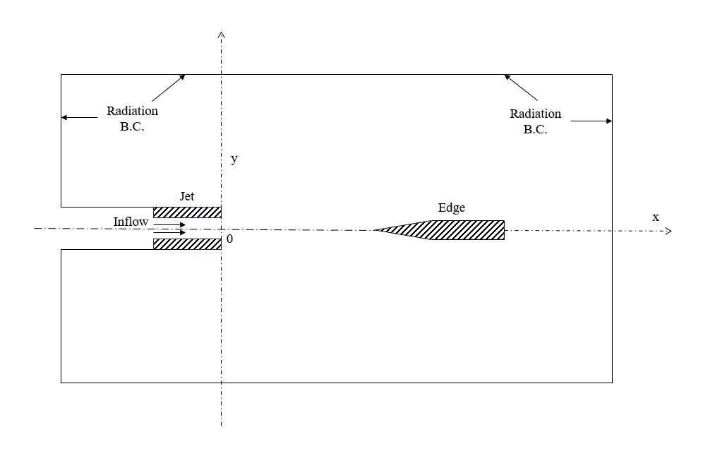Figure 1: 计算域与边界条件设置.

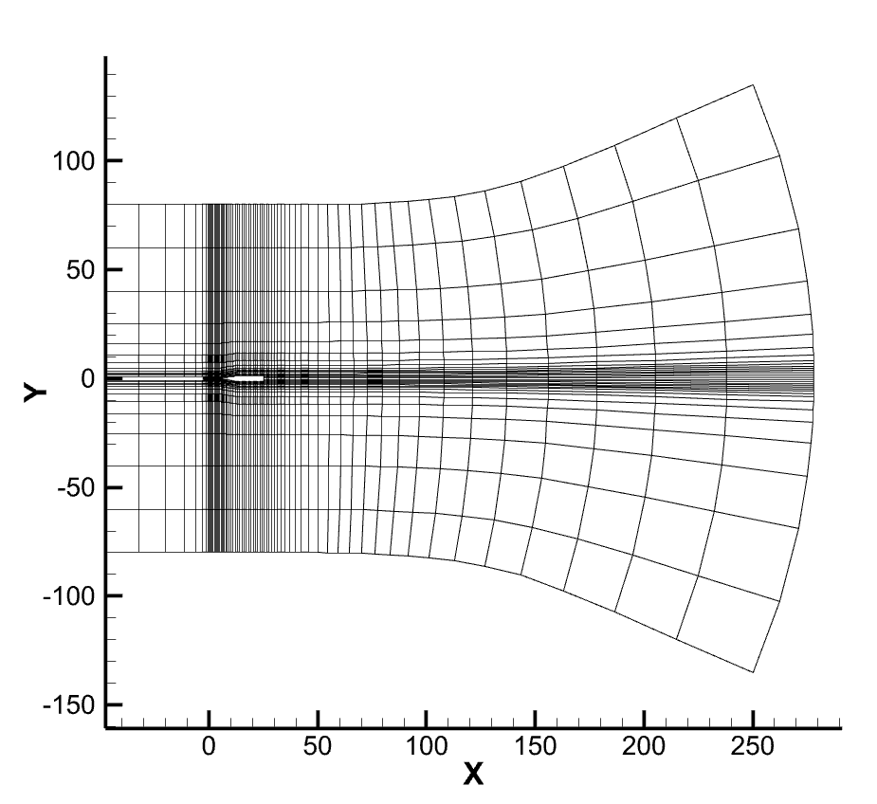
Figure 2: x-y截面计算网格分布（每10个网格点显示一次）.

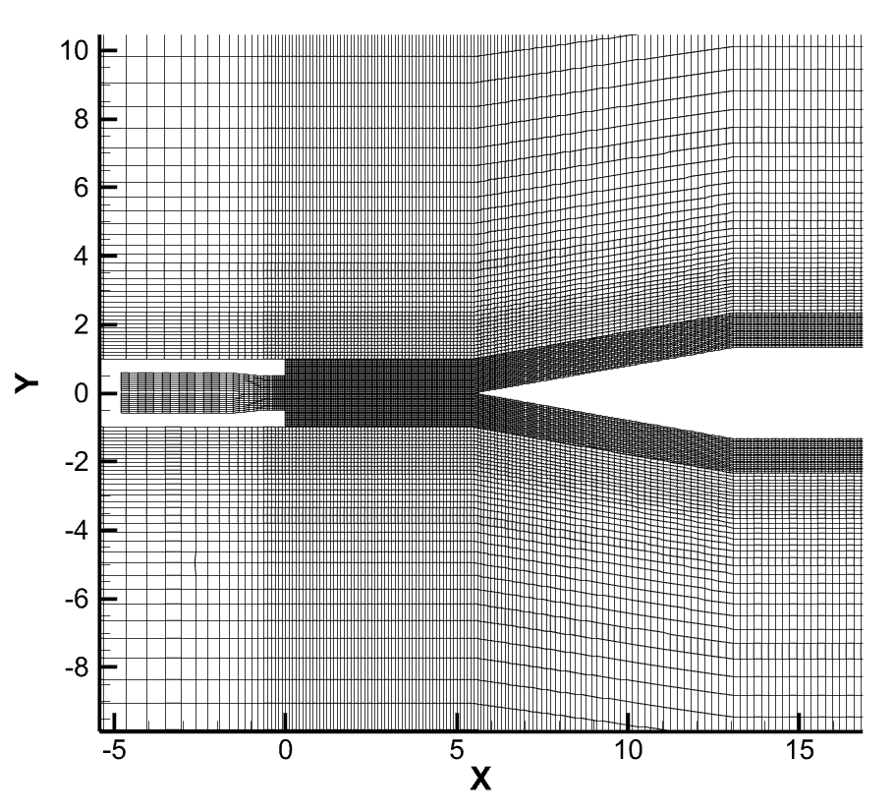
Figure 3: 核心区计算网格分布（每2个网格点显示一次）.

结果与讨论
本文中对喷流马赫数分别为0.18、0.5和0.8三种工况下的边棱音现象进行了数值模拟。

验证算例
The title should be typeset using 17 point bold Arial or Helvetica font, with capital letters only. The “Title” style has been adjusted to use these values. This style also adjusts vertical spacing above and below the title. If the title is longer than one line, it should be manually broken to equalize line lengths.

Author names and affiliations
Author names should be typeset using 14 point, Times New Roman font, while affiliations should be typeset using 12 point italics Times New Roman font. “Author” and “Affiliation” styles have been defined to use these values. The styles also adjust vertical spacing above and below author and affiliation lines as well as left and right line indentations.

One author
There is nothing special in case of one author of the manuscript.

Two or more authors
If there are two or more authors belonging to the same institution, they should be mentioned in one line preceding the affiliation. In this case authors should be separated by commas (,) except for the last author’s name, which should be preceded by and.
If there are two or more authors belonging to different institutions, the affiliation should be written for all the authors with a differing institution affiliation. An example of the affiliation style for two or more authors is provided on the first page of this guide.
In both cases, there should be only one email address, preferably that of the presenting author.

Abstract
The abstract text should be typeset using 11 point Times New Roman font. The abstract text should be separated from the rest of the manuscript with a horizontal line. The “Abstract” style has been created to choose this font, to adjust vertical and horizontal spacing around the abstract, and to add the horizontal line.
The abstract should be self-contained; therefore, do not refer to the list of references. If references cannot be avoided, please put them in full (e.g., “as described in Gnus and Gnats of the World, R. Gneisser, Gnu Publishing, Ltd, 2008”).
The abstract should contain no more than 300 words.

Sections, subsections...
Sections, subsections, and subsubsections should be numbered with Arabic numerals. Section, subsection, and subsubsection headings should be typed in sans-serif font (Helvetica, Arial) and left-justified.
Section heading size should be 14 pt. Section headings should be typed using bold face font. The “Heading 1” style has been adjusted to follow these rules.

Subsections
Subsection headings should be typed using bold face font with 12 pt size. The “Heading 2” style has been adjusted to follow these rules.

Subsubsection
Subsubsection headings should be typed using italic font, with 12 pt size. The “Heading 3” style has been adjusted to follow these rules.
Please do not use deeper section headings than subsubsections.

Mathematical formulas, figures, tables, and references
Mathematical formulas, figures, and tables should be separated from the text by a small amount of space below and above them. This space may be used to justify the content vertically on the page.

Mathematical formulas
Mathematical formulas can be placed in the middle of text lines (inline math) or in separate paragraphs. Inline math should be used only for short equations. Please avoid build-up constructions (like fractions, matrices, etc.) in inline math.
Long and important mathematical formulas should be placed in separate paragraphs, centred, and with a left-justified number, like the following:
(1)
Microsoft Word does not provide convenient tools for automatic numeration of equations and making references to them. The “Equation” style has been created to make it easier to add a progressive numbering and to produce formulas following the above rules.
The style contains two tabulators: a left-justifying tabulator at the left margin and a centring tabulator in the middle of the line. To let the formula go in the middle press Ctrl+Tab.
Generally, all displayed formulas should be numbered consecutively, beginning with 1. However, only one line of a multi-line formula should be numbered, except when separate references to different lines are necessary.

Figures
All illustrations (line drawings, charts, plots, photos, etc.) should be adjusted to provide reasonable trade-offs between resolution and memory usage (the whole paper should be no larger than 2 MB). When scaling an illustration, make sure the font size and line thickness are still large enough to be legible.
All illustrations should be centred on the page. However, when there are two or more narrow illustrations, it may be reasonable to put them side-by-side.
All illustrations should be captioned below the illustration. Captions should be numbered consecutively, centred, and written using a Times family font with point size 11. The “Caption” style has been adjusted to follow these rules.

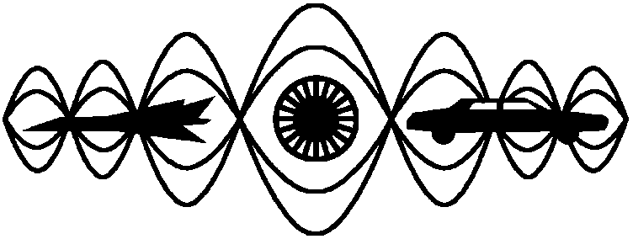
Figure 1: IIAV logo.

Tables
Tables should be centred on the page. All tables should be captioned above the table. Table captions should be numbered consecutively, centred, and written using Times family font with point size 11.
Table 1: ICSV31 registration fees [USD].
Registration Type | Early-Bird | Early | Late | On-site
IIAV members | 800 | 860 | 920 | 1,000
Non-Members | 950 | 1,000 | 1,080 | 1,160
IIAV Retired / Students | 700 | 740 | 800 | 860
Retired/Students | 760 | 800 | 860 | 940
Accompanying Persons | 200 | 200 | 200 | 270

Cross-references

Cross-references to equations, figures, etc.
When referring to equations, enclose the numbers in parentheses and precede them with “Eq.” or “Eqs.” Put an unbreakable space between “Eq.” and the number (press Ctrl-Shift-Space to insert the unbreakable space). For example, you can refer to Eq. (1). You should not begin a sentence with the abbreviation “Eq.” or “Eqs.” Instead, spell out the word.
When referring to figures, precede the number with “Fig.” Put an unbreakable space between “Fig.” and the number (press Ctrl-Shift-Space to insert the unbreakable space). For example, you can refer to Fig. 1. You should not begin a sentence with the abbreviation “Fig.” or “Figs.” Instead, spell out the word.
When referring to tables, precede the number with the word “Table.” Put an unbreakable space between “Table” and the number (press Ctrl-Shift-Space to insert the unbreakable space). For example, you can refer to Table 1.
When referring to sections, subsections, and subsubsections, precede the number with the word “Section.” Put an unbreakable space between “Section” and the number (press Ctrl-Shift-Space to insert the unbreakable space). For example, you can refer to Section 2. Moreover, you can also refer to Section 3.2.2.

Cross-references to the literature
Use numbers in square brackets to refer to particular positions in the literature. For example, to refer to the first position in the literature list presented at the end of this guide, you should write [1].

List of literature references
The heading of the references section should not be numbered. The “RefHeading” style has been created to be used with the references heading.
To save space, references may be set in 10-, 11-, or 12-point type, with 10 point type being the smallest type that should be used for references. The “References” style has been created to be used with the literature list.
All references to the literature should appear at the end of the paper. An example of the proper format for references is given at the end of this guide. Please check how to refer to a book, journal paper, or conference paper. The reference number should be normal text enclosed in square brackets. The title of the journal, book, or conference proceedings should be in italics. The volume number of a journal paper should be typeset using a boldface font.
The numbering of references should be in ascending order and should reflect the order of appearance of the references in the text. An example of the proper format for references is given below.

Other important information

Number of pages
Your manuscript should not exceed the maximum of eight (8) pages. There is only one exception to the above rule: distinguished plenary lecture paper may be up to sixteen (16) pages long.
The ICSV31 Organising Committee has the right to reject papers considered inappropriate for the proceedings, even if the abstract originally appeared to be acceptable.

Submission deadline
Peer-reviewed papers are advised to be received as a PDF file no later than 31 March 2025. Non-Peer-reviewed papers are advised to be received as a PDF file no later than 20 April 2025. In case of any problems in preparing a PDF file, please email the ICSV31 Secretariat at scientific-program@icsv31.org.

All papers must be submitted through the congress website: http://www.icsv31.org/. Please login with your email address and password (created when submitting your abstract). Use the “Remind me my password” link if you have forgotten your password. Then, follow the instructions on the “Paper Submission” subpage. Please note that the online paper submission system only accepts PDF files no larger than 2 MB. In case of any problems during your paper submission, do not hesitate to contact the Congress Secretariat at scientific-program@icsv31.org.

Presentation
The official language of the ICSV31 Congress is English.
The presentation time for distinguished plenary lecture paper will be 45 minutes.
The presentation time planned for all invited and contributed papers is 10 minutes, plus 3 minutes for discussion and 2 minutes for changeover. The session chair is responsible for keeping to these rules. Please make sure you are able to stay within these limits.
Please note that paper presentations will be included in the ICSV31 Scientific Programme and full papers in the Congress Proceedings only if at least one registration fee per paper is received by the ICSV31 Secretariat before 31 May 2025. Each registration fee entitles presentation of only one paper; additional presentations are each charged an extra paper fee of 100 USD.

REFERENCES
- Crocker, M. J. Ed., Handbook of Noise and Vibration Control, John Wiley & Sons, Hoboken, NJ (2007).
- Migdalovici, M., Sireteanu, T. and Videa, E. M. Control of Vibration of Transmission Lines, International Journal of Acoustics and Vibration, 15 (2), 65–71, (2010).
- Každailis, P., Giriūnienė, R., Rimeika, R. and Čiplys, D. Application of leaky surface acoustic waves for investigation of thin film properties, Proceedings of the 18th International Congress on Sound and Vibration, Rio de Janeiro, Brazil, 10–14 July, (2011).
- Finks, K. (2003). Geometrical Acoustics. [Online.] available: http://www.fink.com/Kevin.html
- Yang, J. N., Akbarpour, A., and Ghaemmaghami, P. Technical Report NCEER-87-0007, Instantaneous Optimal Control Law for Tall Buildings Under Seismic Excitations, (1987).
- Poese, M. E., Performance Measurements on a Thermoacoustic Refrigerator Driven at High Amplitudes, Master of Science Thesis, Graduate Program in acoustics, Pensylvania State University, (1998).

