1.

a. Not ML.

b. Supervised learning. Binary Classificaiton.

c. Supervised learning. Multiclass classification

d. Unsupervised learning. Clustering.

e. Reinforcement learning.

2.

(a).

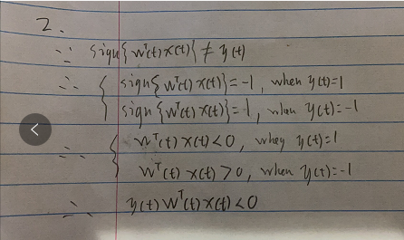

(b).

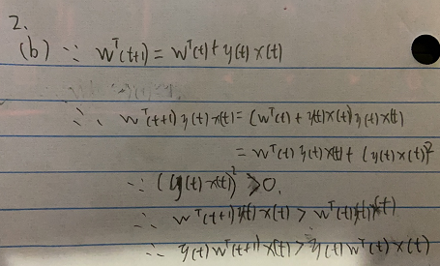

(c)

Because y(t)wT(t+1)x(t) > y(t)wT(t)x(t), we can assume that if y(t)=1 and wT(t)x(t)=-1, then wT(t+1)x(t) > wT(t)x(t), which means wT(t+1)x(t) is closer to 1(y(t)) than wT(t)x(t); if y(t)=-1 and wT(t)x(t)=1, then wT(t+1)x(t) < wT(t)x(t), which means wT(t+1)x(t) is closer to -1(y(t)) than wT(t)x(t).

So the move from w(t) to w(t+1) is a move in the right direction.

3.

(a)

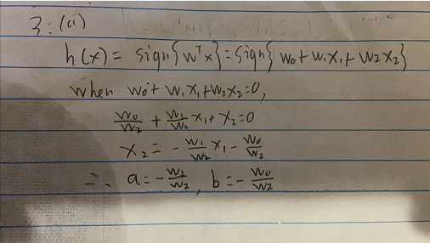 (b)

(b)

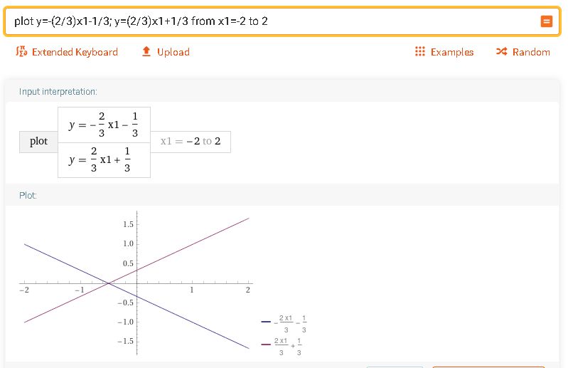

4.

Please see problem4.ipynb

5.

Please see problem5.ipynb

6.

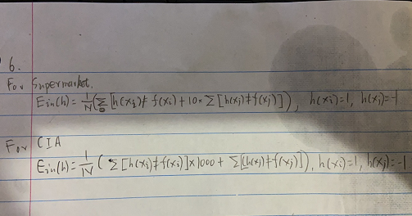

7. Please see problem7.ipynb