# ILN // Module 1 : Renewables energies // Practical exercises

## Theory Part // Electrical engineering

* Learning the concepts: Voltage, Current & Wattage

To use the Energy meter sensor, it is necessary to learn some electrical concepts about the Voltage, Current & Wattage.

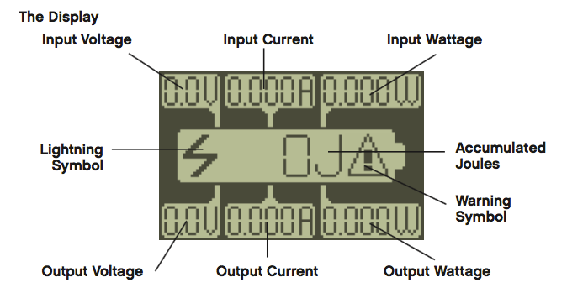Illustration 1: The display

### Voltage

Voltage, electric potential difference, electric pressure or electric tension (denoted ∆V or ∆U) is the difference in electric potential energy between two points per unit electric charge. The voltage between two points is equal to the work done per unit of charge against a static electric field to move the charge between two points and is measured in units of volts (a joule per coulomb).

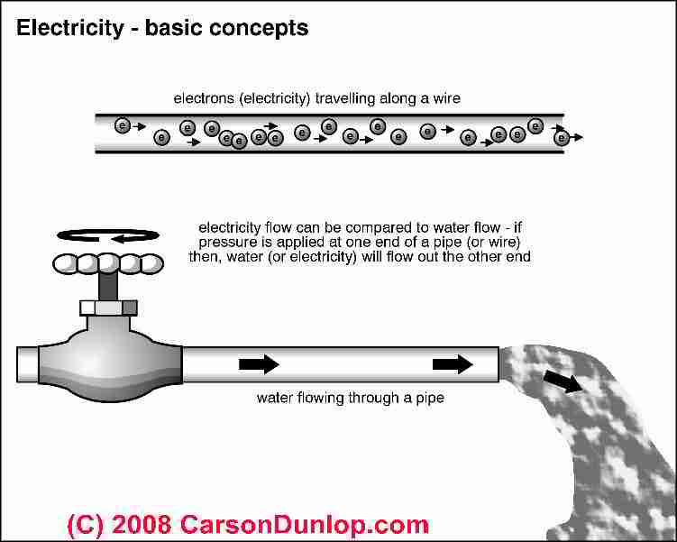Illustration 2: Electrical analogy with the water

**Volt**, formally, is defined as the potential difference across a conductor when a current of one ampere dissipates one watt of power. This definition is not very helpful to consumers. Using a water-in-pipes analogy, volts is analogous to water "pressure" in the electrical system. Having higher "pressure" in a pipe (or electrical conductor) means that conductor is capable of delivering more energy to the user.

Just as a 10 gpm flow rate of water through a pipe provides half the amount of water as a 20 gpm flow rate, 10 amps of current in a conductor provides half the energy as 20 amps of current.

### Current

Amps, as we discussed above, is a measure total current flow (or "gallons per minute" or "gpm" using the popular water analogy) available from an electrical service.

### Wattage

Watts is a measure of the amount of electricity being used - a rate of electrical power consumption. Most people use a very simple mathematical formula to determine how many watts an electrical circuit can carry or how many watts an electrical device will require:

* Watts = Volts x Amps

This formula shows how Watts relates to Volts and Amps. You can rearrange this equation using simple algebra or you can re-write it using Ohm's law. (Ohms is a measure of electrical resistance, which also measures the heat that will be generated in a wire carrying a given current.)

* Amps = Volts / Ohms

Given those two equations just cited, we can also write:

* Watts = Volts x (Volts / Ohms)

## Exercise 1 // Electrical engineering

* Learn to use Energy meter sensor

### Introduction

The Energy Meter is part of the Renewable Energy Add-On Set. If you connect the Energy Meter to a sensor port on the EV3 Brick, the meter can provide data about the electrical energy storage, input, and consumption of the electrical components connected to it.

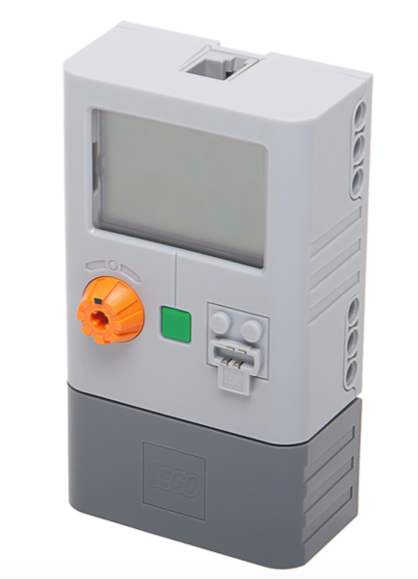Illustration 3: Energy meter sensor

### The display

Energy meter show the following information in the LCD display:

The Energy Meter provides seven kinds of Numeric data:

Illustration 4: The display

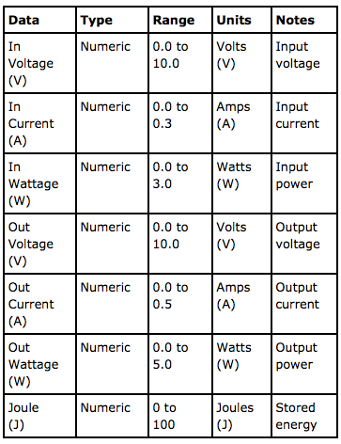Illustration 5: Information provided by the Energy Meter

### Technical Specifications

At least 1 J of energy must be stored before power can be drawn from the Energy Meter

Input voltage .................................................................. 0.0 - 9.9 V

Input current ...................................................................0.000 - 0.200 A

Input wattage ............................................................... P = V x I

Output voltage .......................................................... 0.0 - 9.9 V

Output current ........................................................... 0.000 - 0.450 A

Output wattage ....................................................... P = V x I

Accumulated joules .................................... 0 - 100 J

Energy Storage ....................................................... 150mAh

### Where to use the sensor

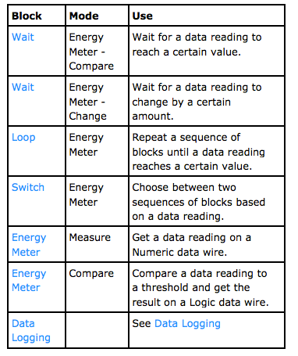Illustration 6: Available blocks to use this sensor

* Practice: 1: Connect the Energy Meter with a Motor

Connect to the energy meter a Lego E-Motor to generate an amount of energy. Learn to read the display.

Practice: 2: Connect the Energy Meter with EV3

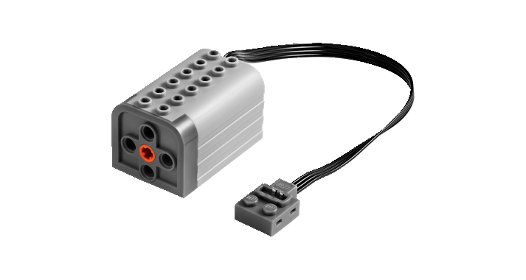Illustration 7: Lego E-motor

Use the port view to read values from the sensor Energy meter

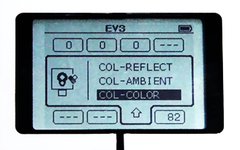Illustration 8: EV3 Port view

* Practice: 3: Show the amount of energy stored in the Energy meter

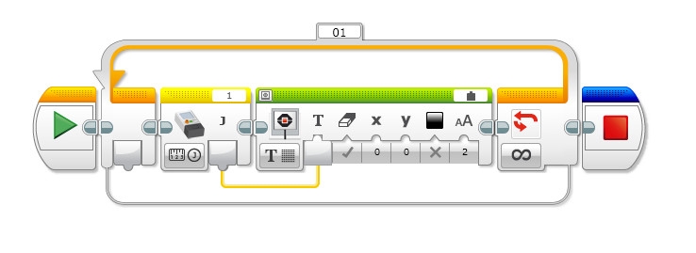Illustration 9: EV3 Program example

* Practice: 4: Play an alert sound when the Energy meter stores 50J

## Extra // Homework

* What batteries do you have at home?

Check Voltage and capacity.

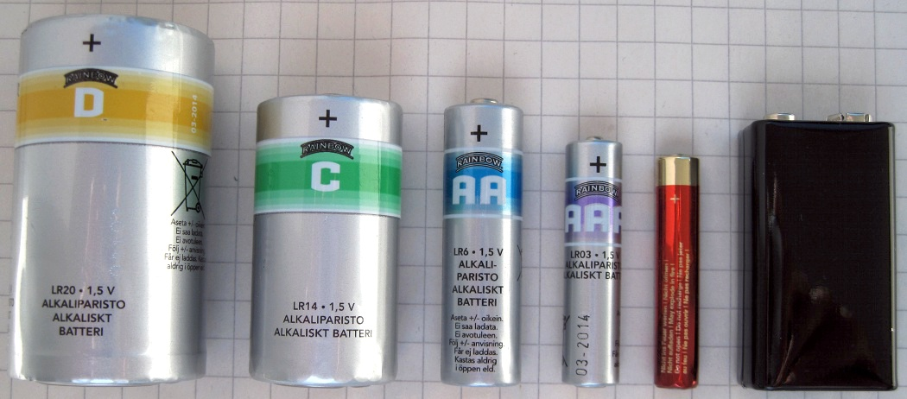

* Homework1: Create a Hand Generator

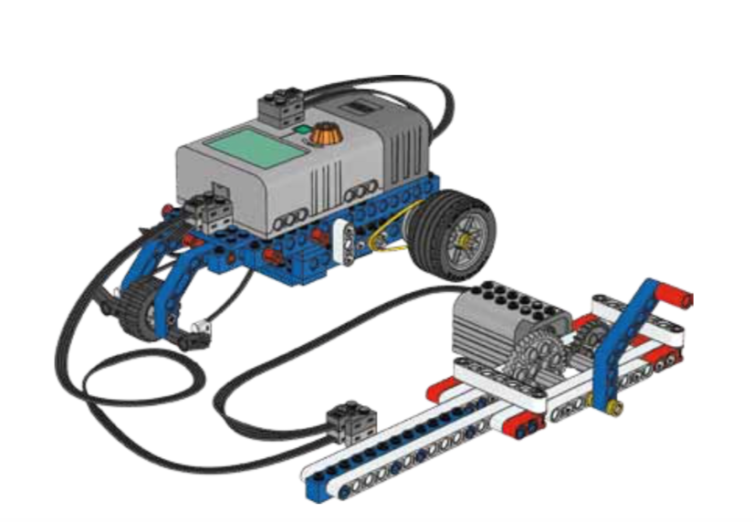

**Ideas:**

<http://www.mocpages.com/moc.php/285654>

<https://www.youtube.com/watch?v=XCoVoF3sgo0>

<https://en.wikipedia.org/wiki/AA_battery>