# Family checklist conversations (Class 20151013)

ILN improves parent-child relationships generating STEAM conversation.

Use this checklist about current class:

1. What is the electrical grid?
2. On the road when you look at the image below, that type of energy does it transport?

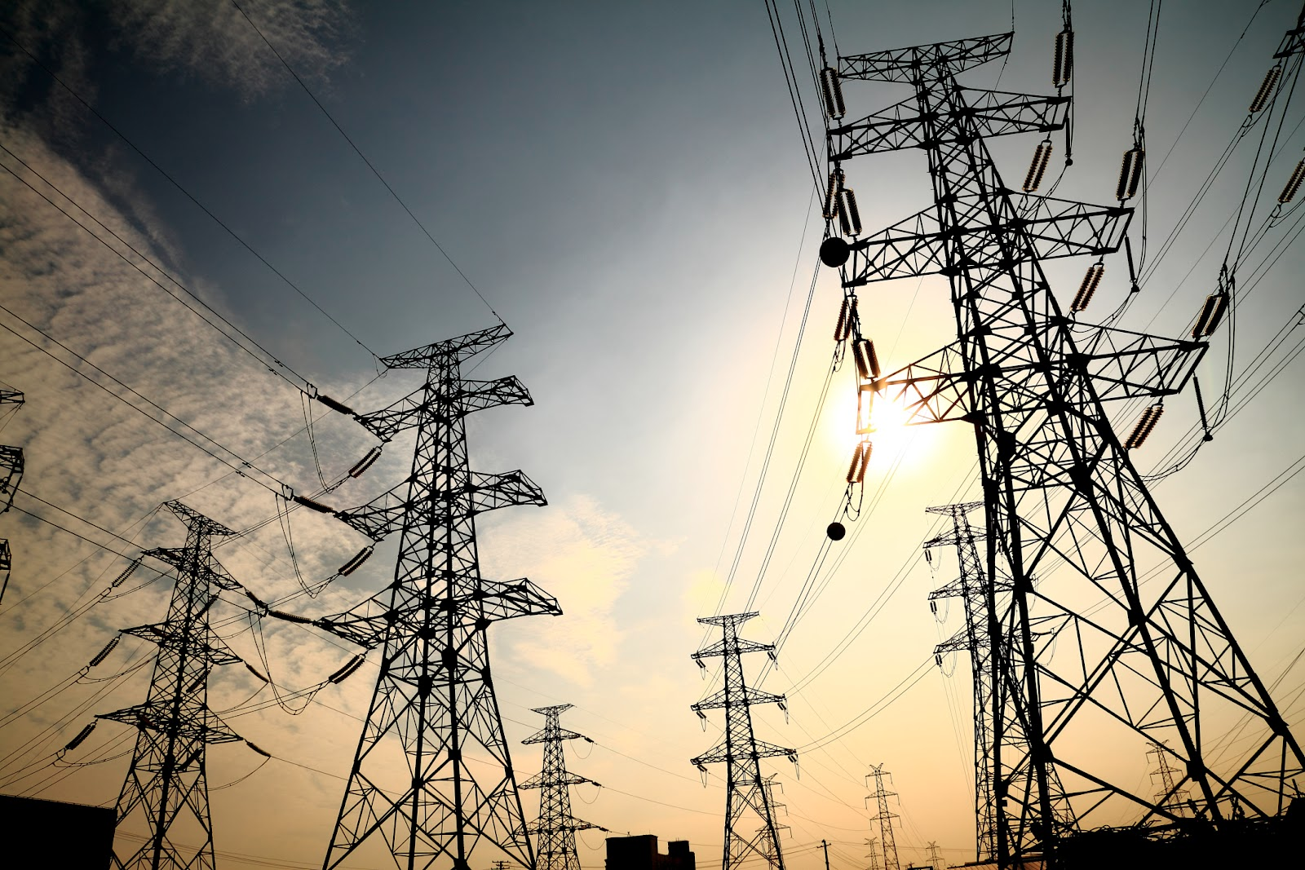

1. How to import a EV3 block in the environment?
2. Can you explain the last programming example to read values from EV3 energy meter?
3. Did you generate energy using the fan?
4. How many Watts do your Wind turbine generates with 3 blades? And with 6 blades?