# Introduction to Electricity with Lego Mindstorms

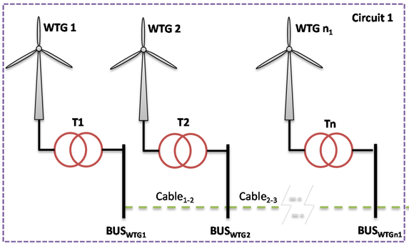

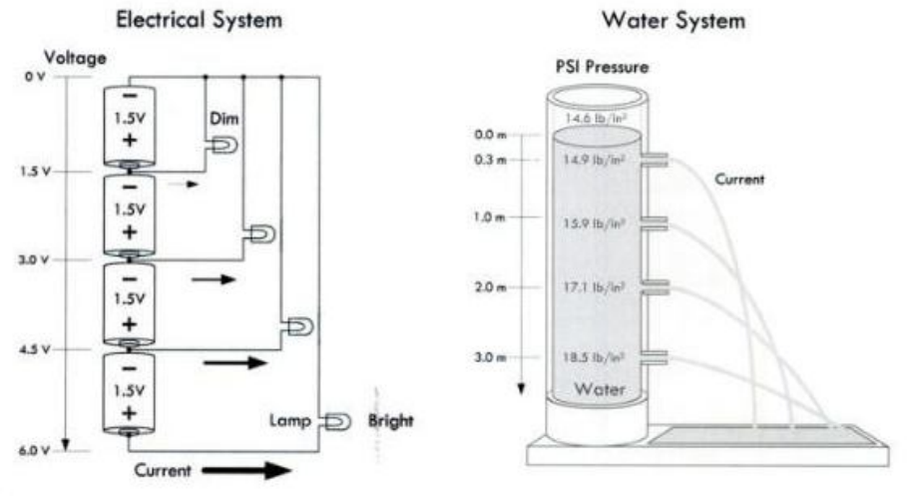

## Electrical concepts

|  |  |  |  |
| --- | --- | --- | --- |
| **Element** | **Symbol** | **Unit** | **Description** |
| Charge | q | Coulomb (C) | The fundamental electric quantity is charge.  Atoms are composed of charge carrying particles: electrons and protons, and neutral particles, neutrons.  The smallest amount of charge that exists is carried by an electron and a proton. |
| Current | I | Ampere | Current is rate of flow of negatively-charged particles, called electrons, through a predetermined cross-sectional area in a conductor. |
| Voltage | V | Volt | Potential difference across two terminals in a circuit “across variable.”  In order to move charge from point A to point B, work needs to be done. |
| Wattage | W | Watt | The watt (symbol: W) is a derived unit of power in the International System of Units (SI), named after the Scottish engineer James Watt (1736–1819). The unit is defined as joule per second and can be used to express the rate of energy conversion or transfer with respect to time. |
| Resistor | I | Ohms  | Flow of electric current through a conductor experiences a certain amount of resistance.  This behavior of materials is often used to control/limit electric current flow in circuits.  A resistor is a dissipative element. It converts electrical energy into heat energy.  It is analogous to the viscous friction element of mechanical system. |
| Capacitor |  |  | A capacitor is an energy storage element which is analogous to the spring element of mechanical systems.  It can store electrical pressure (voltage) for periods of time. |
| Diode |  |  | The fundamental property of a diode is its tendency to conduct electric current in only one direction. |
| Transformer |  |  | A transformer is an electrical device that transfers electrical energy between two or more circuits through electromagnetic induction. Commonly, transformers are used to increase or decrease the voltages of alternating current in electric power applications. |

## Electric elements with Lego

|  |  |  |
| --- | --- | --- |
| **Element** | **Lego component** | **Electric circuit symbol** |
| Battery | http://sariel.pl/wp-content/uploads/2009/12/img_2349.jpg |  |
| Voltimeter | https://a248.e.akamai.net/cache.lego.com/r/education/-/media/lego%20education/home/images/products/machinesmechanisms/9668_718x380_mainproduct.png?l.r2=1649623231 | https://upload.wikimedia.org/wikipedia/commons/5/59/Voltmeter_symbol.png |
| Capacitor | http://www.robotix.es/300/energy-storage.jpg  http://i.ebayimg.com/00/s/NTAwWDUxMA==/z/uq0AAOxy~hdR0xka/$(KGrHqZHJEUFGrdL)9irBR0)k,k+qQ~~60_35.JPG | https://upload.wikimedia.org/wikipedia/commons/thumb/8/89/Capacitor_Symbol.svg/200px-Capacitor_Symbol.svg.png |
| Lamp | http://cache.lego.com/upload/contentTemplating/PowerFunctionsProducts/otherfiles/download2614444020C16A3A492C87B6EA798588.jpg | https://upload.wikimedia.org/wikipedia/commons/thumb/4/4d/Lamp_symbol.svg/1280px-Lamp_symbol.svg.png |
| Motor | http://cache.lego.com/e/dynamic/is/image/LEGO/9842?$main$  http://cache.lego.com/e/dynamic/is/image/LEGO/45502?$main$  http://cache.lego.com/e/dynamic/is/image/LEGO/45503?$main$ | http://www.cdn.sciencebuddies.org/Files/4665/6/light-bristlebot-motor-symbol_IMG.jpg |
| Generator | http://cache.lego.com/r/education/-/media/lego%20education/home/images/products/machinesmechanisms/9670_713x380_mainproduct.png?l.r2=149306119 | http://www.pd4pic.com/images/symbol-electric-power-circuit-supply-generator.png |
| Switch | http://cache.lego.com/e/dynamic/is/image/LEGO/8869?$main$ | http://img.bhs4.com/36/8/3681901245dc494588038b4e1c6537f890f017b9_large.jpg |