# Introduction to Electricity with Lego Mindstorms

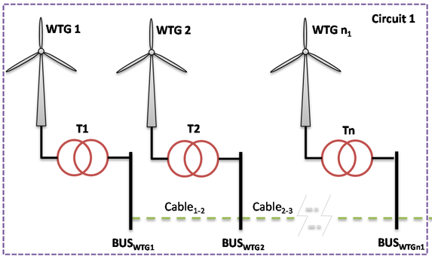

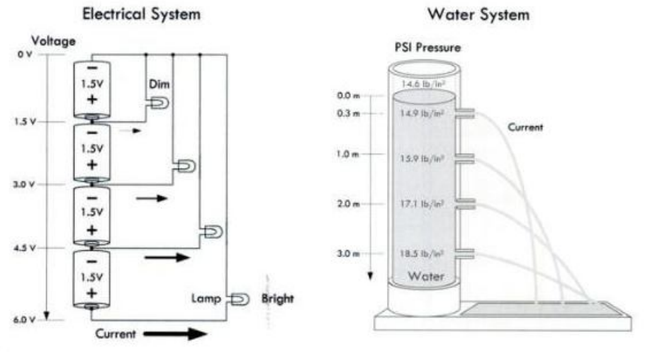

## Electrical grid

Illustration 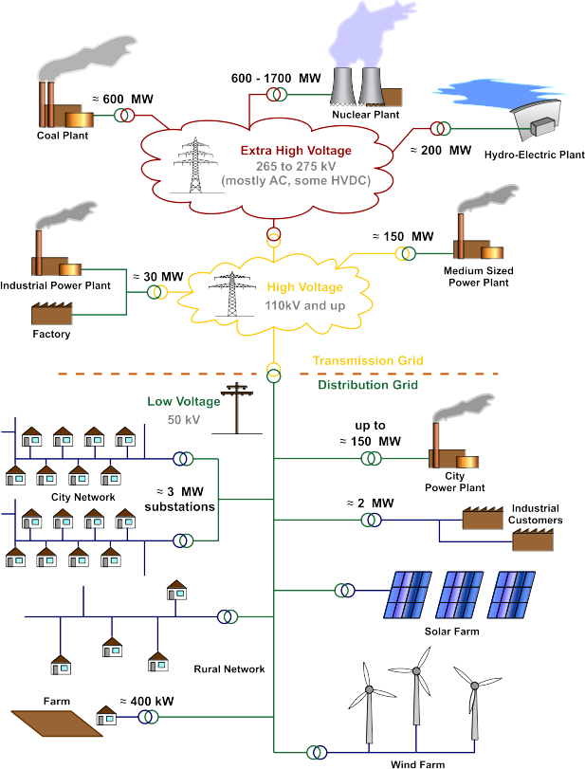1: Electrical grid

Illustration 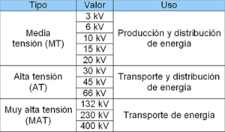2: Super High, High, Middle Voltage

Illustration 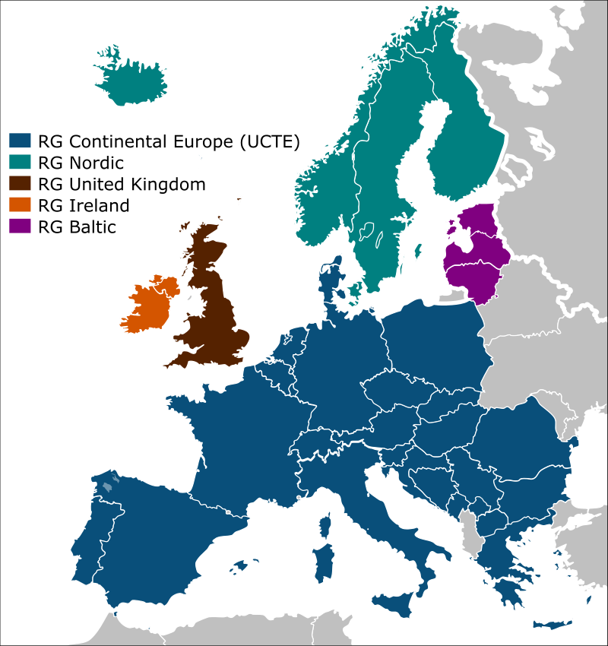3: European electrical grid