# Family checklist conversations (Class 20151027)

ILN improves parent-child relationships generating STEAM conversation.

Use this checklist about current class:

1. What is a Cross-multiplication?
2. What is the main advantage when I use a Module in EV3?
3. Does people in Comunidad de Madrid used more or less energy in latest years?
4. Can you explain all values showed in Lego Energy Meter?

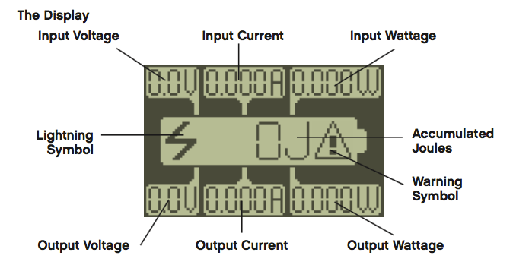

1. What is the relation of Watts and Julius?
2. Why is it necessary a Transformer in a Wind plant?
3. At home, do your family use Low, Middle, High or Super High Voltage?
4. What motor offer better performance to generate energy?
   1. Why did you use Gears?