# Introduction to Electricity with Lego Mindstorms

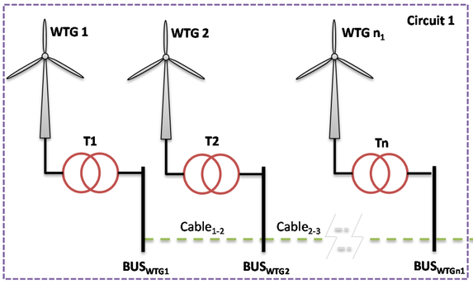

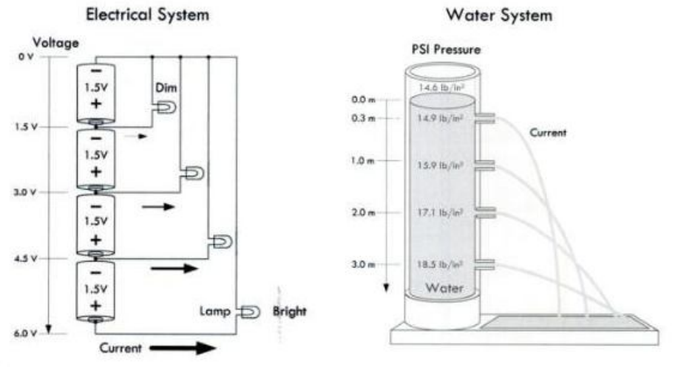

## Spreadsheets

A spreadsheet is an interactive computer application program for organization, analysis and storage of data in tabular form. Spreadsheets developed as computerized simulations of paper accounting worksheets. The program operates on data represented as cells of an array, organized in rows and columns.

* Tep: 41 868 000 000 J (julios) = 11 630 kWh (kilovatios-hora).

**Examples:**

* Cross-multiplication
* Sum a set of columms